The Eigenvalue Multiplicity Problem in the Pole-Placement Method of State-Variable Feedback Control Design

Rhiza S. Sadjad
Department of Electrical Engineering Hasanuddin University
Makassar INDONESIA 90245
rhiza@unhas.ac.id, http://ww.unhas.ac.id/~rhiza/

Abstract. A very basic approach of stabilizing an unstable second order plant is by placing its two poles at the same location, so that the response will be a desirable critically damped response (ξ = 1). For higher order systems, the same approach can be made by placing their two dominant poles at the same location. Unfortunately, the multiplicity of eigenvalues creates numerical difficulty in the gain matrix K computation of the pole-placement method for the state variable feedback control design. This article proposes to avoid the problem by separating the two poles in a distance of very small number ε or the multiple of ε, either in the real-axis direction or in the imaginary-axis direction, or both. The cases of a double integrator plant and a linearized inverted pendulum are discussed as practical examples of the proposed method.

Keywords: eigenvalue multiplicity, pole-placement method

.

1. Introduction

It is a well known fact that the pole-placement method of state variable feedback control design can provide a gain matrix K to control any stabilizable plant such that the control system will give a desirable response [1,2].

Supposed that a stabilizable – not necessarily stable – n^{th}-order Linear Time Invariant (LTI) plant is represented in the state equation of its state-space model:
.

x = A x + B u

(1)

then a gain-matrix K can control the plant such that the state equation of the control system becomes:
.

x = [A - BK] x + B r

(2)

with u (the control signal) = r + Kx, and r is the reference input. Since all the eigenvalues of the [A - BK] matrix can be placed anywhere in the complex plane by adjusting K, then the plant can be controlled to give any desirable response.

The gain-matrix K can be determined analytically and numerically.based on the desired eigenvalues of the [A - BK] matrix to yield a certain response. Determining the gain-matrix K is the state-variable feedback control design fundamental.

2. The Pole-Placement Method

Consider a Single-Input Single-Output (SISO) n^{th}-order LTI plant, controlled by state-variable feedback with the gain-matrix:

K = [k₁ k₂ ……………… k_{n} ] (3)

The characteristics equation of the [A – BK] matrix can be determined as an n^{th}-order polynomial with all coefficients in terms of combinations of k₁, k₂, ……, k_{n}.

If the control design requires all eigenvalues to be placed at:
λ₁
λ₂
λ = .
.
.
λ_{n}

(4)

then the characteristics equation of the [A – BK] matrix is:

(λ −λ₁)(λ −λ₂) ..........(λ −λ_{n}) = 0 (5)

Equating the characteristics equation (5) to the characteristics equation with all coefficients expressed in terms of k₁, k₂, ……, k_{n}, will form a set of n equations with n unknowns. The exact values of k₁, k₂, ……, k_{n} can be obtained analytically by solving these equations.

3. The Eigenvalue Multiplicity Problem.

The gain-matrix K can also be determined numerically using a software package such as MATLAB (copyright by The MathWorks, Inc). Its Version 6.5.0 Release 13 of June 18, 2002 provides a line command to compute the gain-matrix K of the pole-placement method. This line command “place” works very well to place the eigenvalues of [A – BK] matrix anywhere in the complex plane, except when the eigenvalue multiplicity problem occurs [3]:
>> K = place(A,B,lambda)
??? Error using ==> place
Can't place poles with multiplicity greater than rank(B).

This eigenvalue multiplicity problem occurs due to the numerical complication when the package is trying to solve the n equations with n unknowns, with a number of eigenvalues are to be placed at the same location. In order to avoid the computing error, the number of similar eigenvalues should not exceed the rank of the B matrix of the plant ‘s state equation.

On the other hand, many state-variable feedback control design procedures require to place a number of [A – BK] matrix’s eigenvalues at the same location to obtain a desirable critically damped response with a damping ratio ξ = 1.
The following method of slightly separating the multiple eigenvalues will be shown to avoid the occurrence of the problem mentioned above.

4. Slightly Separating The Multiple Eigenvalues.

The smallest number that the MATLAB package can handle in its numerical computation is called “eps” (abbreviated from “epsilon” or ε). The value is speified as small as [4]:
ε = 2.220446049250313 X 10 ⁻¹⁶

The small number above can be used to separate the multiple eigenvalues so that they become different - but still close enough - from each other. The separation is not supposed to significantly alter the results of the gain-matrix K computation. For instance, if two eigenvalues are to be placed at λ₁ = λ₂ = –a, then for the sake of the numerical computation, they can be placed as follows:

λ₁ = –a + k ε
λ₂ = –a – k ε (6a)
or
λ₁ = –a + j k ε
λ₂ = –a – j k ε (6b)
for
j = V-1 and k = 1, 2, 3, ………

5. Case 1: A Double Integrator Plant

The double integrator is a standard plant used by many authors as an example[7]. Representing many physical phenomena, it is a linear, unstable - yet stabilizable - second order system. The state-space model of a normalized double integrator includes the state equation with A and B matrices as follows:
0 1 0
A = B =
0 0 1
(7)

The instability of a double integrator plant can be shown by its response to a certain input signal as seen in Figure 1. The state-variable feedback control design enables to stabilize the plant and places both of its eigenvalues at the same location λ₁ = λ₂ = –1 to obtain a desirable critically damped response with ξ = 1.
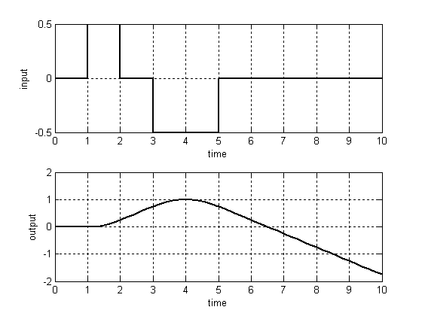

Figure 1 An unstable response of the double integrator plant

The characteristics equation of the state-variable feedback control system’s [A – BK] matrix is:

(λ + 1)( λ + 1) = 0 or λ² + 2 λ + 1 = 0 (8)

In terms of k₁ and k₂ , the characteristics equation can be stated as:

λ² + k₂ λ + k₁: = 0 (9)

So that the gain-matrix can be solved right away as: K = [1 2] by equating Equation (8) and (9). This simplicity of obtaining the analytical solution of the gain-matrix K does not apply to the numerical computation of the same solution, because the number of eigenvalue multiplicity is exceeding the rank of the B matrix The complication of computing the gain-matriz K can be avoided by slightly separating the two eigenvalues:

λ₁ = –1 + 2 ε
λ₂ = –1 – 2 ε (10)

or
λ₁ = –1 + j 2 ε
λ₂ = –1 – j 2 ε (11)
in order to avoid the computational error due the eigenvalue multiplicity problem. The stabilized system’s response to the same input as the previos one is shown in Figure 2.
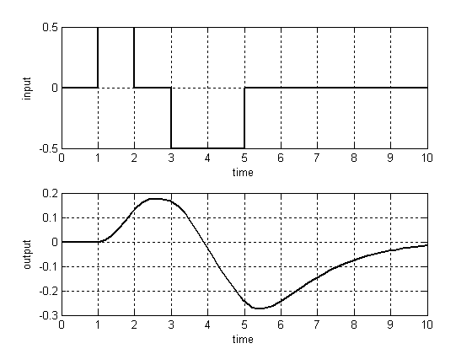

Figure 2 The stabilized system’s’response.

6. Case 2: A Linearized Model of an Inverted Pendulum.

Inverted pendulum is an unstable, fourth-order, non-linear plant. To apply the state-variable feedback control design, the non-linear plant should be linearized. The typical linearized – and normalized - model of an inverted pendulum includes a state equation with matrices [1]:

0 0 1 0 0

0 0 0 1 0
A = B =
0 - 1 0 0 1

0 11 0 0 -1

(12)

The instability of the pendulum can be shown in Figure 3. The two outputs are the cart’s position and the bob’s angular position, respectively.
To stabilize the cart’s and bob’s position, a state-variable feedback control design is carried out by placing all four eigenvalues at the same location λ₁ = λ₂ = λ₃ = λ₄ = –1.

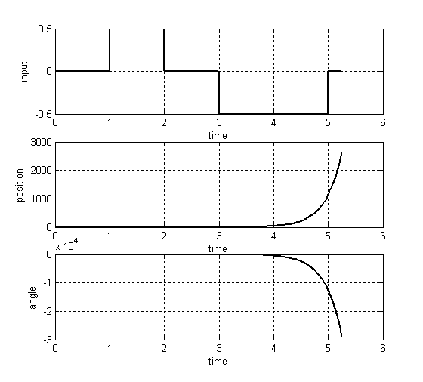

Figure 3 The unstable response of the inverted pendulum

The characteristics equation of the [A – BK] matrix is:

(λ + 1) ⁴ = 0 or λ⁴ + 4λ³ + 6λ² + 4λ +1 = 0
(13)

The same equation can be stated in terms of k₁, k₂, k₃ and k₄ as:

λ⁴ + (k₃– k₄)λ³ – (11– k₁+ k₂)λ²
– 10 k₃ λ – 10 k₁= 0 (14)

The exact analytic solution for the gain-matrix K is obtained by equating Equation (13) and (14)::

k₁ = – 0.1
k₂ = –17.1
k₃ = – 0.4
k₄ = – 4.4 (15)

Figure 4 shows the response of the stabilized pendulum. Numerically, however, finding the solution of the gain-matrix K is a rather difficult task. The four eigenvalues must be separated into four different location as follows:
λ₁ = –1 + 10¹² ε = –0.99997779553951
λ₂ = –1 – 10¹² ε = –1.00002220446049
λ₃ = –1 + j 10¹² ε =
–1 + j 0.00002220446049
λ₄ = –1 – j 10¹² ε =
–1 – j 0.00002220446049
(16)

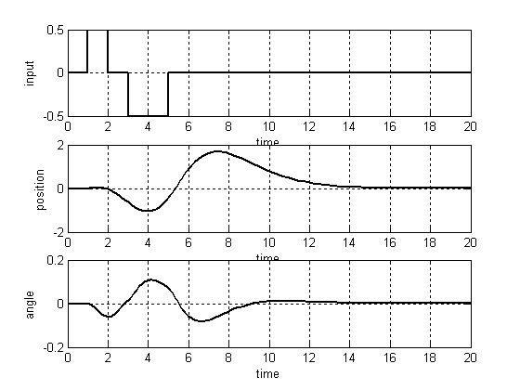

Figure 4 The stabilized response of the inverted pendulum

The results of the numerical computation of the gain-matrix K are as follows:

k₁ = – 0.09995809805877
k₂ = – 17.09870137831270
k₃ = – 0.39987431110188
k₄ = – 4.39945546092469 (17)

Compared to the exact solutions shown in Equation (15), the average error of the numerical computation of the gain-matrix K for this case is only: 0.0233%.

7. Concluding Remarks.

The eigenvalue multiplicity creates a complication in the numerical computation of the gain-matrix K for the pole-placement method in the state-variable feedback control design. This problem is avoided by slightly separating the multiple-eigenvalue locations in the real-axis direction, or in the imaginary axis direction, or both. A very small number ε is used to determine the distance of separation. In the case of a second-order system - a double integrator plant - the desired eigenvalues must be separated as far as 2ε from their original location. To avoid the similar computation error, in the case of a fourth-order system - a linearized inverted pendulum - the desired eigenvalues must be separated as far as 10¹²ε from their original location. The results of the numerical computation of the gain-matrix K in both cases have shown a negligible error as compared to the analytical results.
The future research based on this result is to develop a modified numerical method that automatically separates any multiple eigenvalue to a minimum distance to compute the gain-matrix K with a minimum error.

Acknowledgment

The author would like to thank his former student Muhammad Syarif for pointing-out the complication of gain-matrix K numerical computation in a multiple-eigenvalue case.

Bibliography

[1] Friedland, Bernard, [1986], “Control System Design”, McGraw-Hill, Inc., New York.
[2] Ogata, Katsuhiko, [1982], “Modern Control Engineering”, Prentice-Hall of India, Ltd.., New Delhi.
[3] MATLAB Help, Release 13, [2002], MathWorks, Inc.
[4] Mathews, John H. and Kurtis D. Fink, [2004], “Numerical Methods Using MATLAB ”, Pearson Prentice-Hall., New Jersey.
[5] Antoulas, Thanos and John Slavinsky, [accessed April 21, 2008], “Eigenvalue Decomposition”, http://cnx.org/content/m2116/latest/
[6] Brookes, Mike , [accessed April 21, 2008], “Matrix Reference Manual”, http://www.ee.ic.ac.uk/hp/staff/dmb/matrix/intro.html#Intro
[7] Astrom, Karl J. and Bjorn Wittenmark, [1984], “Computer-Controlled Systems, Theory and Design”, Prentice-Hall, Inc., New Jersey.

