Ohm’s Law with Temperature Correction in a Case of Alternating Current (AC) Circuit with a Resistive Load

Rhiza S. Sadjad
Department of Electrical Engineering Hasanuddin University
Makassar INDONESIA 90245
rhiza@unhas.ac.id, http://www.unhas.ac.id/~rhiza/

Abstract. The infamous Ohm’s Law is usually presented with a basic assumption that the resistance in an electrical circuit is constant. This is roughly true when the temperature of the resistor is held constant by removing all the dissipated heat out to the surrounding environment. If a portion of the dissipated heat remains in the body of the resistor, the temperature increases, and the resistance will either increases or decreases proportionally depends on the temperature constant. This phenomenon creates an interesting – yet educative - non-linear dynamics as presented in this article.

Keywords: Ohm’s Law, temperature correction, temperature constant

1. Introduction

A simple alternating current (AC) circuit with a voltage source v_{i}(t) and a constant resistive load R is shown in Figure 1.

].
i(t)
R
v_{i}(t)
Figure 1 A simple electrical circuit with a resistor and an AC voltage source

The current flowing through the resistor is calculated conventionally according to Ohm’s Law as [1, 3, 4]:
i(t) = v_{i}(t)/ R

(1)

Then, the instantaneous average electrical power dissipated at the resistor is:
P = I_{eff} ² R

(2)

where I_{eff} is the root mean square (RMS) or the effective value of the current.

The conventional Ohm’s Law works accurately with the basic assumption that all the dissipated power is removed out of the resistor to the surrounding environment, then the resistor’s temperature remains constant and so the resistance [2]. .

As a matter of fact, it is physically more realistic to consider that a portion of the heat remains at the body of the resistor so that its temperature increases and the resistance changes. Hence, the computation of the effective current and the average power has to be corrected.

2. Dissipated Heat and Increasing Temperature.

Supposed the resistance changes with time t and denoted as R(t), then the computation of the current and power is carried out as follows:
i(t) = v_{i}(t)/ R(t)

(3)

I_{eff} (t) =
The effective value of the current at every instant t is:

(4)

Consequently, the instantaneous power dissipated at any time t is:
P(t) = [I_{eff} (t)]² R(t)

(5)

Suppose that the resistor’s temperature varies with time t and indicated as T(t), then the increase of the temperature is directly proportional to the remaining dissipated power at the body of the resistor:

$$\frac{\text{dT}(t)}{\text{dt}} = p[P(t)\text{ - }k\text{ T}(t)]$$

(6)

where:
P(t) : the instantaneous power dissipated at time t, [Watt]
k T(t): the instantaneous power removed to the environment at time t, [Watt]
$\frac{\text{dT}(t)}{\text{dt}}$: the rate of change of temperature, [ºC/second]

The constants p and k denote the conversion of physical units, for instance: if the physical units of electrical power P(t) and T(t) are [Watt] and [ºC] respectively, then the physical units of p and k are [ºC]/[Watt][second] and [Watt]/[ºC] respectively. The values of both constants can be determined by a calculation based on experiments or simply normalized to 1.

3. The Variation of Resistance and the Steady State Analysis.

The variation of the resistance over time t is proportional to the variation of the temperature:
R(t) = R(0) + α [T(t) – T(0)]
(7)

where:
α : the temperature constant, either positive (PTC = Positive Temperature Constant) for a certain types of materials, 0 (assumed in general) or negative (NTC = Negative Temperature Constant).
T(0) and R(0) : the room temperature and the resistance at the room temperature both at t = 0, and considered as the initial conditions of the derived differential equation:

$\frac{\text{dR}(t)}{\text{dt}} = \text{α }\frac{\text{dT}(t)}{\text{dt}}$ (8)

The temperature and the resistance are assumed to reach equilibrium (the steady state) after t >>> 0, denoted by T_{ss} and R_{ss} respectively. The effective value of the current can be computed from Eq. (4) as follows:

$I_{\text{eff}} = \sqrt{\frac{1}{t}\int_{0}^{t}{[}v_{i}}(t){\text{/R}}_{\text{ss}}]^{2}\text{dt } = \frac{V_{\text{eff}}}{R_{\text{ss}}}$ (9)

The average power P_{av} is computed from Eq. (5):
P_{av} = [I_{eff}]² R_{ss}

(10)

At the equilibrium, when the temperature is constant, the constant k can be solved from Eq. (6), as follows:

0 = p [P_{av} – k T_{ss}]

thus:
$k = \frac{P_{\text{av}}}{T_{\text{ss}}}$ (11)
T_{ss} can be measured in an experiment and P_{av} can be expressed in terms of V_{eff} (specified) and R_{ss}. The value of R_{ss} can be expressed by Eq. (7):
R_{ss} = R(0) + α [T_{ss} – T(0)]
(12)

Since T(0)) and R(0) are specified as the room temperature and the resistance at the room temperature respectively, then the only unknown parameter in the steady-state analysis is the temperature constant α.
Physically, only positive R_{ss} is considered. Therefore, the minimum value α of can be obtained from Eq. (12):
R_{ss} = R(0) + α [T_{ss} – T(0)] > 0
α_{min} = – R(0)/[T_{ss} – T(0)] (13)

Example:

A 100 Watt, 220 Volt light bulb has a steady state temperature T_{ss} of 150 ºC. If the room temperature T(0) is 26 ºC then specify the average power P_{av}, the steady state resistance R_{ss} and the constant k for various values of temperature constant α .

Solution:

The room temperature resistance R(0) is calculated from the light-bulb specifications, as follows:
R(0) $= \frac{[\text{220}]^{2}}{\text{100}} \text{Ohm }=$ 484 Ohm
The minimum value of α is computed by the Eq. (13):
α_{min} = – R(0)/[T_{ss} – T(0)] = – 3,90323

Then using the Eqs. (10), (11) and (12), R_{ss},, P_{av} and k are calculated for each specified α as shown in Table (1):and the plot in Figure 2. The steady state resistance R_{ss} increases linearly with increasing α . For PTC type of resistors, the steady state average dissipated power P_{av} decreases almost linearly with increasing α. For NTC type of resistors, the steady state average dissipated power P_{av} increases non-linearly with decreasing α, and as α approaches α_{min}, P_{av} grows rapidly to infinite.

4. Dynamic Analysis and Transient Response.

Except for the case of α = 0, the temperature phenomenon of a resistor in an AC circuit exhibits a case of non-linear dynamics. Hence, to obtain the transient response, it is more convenient to solve the equation numerically rather than analytically. Figure 3 shows a numerical simulation of this phenomenon using the ©Simulink facility on ©MATLAB 6.5 [5, 6].

Table (1)
R_{ss}, P_{av} and k for α > – 3,90323
α | R_{ss} [Ohm] | P_{av} [Watt] | k
10 | 1724,00 | 28,0742 | 0,18716
5 | 1104,00 | 43,8406 | 0,29227
4 | 980,00 | 49,3878 | 0,32925
3 | 856,00 | 56,5421 | 0,37695
2 | 732,00 | 66,1202 | 0,44080
1 | 608,00 | 79,6053 | 0,53070
0,6 | 558,40 | 86,6762 | 0,57784
0,4 | 533,60 | 90,7046 | 0,60470
0,2 | 508,80 | 95,1258 | 0,63417
0,1 | 496,40 | 97,5020 | 0,65001
0,01 | 485,24 | 99,7445 | 0,66496
0 | 484,00 | 100,0000 | 0,66667
-0,01 | 482,76 | 100,2569 | 0,66838
-0,1 | 471,60 | 102,6293 | 0,68420
-0,2 | 459,20 | 105,4007 | 0,70267
-0,4 | 434,40 | 111,4180 | 0,74279
-0,6 | 409,60 | 118,1641 | 0,78776
-1 | 360,00 | 134,4444 | 0,89630
-2 | 236,00 | 205,0847 | 1,36723
-3 | 112,00 | 432,1429 | 2,88095
-3,01 | 110,76 | 436,9809 | 2,91321
-3,1 | 99,60 | 485,9438 | 3,23963
-3,2 | 87,20 | 555,0459 | 3,70031
-3,4 | 62,40 | 775,6410 | 5,17094
-3,8 | 12,80 | 3781,2500 | 25,20833
-3,9 | 0,40 | 121000,0000 | 806,66667
-3,90323 | 0,00 | N/A | N/A

The temperature constant α depends on the inherent characteristics of the resistor’s material. There are 3 (three) types of material considered: (1) a “theoretical” resistor with α = 0, (2) a PTC with α > 0, and (3) an NTC with α < 0. The constant k depends on α and the (measureable) steady state temperature.
The only remaining constant from the dynamic equation stated in Eq. (6) is p. This constant p does not have an effect on the steady state behavior, so it should have represented the transient behavior. From the physical point of view, the constant p determines the heat transfer process from the resistor to its surrounding environment. The larger p, the faster the resistor will reach the steady state, as demonstrated later.

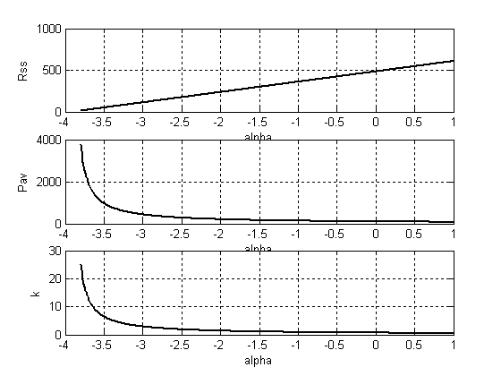
Figure 2
The Plot of R_{ss}, P_{av} and k
for 1 > α > – 3,8

PTC
NTC

For α = 0, the transient behavior exhibits a linear first-order system dynamic as shown in Figure 4. In the case of the light bulb previously described, the temperature increases from 26 ºC to 150 ºC. Figure 5 and 6 have clearly shown the non-linear dynamic transient behavior from a PTC (α = 1) type of resistor and an NTC (α = –1) type of resistor respectively. While the temperature constant α (and the constant k) represents the inherent temperature characteristics of the heated resitor, the constant p represents the ambient or environmental condition and the way how the heat transfer process between the resistor and its environment is conducted.
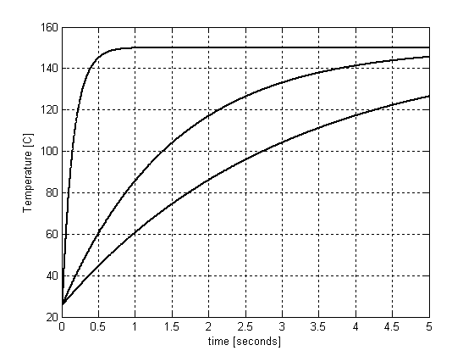
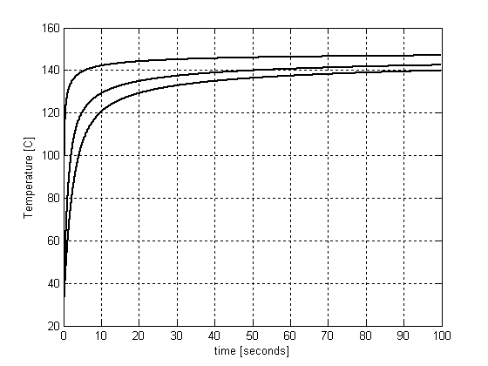
Figure 4
The temperature transient response for α = 0 and various values of constant p
p = 10
p = 1
p = 0.5
α = 0
Figure 5
The temperature transient response for α = 1 and various values of constant p

p = 10
p = 1
p = 0.5
α = 1
Figure 6
The temperature transient response for α = –1 and various values of constant p

p = 10
p = 1
p = 0.5
α = –1

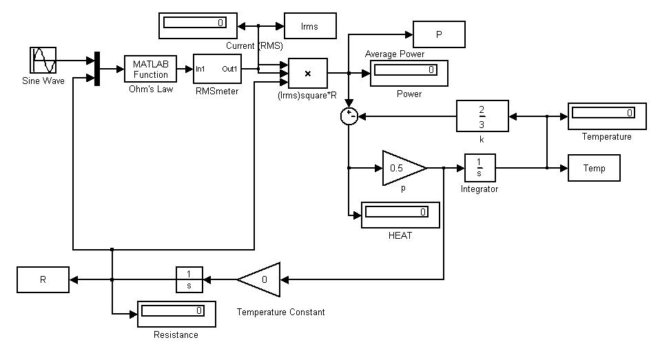
Figure 3
The simulation of the temperature phenomenon of a resistor in an AC circuit
α

5. Concluding Remarks

The results presented in this article have opened new perspectives in studying fundamental theorems in the area of Electrical Engineering such as the conventional Ohm’s Law. The advantages of numerical analysis and simulation have enabled students and researchers to look at the behavior of a physical material, such as a simple resistor in an AC circuit, more realistically in relation with other physical variables such as the heat and temperature.

A “theoretical” resistor is assumed to have zero temperature constant α. More realistic resistors, in fact, are either a PTC with α > 0 or an NTC with α < 0. The steady state analysis introduces another constant k to represent the behavior of the resistor when its temperature reaches the final value. This constant k is obtained experimentally in terms of α and the steady state temperature T_{ss}. Both constants α and k determine the correction of the average dissipated power (P_{av}) calculation in the conventional circuit analysis.

The enviromental condition and the way how the heat is transferred from a resistor to its environment are influential factors to determine the temperature transient response, i.e. the dynamic behavior of the resistor related to its temperature characteristics. A “theoretical” resistor with α = 0 exhibits the dynamic of a first-order system, while both PTC and NTC-type of resistors have shown the properties of high order non-linear dynamics. A constant p is introduced to describe this behavior. In all cases, the larger p, the faster the resitor reaches its steady state temperature.

Finally, it is expected that various research projects based on this correction of Ohm’s Law can be proposed in the future. Just to mention a few of them [7, 8]: in depth mathematical studies to derive an analytic solution of the non-linear dynamics, further experimental studies on the transient and steady state behavior of heating elements, studies on the fuses and circuit protection systems, studies on heat transfer processes of resistive elements, studies on the power factor of inductive and capacitive heating elements, studies on temperature charracteristics of materials, and many more.

Bibliography

[1] Smith, Ralph J., [1976], “Circuits, Devices and Systems”, John Wiley and Sons, Inc., New York.
[2] Anonymous, [accessed May 4, 2008], http://en.wikipedia.org/wiki/Ohm%27s_law#Temperature_effects
[3] Anonymous, [accessed May 4, 2008], http://www.the12volt.com/ohm/ohmslaw.asp
[4] Anonymous, [accessed May 4, 2008], http://www.grc.nasa.gov/WWW/K-12/Sample_Projects/Ohms_Law/ohmslaw.html
[5] MATLAB© Help, Release 13, [2002], MathWorks, Inc.
[6] Mathews, John H. and Kurtis D. Fink, [2004], “Numerical Methods Using MATLAB ”, Pearson Prentice-Hall., New Jersey.
[7] Rizzoni, Giorgio, [1993], “Principles Applications of Electrical Engineering”, Richard D. Irwin, Inc., Illinois.
[8] Johnson, J. Richard, [1984], “Electric Circuits”, Hayden Book Coy., New Jersey.

