

EAC of ABET
Readiness Review Report
for the
ELECTRICAL ENGINEERING
UNDERGRADUATE STUDY PROGRAM
at
HASANUDDIN UNIVERSITY
Makassar, INDONESIA
September 2018

CONFIDENTIAL

The information supplied in this Readiness Review Report is for the confidential use of ABET and its authorized agents, and will not be disclosed without authorization of the institution concerned, except for summary data not identifiable to a specific institution.

BACKGROUND INFORMATION

Contact Information
Dr. Ing. Ir. Faizal Arya Samman, S.T., M.T.
e-mail: faizalas@unhas.ac.id
mobile: +62 856 5738 7523
address: Department of Electrical Engineering
Faculty of Engineering Hasanuddin University
Jalan Poros Malino km. 6 Bontomarannu
GOWA, South Sulawesi 92171 INDONESIA

Program History
The ELECTRICAL ENGINEERING STUDY PROGRAM (EESP) at Hasanuddin University, Makassar, INDONESIA was founded in 1963 as a part of the Faculty of Engineering established a few years earlier. The campus was originally located at Baraya, near the downtown of Ujung Pandang, the old name of the city of Makassar. In early 1980s, the university campus was relocated to Tamalanrea, about 10 km north-east of downtown Makassar. More than 30 years later, the Faculty of Engineering was relocated again to its new campus at Gowa, 20 km south of Tamalanrea, and the EESP - under the Department of Electrical Engineering - officially settled at its new facilities in the new campus at Gowa in 2017.

During the first years after its establishment in mid 1960s, most EESP students of Hasanuddin University continued and completed their undergraduate degrees in 2 (two) major universities in Indonesia, namely Gajah Mada University (UGM) in Jogyakarta and Bandung Institute of Technology (ITB) in Bandung. The majority of the graduates from this period made their careers as academicians, or as engineers at the state-owned electrical power company (PLN) and telecommunication (TELKOM), or started their own private companies related to electricity and telephone businesses.

A major change of curriculum was implemented in 1980. The EESP was split into 2 (two) sub-study programs or concentrations, namely: (1) The Electrical Power Engineering and (2) The Telecommunication and Electronic Engineering. It was an 8 (eight) semester undergraduate engineering study program provided in 4 (four) academic years. In the first three semesters, the students took common courses on the fundamentals of Electrical Engineering and the required mathematics, physics and chemistry. Beginning at the fourth semester, the students voluntarily selected their preferences of concentration, and took different required and elective courses accordingly.

The next stage of curriculum development was started in 1995. A new concentration was established by dividing the Telecommunication and Electronic Engineering sub-study program into 2 (two), i.e. (1) The Telecommunication Engineering and Information Systems, and (2) The Computer, Control and Electronic Engineering sub-study programs. Common courses for both new concentrations were listed until the fourth semester. The basis of the curriculum establishment was the nationally decreed higher education curriculum development in Indonesia: Competency-Based Curriculum (KBK).
Tabel 1-1 The Summary of Major Changes in the History of Hasanuddin University Electrical Engineering Study Program

Most recently, a major change in the EESP curriculum was made related to the campus relocation to Gowa in 2015. The new campus is designed to support the Laboratory-based Education (LBE) system adopted by the Faculty of Engineering. By this time the EESP has established its Masters and Doctoral Degree programs supported by no less than 20 research laboratories and working groups (see Table 1-2 in the next section). The process of curriculum development was managed by a Focus Group Discussion (FGD) on Curriculum 2015 in a 5 (five) year working period from 2012 to 2017, with a tagline: “From Competency To Contribution”.

The main idea of the recent curriculum change is to extend the competency-based curriculum previously implemented to a brand new curriculum called the “R&D-(research and development)-based curriculum”. The existing (since 1995) three concentrations were discontinued and all merged back to only one EESP. The curriculum structure is now composed of 4 (four) semesters of fundamentals and 2 (two) semesters of (elective) course packages to develop the competency, and the final laboratory-based, or R&D-based, 2 (two) semesters to make the contribution (see Figure 1-1 in the next section).

The timeline of the EESP 55 year history is summarized in Table 1-1. After 1995, in fact, the EESP curriculum has been revised every 5 (five) years, in 2000, 2005 and 2010 consecutively, but only with minor revisons.

Options
The main structure of the curriculum is shown by Figure 1-1. In the first 4 (four) semesters, freshmen and sophomores spend most of their time in classrooms and supporting teaching laboratories to develop their knowledge on required and relevant mathematics and basic sciences (physics and chemistry), and the Electrical Engineering fundamentals, especially the 4 (four) basics namely: (1) Electric Circuits, (2) Electro-magnetics, (3) Solid-state Electronics and (4) Digital Logic Circuits. They also begin to develop their skills to conduct simple experiments, to analyse, intepret and present data, to enhance their knowledge on the required subjects.

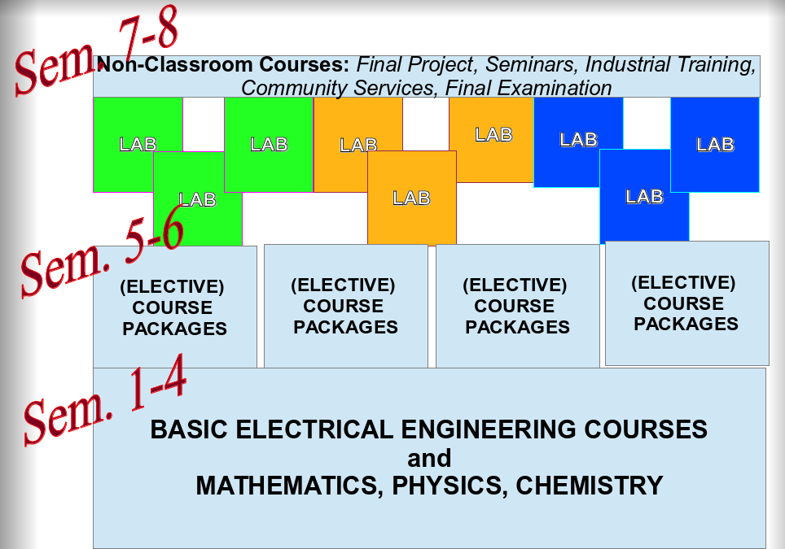
Figure 1-1 The Curriculum Structure

After completing all basic and fundamental courses, in the third year the students are supposed to take at least one elective-course package per semester consisting of 3 to 4 courses in a specific area of electrical engineering that will - but not necessarily - lead to one of the research laboratories or working groups in the fourth year that they are interested to apply. Roughly 6 to 8 elective-course packages are offered each semester to juniors, covering the total of more than 50 elective-courses.

Beginning in the fifth semester, a junior should make a decision to choose at least one of the following 5 (five) options by solicitedly selecting the related package of elective courses:

OPTION 1: Electrical Power Engineering and Electricity
OPTION 2: Telecommunication Engineering and Information Systems
OPTION 3: Computer Engineering and Robotics
OPTION 4: Control Systems and Instrumentation
OPTION 5: Electronic Engineering

The ultimate learning process is at the final fourth year. Seniors are required to apply to one of the research laboratories or working groups. When a senior is admitted to a research laboratory or working group then he or she becomes a member of the laboratory or group by signing an annual contract with the head of the laboratory or the chairman of the group. The seniors will work together with professors and their associates and assistants, their fellows graduate and undergraduate students, to develop their ability to apply their knowledge and to design experiments, systems, processes and/or components to meet desired needs. They also learn how to work effectively not only as individuals but also in teams, either as leaders or members.

Tabel 1-2 List of Available Research Laboratories and Working Groups in the Academic Year of 2018-2019

In the seventh semester, the students are expected to learn how to identify and formulate a problem, present it and propose a final project in a seminar to solve it. They should be able to define the scope of the problem so that they could complete the solution within months in the next eighth semester.

The final examination at the end of eighth semester is a special occasion to give an opportunity for graduating students to show their in-depth technical competence in at least one area of Electrical Engineering and to prove their academic contributions by demonstrating and defending their final undergraduate projects.

Program Delivery Modes
The Faculty of Engineering officially runs all academic activities in working hours 07:00 AM to 05:00 PM Monday to Friday, 2 (two) semesters per academic year, 16 weeks per semester. Traditional or regular lecture courses are delivered during these working hours, while other activities, including non-lecture activities, may be delivered in these working hours or in the other time.

An EESP graduate must complete at least 145 credit hours of courses, a total of 28 credits hours equivalent of those are non-lecture courses, incuding:
(a) The Undergraduate Final Project Report (called “SKRIPSI”), presented and defended in a Final Examination, 4 credit hours
(b) Seminar on the Undergraduate Final Project Results, 2 credit hours
(c) Seminar on the Undergraduate Final Project Proposal, 2 credit hours
(d) Community Services (called “Kuliah Kerja Nyata” or KKN), an off-campus 1 month activity run by the university, usually in a remote area or a village, 4 credit hours
(e) Practical (Industrial or “On Job”) Training, an off-campus 1 to 2 month activity, typically in an industrial site, 2 credit hours
(f) Laboratory 1, an intra-laboratory or working-group R&D activity, semester 7, 8 credit hours, to develop an undergraduate final project proposal
(g) Laboratory 2, an intra-laboratory or working-group R&D activity, semester 8, 8 credit hours, to produce a contribution from the undergraduate final project

The remaining 117 credit hours are delivered as regular lecture courses in classrooms supported by prescribed syllabii and text books, and/or by conducting experiments in the teaching laboratories: Basic Physics Laboratory, Basic Electrical Engineering Laboratory and Computer Software Laboratory.

Program Locations
All academic teaching and learning processes are located in the new Faculty of Engineering campus at Gowa, about 20 km to the south from the old campus at Tamalanrea, Makassar. The new campus is designed to accomodate the concept of Laboratory-based Education (LBE) adopted by the Faculty of Engineering. Common facilities such as classrooms, the central library and the Faculty of Engineering administrative offices, are located in the main area of campus. A three-story building as seen in Fig. 1-2 is functioned as the Classroom Building to house classrooms with the capacity of 20 to 100 students. Lecture theaters for an audience of hundreds of students are also available for general lectures. For smaller classes, less than 20 students, the seminar and meeting rooms in laboratories at the Electrical Engineering Building can be used, as shown in Fig. 1-3.

Figure 1-2 The Faculty Engineering's Common Classroom Building
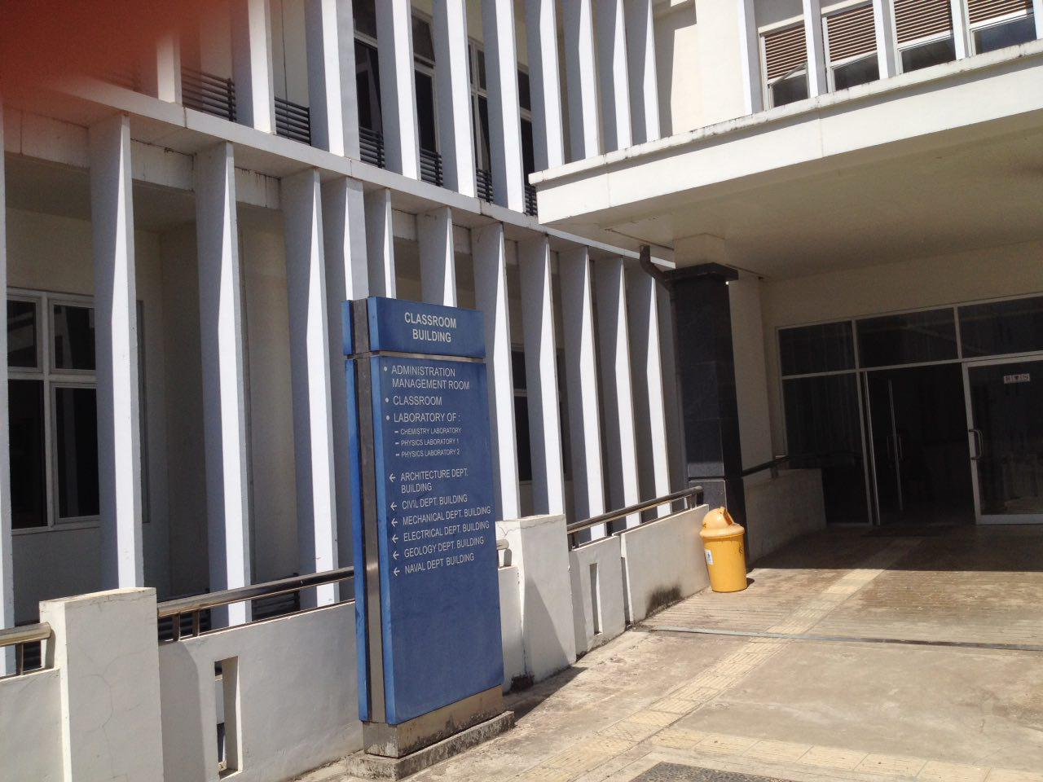
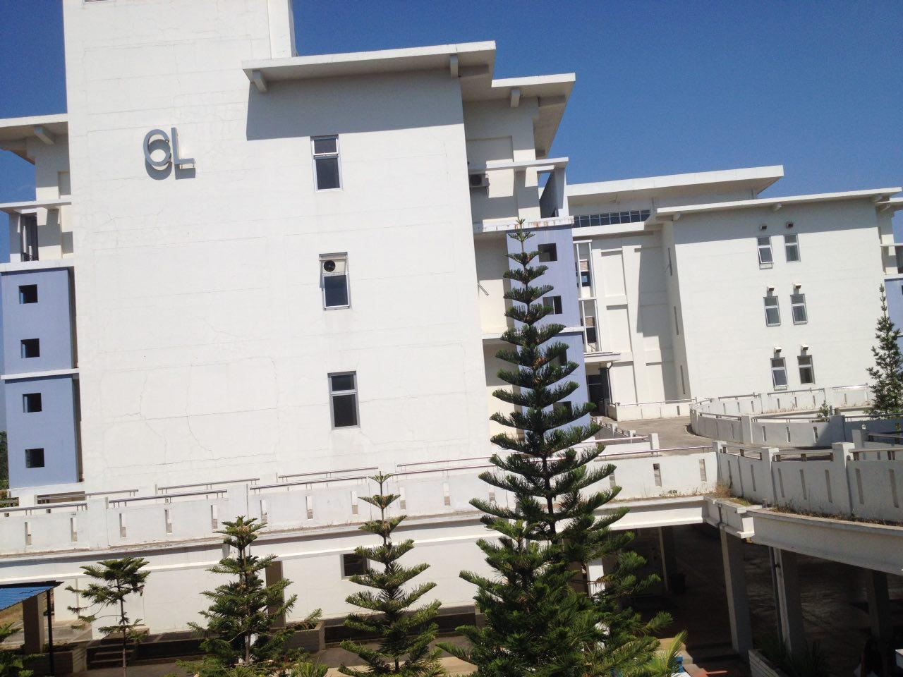

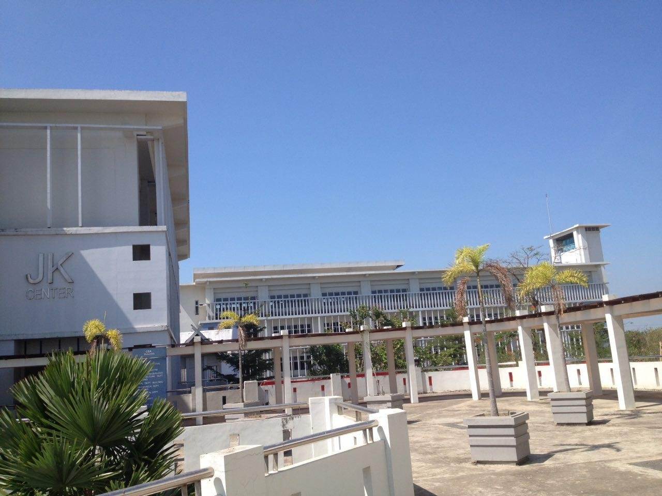
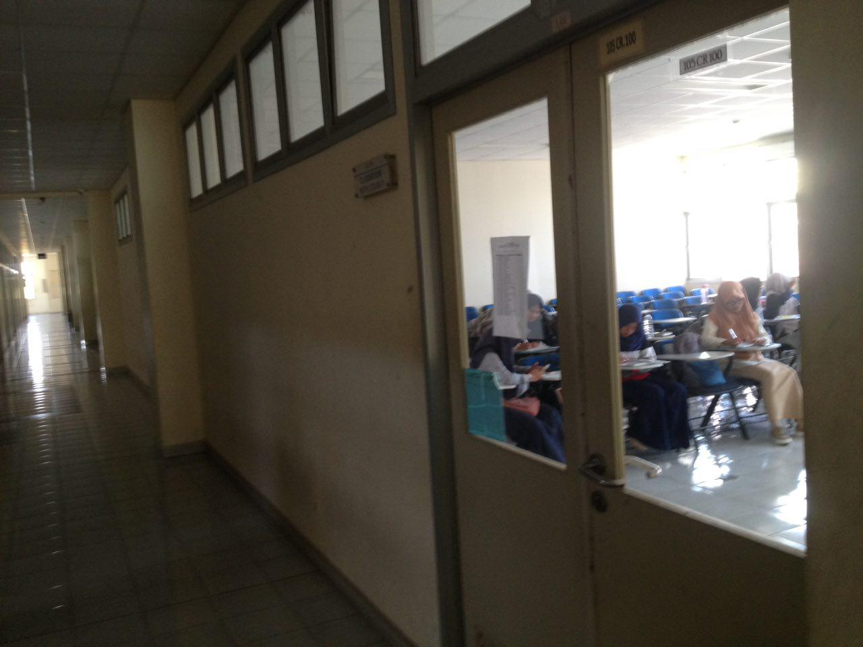

Figure 1-3 The Electrical Engineering Building
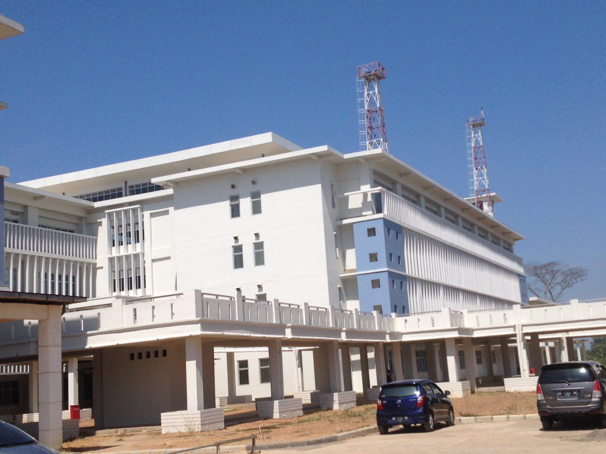
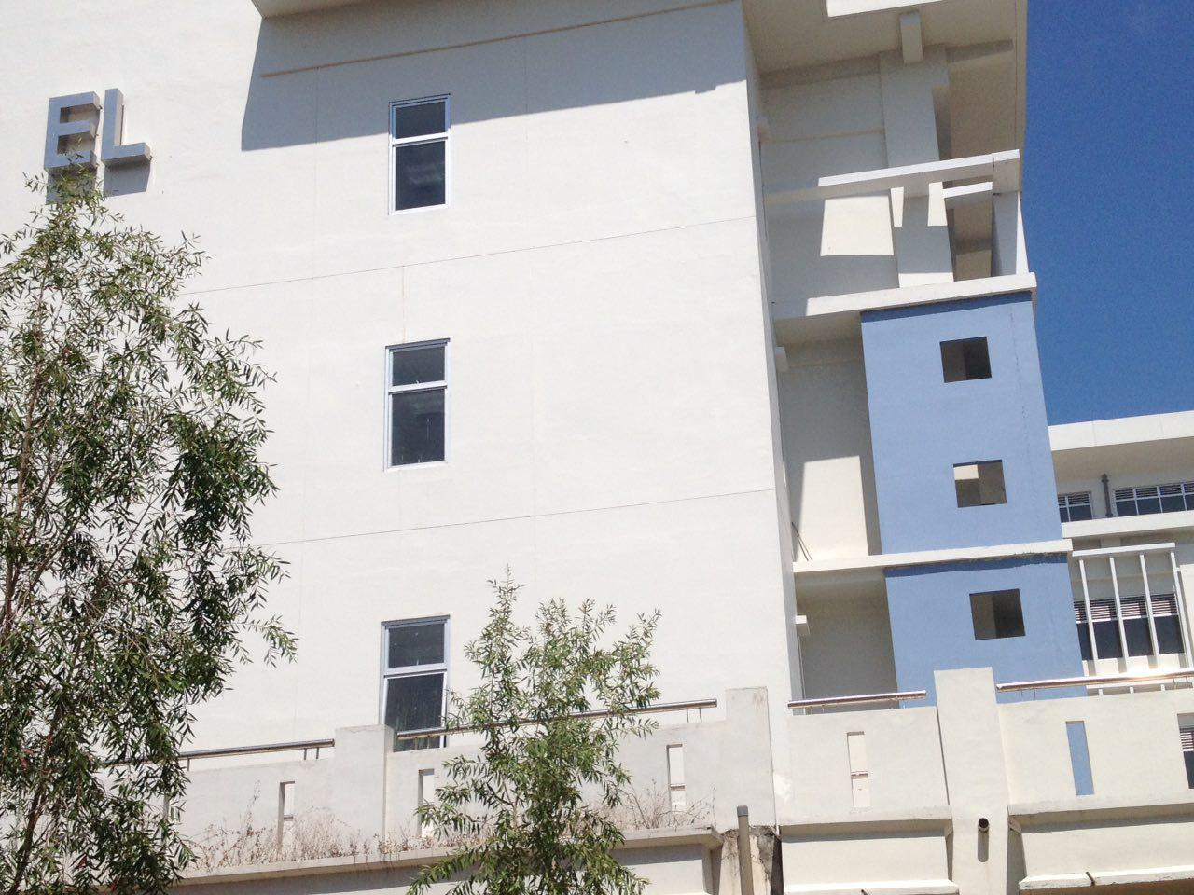

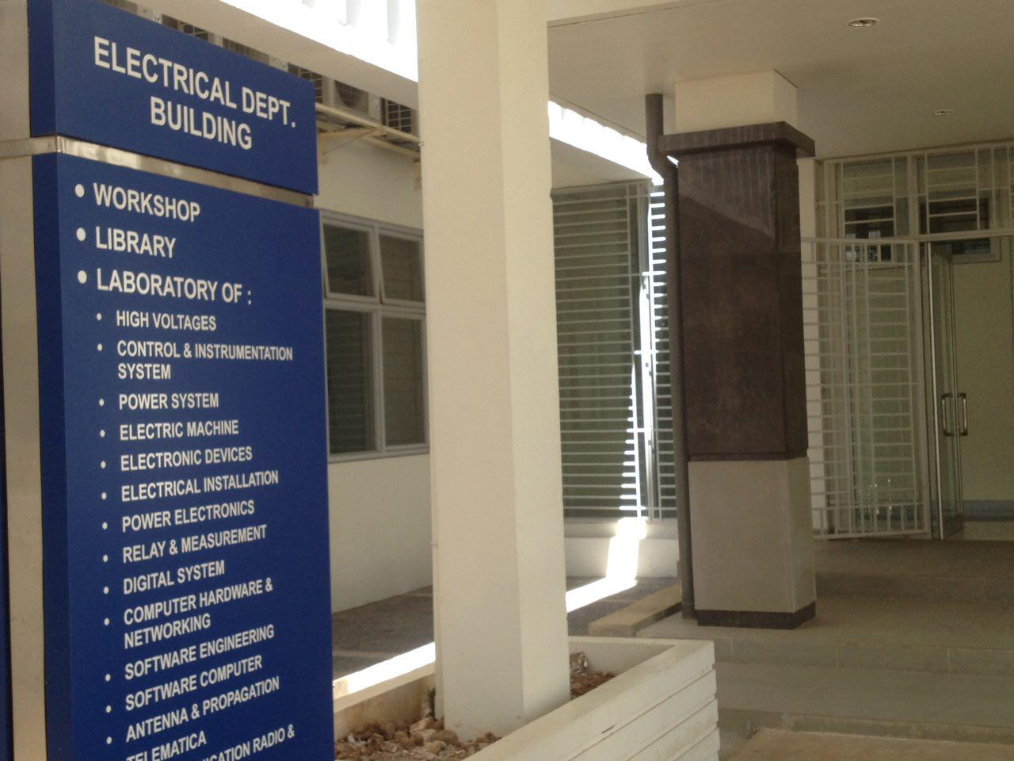
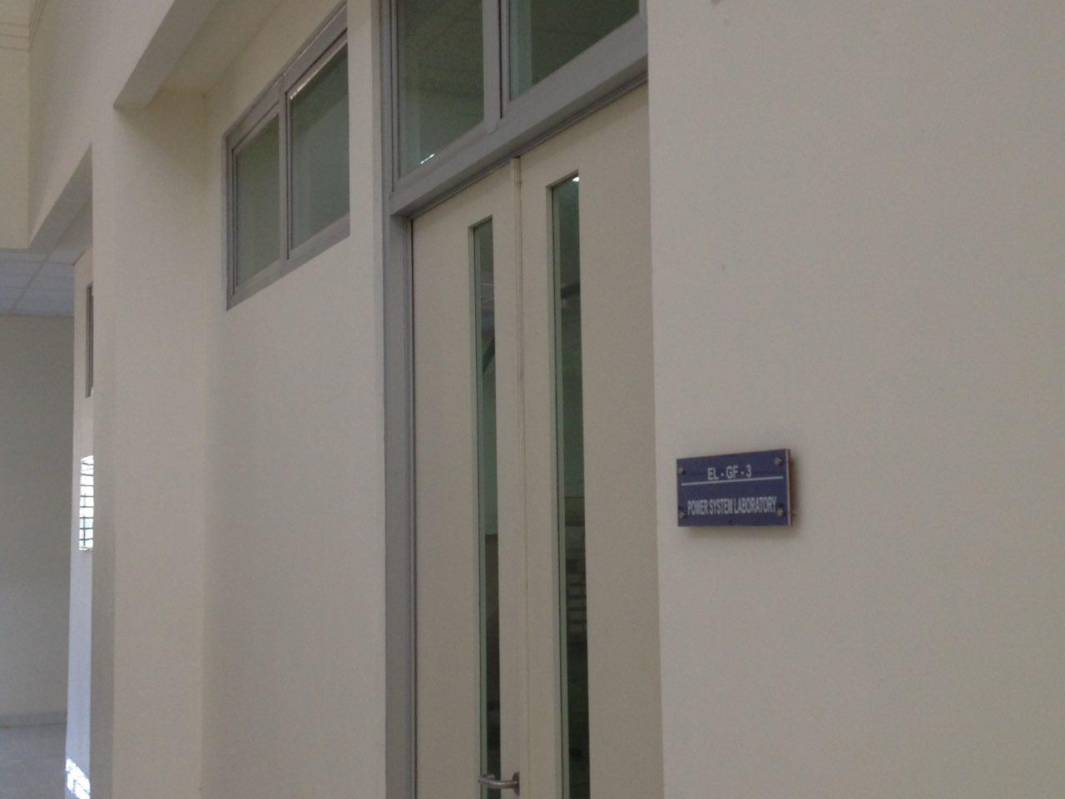

Public Disclosure
The information regarding the PEOs, SOs, annual student enrollment and graduation data, etc. is posted both on the standing banners in front of the Department's administrative office (see Fig. 1-4) and in the official website of the EESP (see Fig. 1-5): http://elektro.unhas.ac.id/ or http://eng.unhas.ac.id/elektro/en/

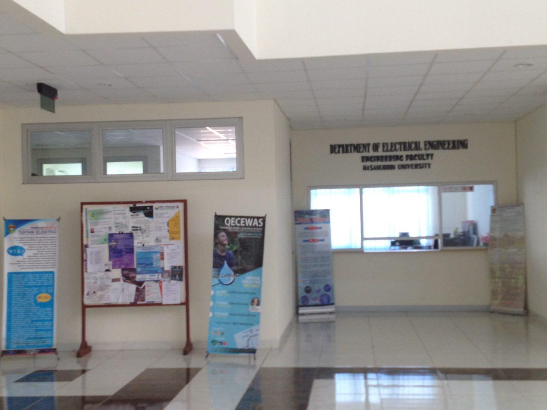
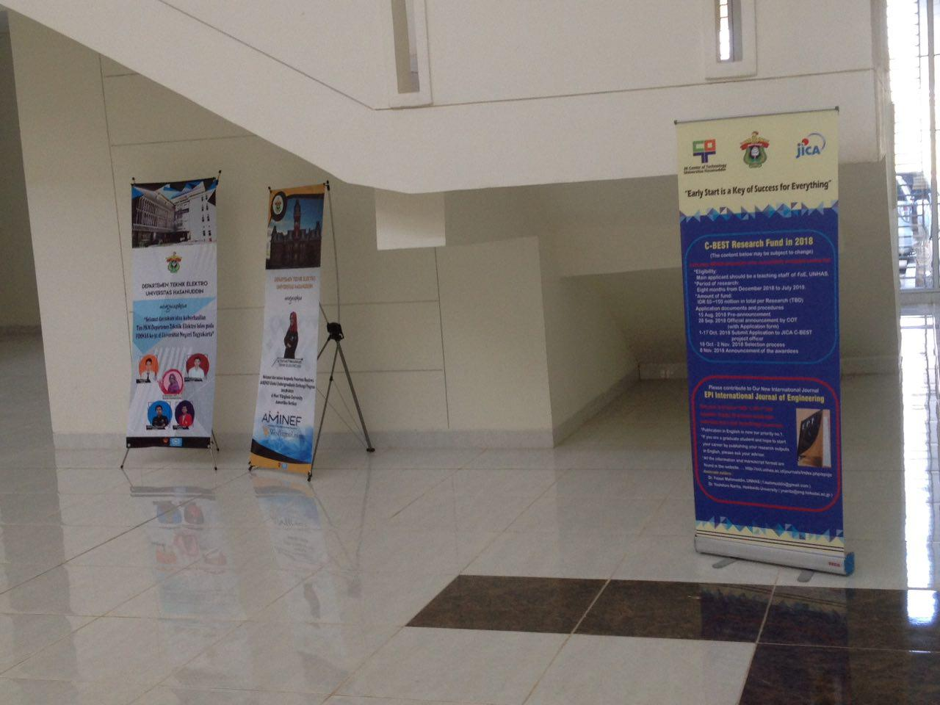
Figure 1-4 The Standing Banners in Front of the Depatment's Administrative Office

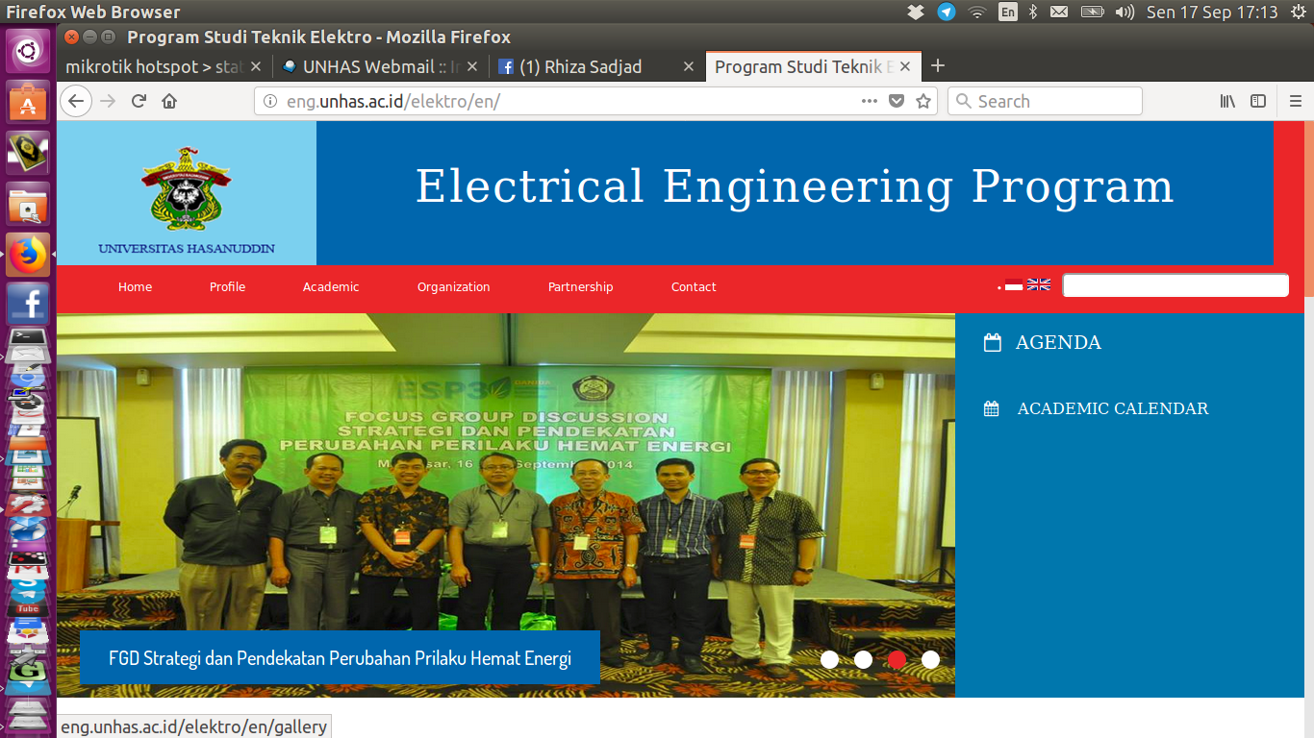
Figure 1-5 The Screen-Shot of the Front Page of the EESP Official Website

Rizzoni, Giorgio, “Principles and Applications of Electrical Engineering”, [1993], Boston, MA, USA, page 2.

