CRITERION 5. CURRICULUM

A. Program Curriculum

The Program Curriculum of the EESP is designed to meet the program educational objectives.  
The EESP requires that all educational programs must have a freshman year that consists of mathematics and basic science, a set of general education, and engineering topics. With these constraints, the implementation of the EESP curriculum consists of three elements and with a total minimum of 145 credits hours as shown in the Figure 5-1.

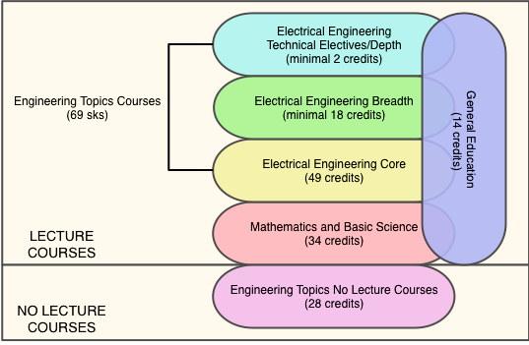

Figure 5.1 Overview of EESP curriculum.

Table 5-1 describes the plan of study for students in this program including information on course offerings in the form of a recommended schedule by year and term along with maximum section enrollments for all courses in the program.

The flowchart or worksheet that illustrates the prerequisite structure of the program’s required courses is shown in Figure 5-2.

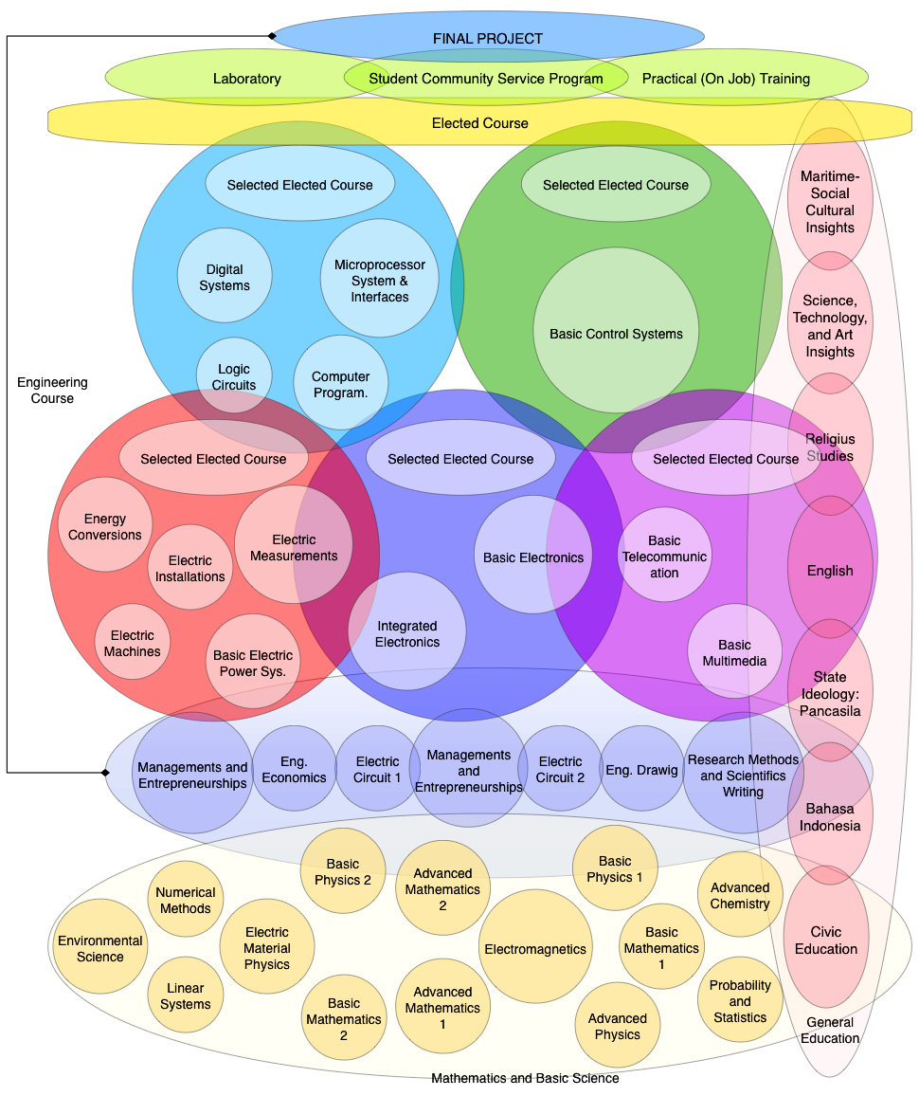

Figure 5-2 Flowchart or worksheet that illustrates the prerequisite structure of the program.

B. Course Syllabi

The Course Syllabi can be found in Appendix A of this Readiness Review Report.

Table 5-1 Curriculum  
Electrical Engineering Study Program

| **Course  Electrical Engineering** | **Required, Elective, or a Selected Elective** | ***Subject Area (Credit Hours)*** | | | | **Last Two Terms the Course was Offered: Year and Semester or Quarter** | **Maximum Section Enrollment for The Last Two Terms the Course was Offered** |
| --- | --- | --- | --- | --- | --- | --- | --- |
| **Math & Basic Sciences** | **Engineering Topics Check If Contains Significant Design ()** | **General Education** | **Other** |
| **Lecture Courses** | | | | | | | |
| *011U0032 Civic Education* | R |  |  | 2 |  | I; 1 | 84 |
| *009U0032 Bahasa Indonesia* | R |  |  | 2 |  | I; 1 | 84 |
| *016U0033 Calculus 1* | R | 3 |  |  |  | I; 1 | 100 |
| *020U0033 Physics 1* | R | 3 |  |  |  | I; 1 | 100 |
| *101D4113 Electrical Circuits 1* | R |  | 3 |  |  | I; 1 | 100 |
| *102D4112 Logic Circuits* | R |  | 2 |  |  | I; 1 | 100 |
| *103D4112 Engineering Drawing* | R |  | 2 |  |  | I; 1 | 100 |
| *104D4112 Advanced Chemistry* | R | 2 |  |  |  | I; 1 | 100 |
| *001U0032 Religious Studies (Islam, Catholic, etc)* | R |  |  | 2 |  | I; 2 | 84 |
| *012U0032 State Ideology: Pancasila* | R |  |  | 2 |  | I; 2 | 84 |
| *010U0032 English* | R |  |  | 2 |  | I; 2 | 84 |
| *017U0033 Calculus 2* | R | 3 |  |  |  | I; 2 | 100 |
| *022U0033 Physics 2* | R | 3 |  |  |  | I; 2 | 90 |
| *105D4123 Electric Circuits 2* | R |  | 3 |  |  | I; 2 | 90 |
| *106D4122 Digital Systems* | R |  | 2 |  |  | I; 2 | 100 |
| *107D4122 Computer Programming* | R |  | 2 |  |  | I; 2 | 95 |
| *108D4121 Electric Circuits Laboratory* | R |  | 1 |  |  | I; 2 | 100 |
| *109D4121 Digital Systems Laboratory* | R |  | 1 |  |  | I; 2 | 95 |
| *008U0032 Principle of Science, Technology, and Art* | R |  |  | 2 |  | II;3 | 70 |
| *201D4113 Advanced Mathematics 1* | R | 3 |  |  |  | II;3 | 85 |
| *202D4112 Basic Electric Power (Systems)* | R |  | 2 |  |  | II;3 | 70 |
| *203D4112 Basic Telecommunication (Systems)* | R |  | 2 |  |  | II;3 | 85 |
| *204D4112 Basic Electronics* | R |  | 2 |  |  | II;3 | 85 |
| *205D4112 Electric Material Physics* | R | 2 |  |  |  | II;3 | 70 |
| *206D4112 Advanced Physics* | R | 2 |  |  |  | II;3 | 85 |
| *207D4111 Basic Electric Power laboratory* | R |  | 1 |  |  | II;3 | 85 |
| *208D4111 Basic Telecommunication Laboratory* | R |  | 1 |  |  | II;3 | 85 |
| *209D4111 Basic Electronics Laboratory* | R |  | 1 |  |  | II;3 | 85 |
| *007U0032 Principle of Maritime Science* | R |  |  | 2 |  | II;4 | 70 |
| *210D4123 Advanced Mathematics 2* | R | 3 |  |  |  | II;4 | 85 |
| *211D4122 Linear Systems* | R | 2 |  |  |  | II;4 | 85 |
| *212D4122 Electric Machines* | R |  | 2 |  |  | II;4 | 70 |
| *213D4122 Basic Multimedia* | R |  | 2 |  |  | II;4 | 70 |
| *214D4122 Integrated Electronics* | R |  | 2 |  |  | II;4 | 85 |
| *215D4122 Microprocessor Systems and Interfaces* | R |  | 2 |  |  | II;4 | 85 |
| *216D4122 Basic Control Systems* | R |  | 2 |  |  | II;4 | 70 |
| *217D4122 Electric Installation and Laboratory* | R |  | 2 |  |  | II;4 | 85 |
| *218D4121 Integrated Electronics Laboratory* | R |  | 1 |  |  | II;4 | 85 |
| *219D4121 Microprocessor Systems and Interfaces Laboratory* | R |  | 1 |  |  | II;4 | 85 |
| *301D4112 Engineering Economics* | R |  | 2 |  |  | III;5 |  |
| *302D4112 Probability and Statistics* | R | 2 |  |  |  | III;5 |  |
| *303D4112 Electric Measurement* | R |  | 2 |  |  | III;5 |  |
| *304D4112 Electromagnetics* | R | 2 |  |  |  | III;5 |  |
| *Selected Elective Course (1 Package)\** | SE |  | 9 |  |  | III;5 |  |
| *342D4122 Numerical Methods* | R | 2 |  |  |  | III;6 |  |
| *343D4122 Energy Conversion* | R |  | 2 |  |  | III;6 |  |
| *344D4122 Environmental Science* | R | 2 |  |  |  | III;6 |  |
| *345D4122 Management and Entrepreneurship* | R |  | 2 |  |  | III;6 |  |
| *Selected Elective Course (1 Package)\** | SE |  | 9 |  |  | III;6 |  |
| *402D4112 Research Methods and Scientific Writing* | R |  | 2 |  |  | IV;7 |  |
| *Elective Course\*\** | E |  | 2 |  |  | IV;7 |  |
| ***Total Required Minimum Lecture Courses*** | | 34 | 69 | 14 | 0 |  |  |
| *Total-ABET Basic Level Requirements* | |  |  |
| *Total Credit Hours for Lecture Courses* | 117 |  |  |  |  |  |  |
| *Percent of Total* | | 29,1% | 59,0% | 12,0% | 0,0% |  |  |
| *Total Must Satisfy Either Credit Hours of Percentage* | Minimum Semester Credit Hours | 32 Hours | 48 Hours |  |  |  |  |
| Minimum Percentage | 25,0% | 37,5% |  |  |  |  |
| **Non-Lecture Courses** | | | | | | | |
| *401D4112 Practical (On Job) Training* | R |  | 2 |  |  | IV;7 |  |
| *403D4112 Final Project Proposal* | R |  | 2 |  |  | IV;7 |  |
| *Laboratory 1* | R |  | 8 |  |  | IV;7 |  |
| *491D4124 Student Community Service Programs* | R |  | 4 |  |  | IV;8 |  |
| *492D4122 Final Project Results* | R |  | 2 |  |  | IV;8 |  |
| *Laboratory 2* | R |  | 8 |  |  | IV;8 |  |
| *493D4122 Final Project Report* | R |  | 2 |  |  | IV;8 |  |
| ***Total Credit Hours for Non-Lecture Courses*** | 28 |  |  |  |  |  |  |
| ***Overall Minimum Total Credit Hours For Completion of The Program*** | 145 |  |  |  |  |  |  |

Notes:

|  |  |  |
| --- | --- | --- |
| **Percentages of** | **Lecturer Course Only (117 credits)** | **Total Courses (145 credits)** |
| Math & Basic Science | 34 (29%) | 34 (23.4%) |
| Engineering Topics | 69 (59%) | 93 (64.2%) |
| General Education | 14 (12%) | 18 (12.4%) |

The proportion of Mathematics and Basic Sciences is only 23.4% of the total 145 credit hours minimum requirement for graduation. However, 28 credit hours out of those 145 credit hours are non-lecturer courses, such as Final Undergraduate Projects (Final Project, Seminars, and Laboratories) and Student Community Services, which may have Mathematics and Basic Sciences contents and are not comparable (“apple to apple”) to the regular lecture courses. Based on argument above, the non- lecture courses may be excluded so that the proportion of Mathematics and Basic Science is now 29.0% of the total of 117 credit hours of regular lecturer courses.

The following information provides the components of the EESP curriculum.

**General Education**

The general education consists of 7 courses (total 14 credit hours). The general educations are listed in Table 5.2 General Education Component below. These fourteen credit hours satisfy all the requirements of the Hasanuddin University general education curriculum, which is design to accomplish the goals of Hasanuddin University as defined by its mission statements.

Table 5-2 General Education Component

|  |  |  |  |  |  |
| --- | --- | --- | --- | --- | --- |
| **Code** | **General Education** | **Credit** | **Course (%)** | **Lab (%)** | **Other (%)** |
| 011U0032 | Citizenship Education | 2 | 100 |  |  |
| 009U0032 | Indonesian Language | 2 | 100 |  |  |
| 001U0032 | Religion | 2 | 100 |  |  |
| 012U0032 | State Ideology: Pancasila | 2 | 100 |  |  |
| 010U0032 | English | 2 | 100 |  |  |
| 008U0032 | Concept of Science and Technology | 2 | 100 |  |  |
| 007U0032 | Social Science of Maritime Culture | 2 | 100 |  |  |

**Mathematics and Basic Science**

The mathematics and basic science consist of 34 (thirty-four) credit hours. It divides to 18 (eighteen) credit hours of mathematics as shown in the Table 5.3 and 16 (sixteen) credit hours of basic science as shown in The Table 5-4.

Table 5-3 Mathematics Component

|  |  |  |  |  |  |
| --- | --- | --- | --- | --- | --- |
| **Code** | **General Education** | **Credit** | **Course (%)** | **Lab (%)** | **Other (%)** |
| 016U0033 | Basic Mathematics 1 | 3 | 100 |  |  |
| 017U0033 | Basic Mathematics 2 | 3 | 100 |  |  |
| 201D4113 | Advanced Mathematics 1 | 3 | 100 |  |  |
| 210D4123 | Advanced Mathematics 1 | 3 | 100 |  |  |
| 211D4122 | Linear Systems | 2 | 100 |  |  |
| 302D4112 | Probability and Statistics | 2 | 100 |  |  |
| 342D4122 | Numerical Methods | 2 | 100 |  |  |

Table 5-4 Basic Science Component

|  |  |  |  |  |  |
| --- | --- | --- | --- | --- | --- |
| **Code** | **General Education** | **Credit** | **Course (%)** | **Lab (%)** | **Other (%)** |
| 020U0033 | Basic Physics 1 | 3 | 75 | 25 |  |
| 022U0033 | Basic Physics 2 | 3 | 75 | 25 |  |
| 206D4112 | Advanced Physics | 2 | 100 |  |  |
| 104D4112 | Advanced Chemistry | 2 | 100 |  |  |
| 205D4112 | Electric Material Physics | 2 | 100 |  |  |
| 304D4112 | Electromagnetics | 2 | 100 |  |  |
| 344D4122 | Environmental Science | 2 | 100 |  |  |

**Engineering Topics**

The engineering topics component divides to 69 (minimum) credit hours of lecture course as shown in the Table 5-5 and 28 credit hours of no lecture course as shown in the Table 5-6.

Table 5-5 Lecture Courses

|  |  |  |  |  |  |
| --- | --- | --- | --- | --- | --- |
| **Code** | **General Education** | **Credit** | **Course (%)** | **Lab (%)** | **Other (%)** |
| 101D4113 | Electric Circuits 1 | 3 | 100 |  |  |
| 102D4112 | Logic Circuits | 2 | 100 |  |  |
| 103D4112 | Engineering Drawing | 2 | 100 |  |  |
| 105D4123 | Electric Circuits 2 | 3 | 100 |  |  |
| 106D4122 | Digital Systems | 2 | 100 |  |  |
| 107D4122 | Computer Programming | 2 | 50 | 50 |  |
| 108D4121 | Electric Circuits Laboratory | 1 |  | 100 |  |
| 109D4121 | Digital Systems Laboratory | 1 |  | 100 |  |
| 202D4112 | Basic Electric Power (Systems)2 | 2 | 100 |  |  |
| 203D4112 | Basic Telecommunication (Systems) | 2 | 100 |  |  |
| 204D4112 | Basic Electronics | 2 | 100 |  |  |
| 207D4111 | Basic Electric Power Laboratory | 1 |  | 100 |  |
| 208D4111 | Basic Telecommunication Laboratory | 1 |  | 100 |  |
| 209D4111 | Basic Electronics Laboratory | 1 |  | 100 |  |
| 212D4122 | Electric Machines | 2 | 100 |  |  |
| 213D4122 | Basic Multimedia | 2 | 100 |  |  |
| 214D4122 | Integrated Electronics | 2 | 100 |  |  |
| 215D4122 | Microprocessor Systems and Interfaces | 2 | 100 |  |  |
| 214D4122 | Basic Control Systems | 2 | 100 |  |  |
| 217D4122 | Electric Installation and Laboratory | 2 | 75 | 25 |  |
| 218D4121 | Integrated Electronics Laboratory | 1 |  | 100 |  |
| 219D4121 | Microprocessor Systems and Interfaces Lab | 1 |  | 100 |  |
| 301D4112 | Engineering Economics | 2 | 100 |  |  |
| 303D4112 | Electric Measurements | 2 | 100 |  |  |
| 343D4122 | Energy Conversions | 2 | 100 |  |  |
| 345D4122 | Management and Entrepreneurships | 2 | 100 |  |  |
| 402D4112 | Research Methods and Scientific Writing | 2 | 100 |  |  |
|  | Selected Elective Course (2 package) | 18 |  |  |  |

Table 5-6 Non-Lecture Courses

|  |  |  |  |  |  |
| --- | --- | --- | --- | --- | --- |
| **Code** | **General Education** | **Credit** | **Course (%)** | **Lab (%)** | **Other (%)** |
| 401D4112 | Practical (On Job) Training | 2 |  |  | 100 |
| 491D4124 | Student Community Service Programs | 4 |  |  | 100 |
|  | Laboratory 1 | 8 | 100 |  | 100 |
|  | Laboratory 2 | 8 | 100 |  | 100 |
| 403D4112 | Final Project Proposal | 2 |  |  | 100 |
| 492D4122 | Final Project Results | 2 |  |  | 100 |
| 493D4124 | Final project Report | 4 |  |  | 100 |