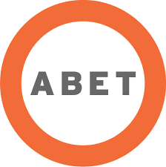

**ABET**

**Self-Study Report**

for the

**Electrical Engineering Study Program**

at

**Universitas Hasanuddin**

**Makassar, Indonesia**

**July 2019**

**CONFIDENTIAL**

The information supplied in this Self-Study Report is for the confidential use of ABET and its authorized agents, and will not be disclosed without authorization of the institution concerned, except for summary data not identifiable to a specific institution.