Competency Based Curriculum, the Complete and the Practical Implementation

Ihan Martoyo
Universitas Pelita Harapan
Karawaci, Tangerang, Indonesia

Abstract: The competency based curriculum (KBK / Kurikulum Berbasis Kompetensi) presents a shift in the learning paradigm. It concentrates on the competencies of students rather than the delivery of course contents. However, the full implementation of KBK requires a difficult change in the university policies and management. It also implies a complete overhaul of the existing curriculum. This represents a rather high cost of implementation. This paper proposes a practical version of KBK, which focuses on the micro-educational aspects of KBK and leaving out the difficult macro-educational changes. This version of KBK offers the benefits of KBK without the high cost of implementation. It can also serve as a transition approach towards a complete implementation of KBK.

Introduction

The competency based curriculum (KBK / Kurikulum Berbasis Kompetensi) is the new curriculum development scheme encouraged by the Indonesian Directorate General of Higher Education (Dikti). The term KBK is sometimes hard to be described precisely. Thus a lot of things are often claimed to be KBK.

However, there are several distinct ideas, which make up the concept of KBK. One of the main characteristics of KBK is the extra focus on soft skills which are to be developed in every lecture. It is based on the paradigm of constructivism and student centered learning, so that the learning process is to be achieved through various activities besides conventional lectures. The KBK also promotes the parallel presentation of academic subjects.

The complete implementation of KBK requires changes in the university management and policies, as well as a new teaching paradigm from lecturers. Both are very difficult to be achieved perfectly in a short time. The author is convinced that a more practical version of KBK is available, which promotes the benefits of KBK, but is still feasible in today’s university situation.

The next section elaborates the complete KBK concept proposed by Dikti. In Section 3 a more practical version of KBK will be presented, followed by several conclusions in Section 4.

The Complete KBK

At the micro-educational level, the KBK concentrates on the achievement of competencies rather than the delivery of subject contents. Competencies can not be imparted through mere lecturing, e.g., the problem solving skill can not be developed through lecturing only. Therefore the KBK rightly embraces the constructivist education view. In this view, the learning process is student centered and is performed through various activities such as: group discussions, role-play & simulations, collaborative learning, case studies and problem based learning (Dikti, “Model-model Pembelajaran SCL).

The change of learning paradigm in KBK also necessitates changes in the assessment of students’ performance. The traditional exams (UTS & UAS) can only capture a limited spectrum of competencies. Therefore, one of the hallmarks of KBK practice is a low grading proportion of UTS and UAS. The grading through the various learning activities will be more dominant in the KBK, so that soft skills can be adequately developed & assessed.

Besides the micro-educational transformation, the complete KBK implementation also demands macro-educational changes. This includes the curriculum development & the university policies. In the traditional curriculum, the delivery of study programs is done serially (see Figure 1). For example, for an engineering department, the mathematics and basic sciences fill up the first semesters of the students’ life, followed by more engineering contents at later semesters. The KBK proposes the parallel delivery of study programs as opposed to the traditional serial approach. This way, the mathematics and basic sciences can be delivered “just in time” together with the context of the relevant engineering disciplines (Jones, 2000).

In the parallel approach, one course can be a combination of several study materials (bahan kajian). One course can contain ethics and engineering materials, or management and engineering (Dikti, “Menuju Perguruan Tinggi yang Berkualitas”). Therefore, the learning process will need a team teaching effort. The team tackles the multifaceted aspects of the course together (team teaching is not the same as taking turns in teaching).

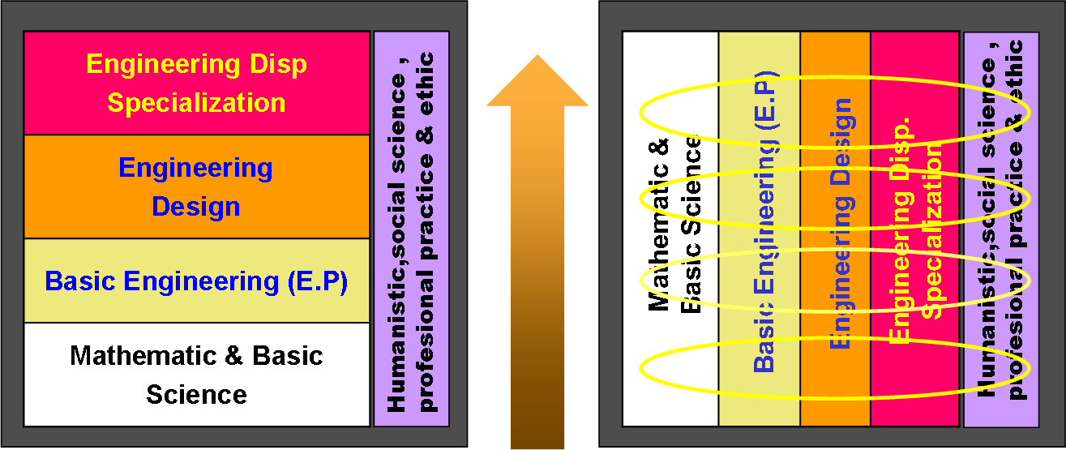

Figure 1 Serial (left) versus parallel (right) study programs (Dikti, “Menuju Perguruan Tinggi yang Berkualitas”)

The development of KBK starts with the identification of the expected alumni profiles. These alumni profiles are shaped by the university values (e.g., integrity & spirituality), scientific vision (e.g., lively scientific innovation & research), and market signal (e.g., team work & communication skills). Thus these alumni profiles point directly to the competencies that should be developed through the curriculum. Table 1 lists an example of competencies for electrical engineering programs.

Alumni Profiles | Characteristic of Program | Characteristic of Institution
Alumni Profiles | Main Competencies | Supporting Competencies | Other Competencies
Engineer & Consultant | EE/Maths knowledge & skills | Integrity/Spirituality | Languages
 | Analysis & critical thinking | Leadership/team work | Law
 | Problem solving |  | Economics
 | Design skill
 | Management & strategical thinking
 | Reading/writing
 | Communication / presentation
Researcher & Educator | EE/Maths knowledge & skills | Integrity/Spirituality | Languages
 | Analysis & critical thinking | Leadership/team work | Law
 | Reading/writing |  | Economics
 | Communication / presentation
 | Problem formulation/Identification
 | Problem Solving
 | Creativity
Manager, Entrepreneur | EE/Maths knowledge & skills | Integrity/Spirituality | Languages
& Marketing | Management & strategical thinking | Leadership/team work | Law
 | Communication / presentation |  | Economics
 | Reading/writing
 | Creativity

Table 1 The expected alumni profiles and their competencies of the electrical engineering program

After listing the alumni profiles & competencies, the list of the competencies will then be put into a matrix together with the study materials (bahan kajian). An example for the nursing education is shown in Table 2. The intersection and combination of competencies and study materials (groups of rows and columns in the matrix) will form the courses in the curriculum.

Table 2 The KBK matrix for nursing education. (Dikti, “Menuju Perguruan Tinggi yang Berkualitas”)

The Practical KBK

From the previous section, it is clear that to implement KBK completely may require a huge effort. Lecturers must transform their teaching according to the constructivist & student centered learning paradigm. This alone, is already hard to achieve. Furthermore, it is even harder to change the university policies to accommodate the team teaching practice required in the parallel program delivery. This involves changing the business processes of the university which might be difficult.

Due to these difficulties a more practical version of KBK is required. The author proposes a reduced version of KBK implementation, which leaves out the parallel program delivery. This way, the courses in the existing curriculum can be retained in their current format, while the soft skills (competencies) can/should be inserted in every course.

This practical version of the KBK does not require a change of the university policies concerning team teaching practice. It also avoids the high cost of overhauling the existing curriculum. While retaining the benefits of KBK (soft skills get a proper attention in each course), this approach may be flexibly executed according to the readiness of the lecturers which play a crucial role in the success of KBK. This practical version of KBK provides an alternative for a graceful transition from the traditional curriculum to the complete KBK approach.

Conclusions

Despite its benefits, the complete implementation of KBK tends to imply a high cost and a huge effort for the university. A practical version of KBK which concentrates on the micro-educational level transformation and leaves out the parallel program delivery is proposed. This practical KBK approach can introduce the benefits of KBK while avoiding the high cost of implementing the complete KBK.

Referensi

Dikti, “Model-Model Pembelajaran SCL”, Presentation at UPH, June 2008.

Dikti, “Menuju Perguruan Tinggi yang Berkualitas”, Presentation at UPH, June 2008.

Malcolm Jones, Curriculum Development, S1 Engineering Programs in Indonesia, Engineering Education Development Project, Dikti, June 2000.

