A Root-Mean-Square-based Measurement Method to Optimize a Parameter in the Control Systems Design
Rhiza S. Sadjad
Department of Electrical Engineering
Faculty of Engineering, Hasanuddin University
Makassar, South Sulawesi 90245 INDONESIA
e-mail: rhiza@unhas.ac.id URL: http://www.unhas.ac.id/rhiza/

Abstract—In the classical control systems design, a parameter is typically determined by the system's time response or frequency response. A standard unstable double-integrator plant with a spring constant K and a mass M is a perfect illustrative example. A stabilizing damper B is determined by setting the time-response to be qualitatively fast and non-oscillatory, which is basically setting the damping-ratio of the second order system equal to 1. The time-response is the system's response to a certain input, such as an impulse-function, a step-function, etc., not its response to an arbitrary disturbance, which is more likely to occur in the field The root-mean-square-(rms)-based approach introduced here allows a designer to estimate a better parameter to minimize an objective function. The objective function is a combined quadratic function of the "error" and the "effort" rms values, both to be minimized by selecting the damper B accurately for each of the 3 (three) different schemes of disturbances. After successfully applied to the standard double-integrator plant given as an illustrative example, the similar approach is implemented for an armature-controlled dc motor speed-control design.
Keywords—root mean square; rms; objective function; double-integrator, disturbance, dc motor

Introduction
Classical methods to determine a parameter in the control systems design have been developed for almost a hundred years [1] since the steam engine's governor was invented. The most common methods are derived analytically from the system's responses to a certain input. The time response of a system to a step-input is one of the most common ways to characterize the performance of a control system [2]. The frequency response is also commonly used such as in methods based on the Nyquist criteria [3], or other methods.
Those methods based on the time response or the frequency response or both are usually valid and analytically verified, but in the field they - at least most of them - are not easily implemented due to a couple of reasons, among others for instance: (1) the methods require the use of sophisticated equipment such as an oscilloscope with the capability of displaying one-shot signals or a spectrum-analyzer for the frequency response, (2) the inputs should be a certain kind that is not easy to generate (an “ideal” step-function or an impulse-function d(t) never actually exists), (3) even if the specific inputs may be approximated for some cases, they are not always applicable, for example: a step input of armature voltage cannot be actually applied to a large DC motor.
Measuring equipments - particularly used in electrical engineering - mostly display the measurement results in rms values - also called “effective” values - especially when the signal being measured varies with time considerably [4]. Other physical units are typically converted into electrical quantities using sensors, and then their rms values are measured.

The Basic Concept

This method is proposed to be applied in a practical situation in the field, so that all quantities are supposed to be physically - or to be more specific: electrically - measureable. All calculations involving the measured quantities should be made available either in analog or digital forms, or both, at the real time during the system operation. The following defined variables are in scalar form for single-input single-output systems, however, they can be generalized into vector and matrix forms for multi-input multi-output systems or systems with multi-variables.

Firstly, we define the error e(t) as the deviation of the actual output y(t) as compared to the desired output y'(t):

(1)

This error is caused by an arbitrary disturbance, which is supposed to be repeatable, most preferably periodic, so that we can measure the rms value of e(t), E, as follows [5]:

(2)

where T is the time period of the disturbance if it is periodic. If the disturbance is not periodic, then we determine T as a finite period of time when the disturbance still considerably affecting the output.

Secondly, we define the control effort u(t) as a designed variable to reduce the rms error E:

(3)

where C ={c1, c2, c3, ......, cn} is a set of control parameters to optimize the system and f(*) is the control algorithm.

The rms value control effort u(t), U, is measured as follows:

(4)

A control system is said to be “correctly designed” if increasing the effort is effectively decreasing the error, and vice versa. This characteristic is very important to guarantee the existence of optimum design obtained by minimizing an objective function J, subject to the variations of control parameters C ={c1, c2, c3, ......, cn} formulated as the following standard unconstrained optimization problem [6]:

minimize: (5)

subject to the variations of C ={c1, c2, c3, ......, cn}

where p and q are coeficients to give a freedom to the designer to emphasize the weight of either the error or the effort, or both, of their contributions to the objective function J. Those coeficients are also useful to equalize the physical units of E and U if they are obtained from different measurement systems. The square-root is optional, just in case the numerical results of squaring the quantities are either too large or too small.

A well established case of control design in the classical control theory is the unstable double-integrator plant model of a spring-mass-damper system with a mass M connected to a reference wall by a spring with the constant K stabilized by a damper with the constant B as represented by the block-diagram shown in Fig. 1. We use this case as an illustrative example of the basic concept described previously.
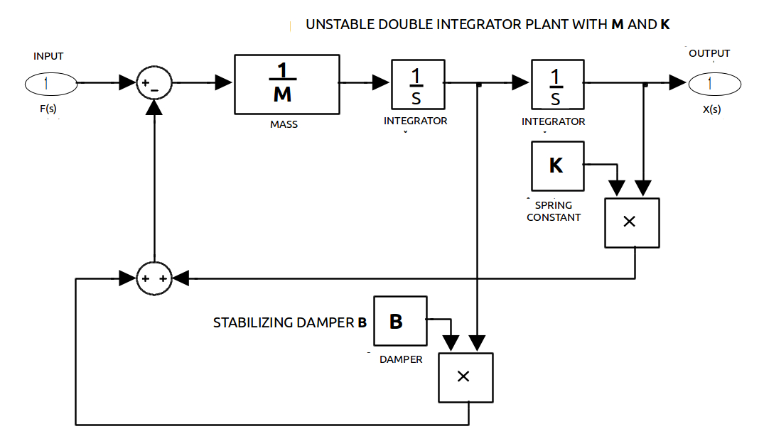
Fig. 1 An unstable double-integrator plant with a mass M and a spring constant K, stabilized by a damper B

The most common time-response is characterized by a step input. For a large B, the response is over-damped, which is characterized as too slow, while for a small B, the response is under-damped, characterized as too oscillatory. The “best” (both fast and non-oscillatory) performance is believed to be attained by setting the damping ratio ξ = 1, or:

6

The response for ξ = 1 is also characterized as critically damped response. A “normalized” plant with M = 1 unit mass and K = 1 unit spring constant requires B = 2 units of damping constant to exhibit a critically damped response to a step input, as shown Fig. 2.
Fig. 2 The step-responses for B = 2 (critically damped), for B = 5 (over-damped) and for B = 0.2 (under-damped)
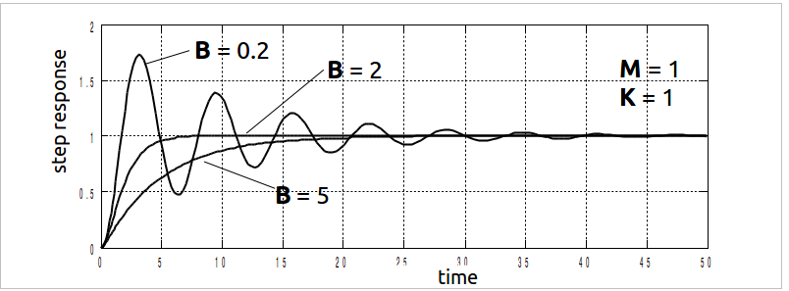

The desired output y'(t) of this system is 0, so by using (1) we define the error e(t) as the actual output y(t), and the rms value of the error e(t) is also the rms value of the actual output y(t) measured using (2):

(7)

The control effort is defined as the force caused by the damper, then by using (3), the control algorithm can be derived as:

(8)

and using (4), the rms value of the control effort is determined as:

(9)

Finally, by setting up the coefficients p = q = 1, the objective function J is derived using (5) as follows:

(10)

J is to be minimized subject to the variation of B.
Control Effort
Force
Disturbance
Velocity
Disturbance
Position
Disturbance
Error
Fig. 3 Force, Velocity and Position Disturbances, Error and Control Effort

An arbitrary disturbance x(t) can be applied as one of three types:

(1) Force Disturbance, where the actual output y(t) is the solution of a differential equation:

(11)

(2) Velocity Disturbance, where the actual output y(t) is the solution of a differential equation:

(12)

(3) Position Disturbance, where the actual output y(t) is the solution of a differential equation:

(13)

Without control effort u(t) or B = 0, and after a time period of T when the disturbunce x(t) is not considerably affecting the actual output y(t), the actual output y(t) approximates the solution of the differential equation:

(14)

which is a sustained oscillation:

(15)

For a “normalized” plant with M = 1 unit mass and K = 1 unit spring constant, the actual output y(t) is a sinusoidal signal with the angular frequency w = 1 rad/sec and with the amplitude A depending upon the magnitude and the duration of the disturbances:

(16)

whose rms value is known asor 0.7071068A. Thus, for B=0, the rms value of the actual output y(t), the rms value of error e(t) and the objective function J is approaching 0.7071068A for all three types of disturbance. Fig. 4 shows all actual outputs of the three types of disturbance and the measurement of their rms values.
Fig. 4 The actual output y(t) of 3 types of disturbances: (1) Force Disturbance, (2) Velocity Disturbance and (3) Position Disturbance, all for no control effort or B = 0.

The application of B > 0 for all three types of disturbances indicates that this control system is “correctly designed” because increasing the control effort is effectively decreasing the error as clearly shown in Fig. 5, Fig. 6 and Fig. 7. This guarantees the existence of optimum B for each case, as described in Table 1 for an objective function J with coefficients p = q = 1. Fig. 8 shows the actual output of each type of disturbance when an optimum B for the objective function J with p = q = 1 is applied.
Fig. 5 The Error, Control Effort and the Objective Function (with coefficients p = q = 1) of the Force Disturbance for Various Constant Spring B
RMS Error
RMS Effort
Objective Function J
Force Disturbance

Fig. 6 The Error, Control Effort and the Objective Function (with coefficients p = q = 1) of the Ve;ocity Disturbance for Various Constant Spring B
Velocity Disturbance
Objective Function J
RMS Error
RMS Effort

Fig. 7 The Error, Control Effort and the Objective Function (with coefficients p = q = 1) of the Position Disturbance for Various Constant Spring B
RMS Effort
Objective Function J
RMS Error
Position Disturbance

Table 1 The Range of Minimizing B and the Damping Ratio x for each Type of Disturbance

The actual output for optimum B, with coefficients of the objective function J equally emphasizing the error dan the control effort (p = q = 1), as shown in Fig. 8, looks too oscillatory, because the damping ratio x of these configurations are all less than 1 (underdamped).
Fig. 8 The actual output y(t) of 3 types of disturbances: (1) Force Disturbance with B=0.7478, (2) Velocity Disturbance with B=0.3594 and (3) Position Disturbance with B=1.0368

Fig. 9 The Error, Control Effort and the Objective Function (with coefficients p = 2.6 and q = 1) of the Force Disturbance for Various Constant Spring B
RMS Error
RMS Effort
Objective Function J
Force Disturbance

The oscillatory behavior of the actual output can be reduced by increasing the system's damping ratio x, or - in this case - the damper constant B. Greater B optimum can be obtained by putting more emphasize on the rms value of the error E in the objective function J, or setting up p > q. For example, the curves of J, E and U looks like the graph shown in Fig. 9 for p = 2.6 and q = 1. The optimum point is reached for B =2, the same as suggested by the classical control analysis (see Eq. (6) previously described), and the actual output is shown in Fig. 10, which is much less oscillatory than before. Thus, this method gives more quantitative and solid basis to the reasoning on the selection of critically damped response for determination of the damper constant B.
Fig. 10 The actual output y(t) of 3 types of disturbances: (1) Force Disturbance, (2) Velocity Disturbance and (3) Position Disturbance all with B=2

The Practical Application
The idea of developing this measurement method came up for the first time when an armature-controlled dc motor required a PID controller to maintain its constant speed during its operation in a changing load condition [7]. The problem of selecting the “best” controller is practically solved by applying this method.

Fig. 11 An experimental scheme to apply the mthod to the dc motor PID speed controller design.

Before you begin to format your paper, first write and save the content as a separate text file. Keep your text and graphic files separate until after the text has been formatted and styled. Do not use hard tabs, and limit use of hard returns to only one return at the end of a paragraph. Do not add any kind of pagination anywhere in the paper. Do not number text heads-the template will do that for you.
Finally, complete content and organizational editing before formatting. Please take note of the following items when proofreading spelling and grammar:

Abbreviations and Acronyms
Define abbreviations and acronyms the first time they are used in the text, even after they have been defined in the abstract. Abbreviations such as IEEE, SI, MKS, CGS, sc, dc, and rms do not have to be defined. Do not use abbreviations in the title or heads unless they are unavoidable.

Units
- Use either SI (MKS) or CGS as primary units. (SI units are encouraged.) English units may be used as secondary units (in parentheses). An exception would be the use of English units as identifiers in trade, such as “3.5-inch disk drive.”
- Avoid combining SI and CGS units, such as current in amperes and magnetic field in oersteds. This often leads to confusion because equations do not balance dimensionally. If you must use mixed units, clearly state the units for each quantity that you use in an equation.
- Do not mix complete spellings and abbreviations of units: “Wb/m2” or “webers per square meter,” not “webers/m2.” Spell units when they appear in text: “...a few henries,” not “...a few H.”
- Use a zero before decimal points: “0.25,” not “.25.” Use “cm3,” not “cc.” (bullet list)
Identify applicable sponsor/s here. If no sponsors, delete this text box (sponsors).

Equations
The equations are an exception to the prescribed specifications of this template. You will need to determine whether or not your equation should be typed using either the Times New Roman or the Symbol font (please no other font). To create multileveled equations, it may be necessary to treat the equation as a graphic and insert it into the text after your paper is styled.
Number equations consecutively. Equation numbers, within parentheses, are to position flush right, as in (1), using a right tab stop. To make your equations more compact, you may use the solidus ( / ), the exp function, or appropriate exponents. Italicize Roman symbols for quantities and variables, but not Greek symbols. Use a long dash rather than a hyphen for a minus sign. Punctuate equations with commas or periods when they are part of a sentence, as in
a  b             
Note that the equation is centered using a center tab stop. Be sure that the symbols in your equation have been defined before or immediately following the equation. Use “(1),” not “Eq. (1)” or “equation (1),” except at the beginning of a sentence: “Equation (1) is ...”

Some Common Mistakes
- The word “data” is plural, not singular.
- The subscript for the permeability of vacuum μ₀, and other common scientific constants, is zero with subscript formatting, not a lowercase letter “o.”
- In American English, commas, semi-/colons, periods, question and exclamation marks are located within quotation marks only when a complete thought or name is cited, such as a title or full quotation. When quotation marks are used, instead of a bold or italic typeface, to highlight a word or phrase, punctuation should appear outside of the quotation marks. A parenthetical phrase or statement at the end of a sentence is punctuated outside of the closing parenthesis (like this). (A parenthetical sentence is punctuated within the parentheses.)
- A graph within a graph is an “inset,” not an “insert.” The word alternatively is preferred to the word “alternately” (unless you really mean something that alternates).
- Do not use the word “essentially” to mean “approximately” or “effectively.”
- In your paper title, if the words “that uses” can accurately replace the word using, capitalize the “u”; if not, keep using lower-cased.
- Be aware of the different meanings of the homophones “affect” and “effect,” “complement” and “compliment,” “discreet” and “discrete,” “principal” and “principle.”
- Do not confuse “imply” and “infer.”
- The prefix “non” is not a word; it should be joined to the word it modifies, usually without a hyphen.
- There is no period after the “et” in the Latin abbreviation “et al.”
- The abbreviation “i.e.” means “that is,” and the abbreviation “e.g.” means “for example.”
An excellent style manual for science writers is [7].

Current and Future Works
After the text edit has been completed, the paper is ready for the template. Duplicate the template file by using the Save As command, and use the naming convention prescribed by your conference for the name of your paper. In this newly created file, highlight all of the contents and import your prepared text file. You are now ready to style your paper; use the scroll down window on the left of the MS Word Formatting toolbar.

Conclusion

Authors and Affiliations
The template is designed so that author affiliations are not repeated each time for multiple authors of the same affiliation. Please keep your affiliations as succinct as possible (for example, do not differentiate among departments of the same organization). This template was designed for two affiliations.

For author/s of only one affiliation (Heading 3): To change the default, adjust the template as follows.

Selection (Heading 4): Highlight all author and affiliation lines.

Change number of columns: Select the Columns icon from the MS Word Standard toolbar and then select “1 Column” from the selection palette.

Deletion: Delete the author and affiliation lines for the second affiliation.

For author/s of more than two affiliations: To change the default, adjust the template as follows.

Selection: Highlight all author and affiliation lines.

Change number of columns: Select the “Columns” icon from the MS Word Standard toolbar and then select “1 Column” from the selection palette.

Highlight author and affiliation lines of affiliation 1 and copy this selection.

Formatting: Insert one hard return immediately after the last character of the last affiliation line. Then paste down the copy of affiliation 1. Repeat as necessary for each additional affiliation.

Reassign number of columns: Place your cursor to the right of the last character of the last affiliation line of an even numbered affiliation (e.g., if there are five affiliations, place your cursor at end of fourth affiliation). Drag the cursor up to highlight all of the above author and affiliation lines. Go to Column icon and select “2 Columns”. If you have an odd number of affiliations, the final affiliation will be centered on the page; all previous will be in two columns.

Identify the Headings
Headings, or heads, are organizational devices that guide the reader through your paper. There are two types: component heads and text heads.
Component heads identify the different components of your paper and are not topically subordinate to each other. Examples include ACKNOWLEDGMENTS and REFERENCES, and for these, the correct style to use is “Heading 5.” Use “figure caption” for your Figure captions, and “table head” for your table title. Run-in heads, such as “Abstract,” will require you to apply a style (in this case, italic) in addition to the style provided by the drop down menu to differentiate the head from the text.
Text heads organize the topics on a relational, hierarchical basis. For example, the paper title is the primary text head because all subsequent material relates and elaborates on this one topic. If there are two or more sub-topics, the next level head (uppercase Roman numerals) should be used and, conversely, if there are not at least two sub-topics, then no subheads should be introduced. Styles named “Heading 1,” “Heading 2,” “Heading 3,” and “Heading 4” are prescribed.

Figures and Tables

Positioning Figures and Tables: Place figures and tables at the top and bottom of columns. Avoid placing them in the middle of columns. Large figures and tables may span across both columns. Figure captions should be below the figures; table heads should appear above the tables. Insert figures and tables after they are cited in the text. Use the abbreviation “Fig. 1,” even at the beginning of a sentence.
- Table Styles
Table Head | Table Column Head
Table Head | Table column subhead | Subhead | Subhead
copy | More table copyª
- Sample of a Table footnote. (Table footnote)

- Example of a figure caption. (figure caption)
Figure Labels: Use 8 point Times New Roman for Figure labels. Use words rather than symbols or abbreviations when writing Figure axis labels to avoid confusing the reader. As an example, write the quantity “Magnetization,” or “Magnetization, M,” not just “M.” If including units in the label, present them within parentheses. Do not label axes only with units. In the example, write “Magnetization (A/m)” or “Magnetization (A ( m(1),” not just “A/m.” Do not label axes with a ratio of quantities and units. For example, write “Temperature (K),” not “Temperature/K.”

Acknowledgment
The preferred spelling of the word “acknowledgment” in America is without an “e” after the “g.” Avoid the stilted expression “one of us (R. B. G.) thanks ...”. Instead, try “R. B. G. thanks...”. Put sponsor acknowledgments in the unnumbered footnote on the first page.
We suggest that you use a text box to insert a graphic (which is ideally a 300 dpi resolution TIFF or EPS file with all fonts embedded) because this method is somewhat more stable than directly inserting a picture.
To have non-visible rules on your frame, use the MSWord “Format” pull-down menu, select Text Box > Colors and Lines to choose No Fill and No Line.

References
The template will number citations consecutively within brackets [1]. The sentence punctuation follows the bracket [2]. Refer simply to the reference number, as in [3]—do not use “Ref. [3]” or “reference [3]” except at the beginning of a sentence: “Reference [3] was the first ...”
Number footnotes separately in superscripts. Place the actual footnote at the bottom of the column in which it was cited. Do not put footnotes in the reference list. Use letters for table footnotes.
Unless there are six authors or more give all authors’ names; do not use “et al.”. Papers that have not been published, even if they have been submitted for publication, should be cited as “unpublished” [4]. Papers that have been accepted for publication should be cited as “in press” [5]. Capitalize only the first word in a paper title, except for proper nouns and element symbols.
For papers published in translation journals, please give the English citation first, followed by the original foreign-language citation [6].

References

- G. Eason, B. Noble, and I.N. Sneddon, “On certain integrals of Lipschitz-Hankel type involving products of Bessel functions,” Phil. Trans. Roy. Soc. London, vol. A247, pp. 529-551, April 1955. (references)
- J. Clerk Maxwell, A Treatise on Electricity and Magnetism, 3rd ed., vol. 2. Oxford: Clarendon, 1892, pp.68-73.
- I.S. Jacobs and C.P. Bean, “Fine particles, thin films and exchange anisotropy,” in Magnetism, vol. III, G.T. Rado and H. Suhl, Eds. New York: Academic, 1963, pp. 271-350.
- K. Elissa, “Title of paper if known,” unpublished.
- R. Nicole, “Title of paper with only first word capitalized,” J. Name Stand. Abbrev., in press.
- Y. Yorozu, M. Hirano, K. Oka, and Y. Tagawa, “Electron spectroscopy studies on magneto-optical media and plastic substrate interface,” IEEE Transl. J. Magn. Japan, vol. 2, pp. 740-741, August 1987 [Digests 9th Annual Conf. Magnetics Japan, p. 301, 1982].
- M. Young, The Technical Writer’s Handbook. Mill Valley, CA: University Science, 1989.

