STATEMENT of PURPOSE

by Rhiza S. Sadjad
Control Systems and Instrumentation Laboratory, Department of Electrical Engineering,
Faculty of Engineering, Hasanuddin University, MAKASSAR Indonesia 90245
e-mail: rhiza@unhas.ac.id, URL: http://www.unhas.ac.id/rhiza/

Introduction

In relation to the Hasanuddin University's New Engineering Campus Development Project (JICA Loan No. IP-541), a research fellowship program has been offered to interested faculty members, arranged in a 6 (six) month visit to a university in Japan. This program is intended to enhance the concept of Laboratory-based Education (LBE) that is planned to be implemented at the new campus. This paper is to describe my plan to participate in the program next year, approximately in early 2012.

Background

I was the chairman of the department in 2003 when I received a feedback from my former student who worked at an oil refinery plant. He told me that the control systems he dealt with in his daily work were very different from the control systems he learned during his study in the Department of Electrical Engineering at our university. It was really a surprise for me because to the best of my knowledge at that time, our curriculum was designed to conform with the international standard, and the syllabii for all Control Systems courses were derived from standard textbooks for Electrical Engineering. After a quick investigation, I realized that our former students who worked at physical plants of manufacturing companies were positioned more or less as process control engineers, rather than as electrical or electronic engineers. In fact, until now, our university - which is the largest and the oldest university in the eastern region of Indonesia - has no Department of Chemical Engineering nor Department of Engineering Physics that would have graduated process control engineers. Nevertheless, the surrounding industrial world in the eastern region of Indonesia, where our university is located, has positioned our electrical engineering graduates at the process control engineers' positions. Realizing this fact, I took an initiative to accommodate the subject of Process Control Systems and Technology in our Electrical Engineering curriculum, and became one of the features of our study program, both in our undergraduate as well as our graduate programs.

A couple of years ago I started to supervise a Ph.D. candidate to conduct a research project on the development of the miniature of a process control plant for solid materials ^{[1]}. The project was completed in 2010 and the mini-plant is now installed at our laboratory (see Figure 1). Several undergraduate final projects and Masters' thesis were produced based on this Ph.D. project. I strongly believe that the field of research in the process control technology will open a wide opportunity for our department in its future new engineering campus.

In 2004 our laboratory proposed to develop a large Process Control Training System consisting of several mini-plants originally created by Syntek Group, a process control specialist from Malaysia. The main goal of the development was to build an industrial training center on campus. We were very certain that such an industrial training center would open the gate to the collaboration between the academic world and the real industrial world. A set of boiler drum for temperature control is currently in the procurement process, funded by a central government's agency: the Ministry of Energy and Mineral Resources. Another set of air pressure and temperature control will be purchased through the Hasanuddin University's New Engineering Campus Development Project (JICA Loan No. IP-541) Package 2.
In the future, when our department moves to the new campus approximately in 2013 or 2014, our laboratory will not only be able to support the academic program of our department - the Laboratory-based Education (LBE) program - but more than that, it will take its role as the important part of an industrial training center serving the industrial community in the surrounding area, the eastern region of Indonesia.

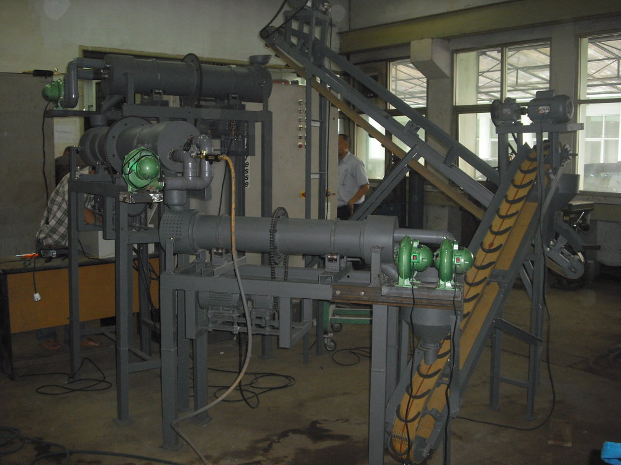

Figure 1
The Miniature of a Process Control Plant for Industrial Solid Materials

Japan has a long experience with the university-industry collaboration, especially in the field of process control technology ^{[2,3]}. The short visit to both the university and the industrial world in Japan will be very beneficial for the future of our laboratory at its location in the new campus. The main concern is about the university-industry collaboration itself, another concern is related to the industrial experience during the visit.

Objectives

The main goal of the 6 (six) month visit to Japan is to collect the lessons learned from the Japanese experience in the collaboration between the academic world and the real industrial world, especially in the field of process control technology. The best model of university-industry collaboration is developed as the main outcome of the visit. For this purpose, it is expected that at least two-third of the time allocation will be spent in the real industrial world.

The more specific purpose of spending much time visiting the industry is to develop mathematical models of the industrial process plants. While visiting the industry, we plan to derive accurate, verified and validated mathematical models of the process components as many as possible. These mathematical models of the real industrial process plants will be very useful in the future, especially for the problem-based teaching and learning process as the crucial part of the Laboratory-based Education (LBE).

Schedule

Tentatively, the schedule of the visit can be arranged as follows:

- Day 1 to Day 5: Orientation and preliminary discussion with the host professor at the university.
- Week 2 to Week 4: Detail planning of the visit, searching the best industrial objects.
- Month 2 to Month 5: Visit to industry as a research fellow at the R & D facilities, if available.
- Month 6: Back to the university, writing reports and papers.

References

[1] Andani Ahmad, “The Miniature of an Industrial Solid Material Process Plant”, Ph.D. Dissertation, Hasanuddin University Graduate Program, Makassar, Indonesia, 2010.
[2] Manabu Kano, “Recent Development of Process Control Technology through Industry-University Collaboration in Japan ”, The 13th Asia Pacific Confederation of Chemical Engineering Congress , Taipei, Taiwan, October 5-8, 2010.
[3] Kano M. and Ogawa M., “The State of the Art in Advanced Chemical Process Control in Japan”, IFAC ADCHEM, CD-ROM, Istanbul, Turkey, July 12-15, 2009

Curriculum Vitae


Rhiza S. Sadjad, was born in 1957, completed his elementary and secondary education at his home town Bogor, Indonesia. He received his first college degree of Ir. from the Department of Electrical Engineering, Bandung Institute of Technology (ITB), Bandung, Indonesia in 1981, then received the M.S.E.E. (1989) and the Ph.D. (1994) majoring in Automatic Control Systems from the Department of Electrical and Computer Engineering, University of Wisconsin, Madison WI, USA.
In 1981 he took a teaching position at the Faculty of Electrical Engineering, Satya Wacana Christian University in Salatiga, Central Java, Indonesia, then moved to the Department of Electrical Engineering, Hasanuddin University, Makassar, South Sulawesi, Indonesia in 1983 and has been with this department until now.. He founded the Control Systems and Instrumentation Laboratory in 1995 and has been the head of the laboratory since then. He teaches almost all courses in automatic control systems area, and has recently been interested in the process control systems and technology. He has supervised a Ph.D. dissertation (completed in 2010) to develop a process control mini-plant for industrial solid materials, and now is advising undergraduate and masters students whose final projects and thesis are related to the field of process control technology.

