Q.1.
A multinational company want to setup its computer network in Indonesia. This (Indonesia) branch then given a block of the company's internal IP. The block is 192.168.80.0/20. Indonesian branch have three sites, they are Jakarta, Makassar and Jayapura site. Jakarta-Makassar and Makassar-Jayapura sites each connected via serial leased line. There are 300 terminals in Makassar while there are 200 in Jayapura. Jakarta site, for security reason then divided into three vlan which are Finance(50), IT(50) and HQ(400). The number beside the vlans is the number of their terminals. You are as Head of IT Dept. need to design an effective/efficient addressing scheme to accommodate the growth of the company that expected to become 150%-200% for the next 5 years
a. Design your addressing scheme. Please explain how it works, and the reason for the choices
b. What routing protocol would you use? do explain why and how it work

Q.2.
Using the picture below we need to troubleshoot a network communication problem.
This network was recently setup by a competitor and here it is Monday morning and you need clean up their mess.
How should you solve this problem?
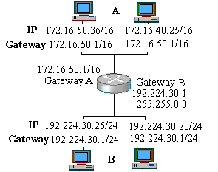

Q.3.
Using the picture below to troubleshoot the following network problem.
Client 1 and client 4 do not have any problems communicating with Server B and Server A.
As well Client 5 can communicate with Client 1 and Client 4, and Server A.
Client 1 and 4 cannot access the resources that are located on Client 2.
How should you solve this problem?
