**AUTONOMOUS VEHICLE TRACKING CONTROL FOR A CURVED TRAJECTORY**

**Hasnawiya Hasan1,2, Faizal Arya Samman1, Muh. Anshar1, Rhiza.S.Sadjad1**

1Department of Electrical Engineering, Faculty of Engineering, Hasanuddin University, Indonesia

2Department of Marine System Engineering, Faculty of Engineering, Hasanuddin University, Indonesia

Email : [hasnahasan@unhas.ac.id](mailto:hasnahasan@unhas.ac.id) (H.Hasan); [faizalas@unhas.ac.id](mailto:faizalas@unhas.ac.id) (F.Samman); [anshar@unhas.ac.id](mailto:anshar@unhas.ac.id) (M.Anshar); [rhiza@unhas.ac.id](mailto:rhiza@unhas.ac.id)(R.Sadjad)

|  |  |  |
| --- | --- | --- |
| **Article Info** |  | **ABSTRACT** (10 PT) |
| ***Article history:***  Received month dd, yyyy  Revised month dd, yyyy  Accepted month dd, yyyy |  | *Recently, research about trajectory tracking of autonomous vehicle has give a major contribution to the development of autonomous vehicle technology, particularly with the application of some novel control methods for this technology. However, tracking a curved trajectory still a challenge for autonomous vehicle. This research proposes a state feedback linearization with a PD observer feedback to overcome some difficulty that arise from such as path. This approach is consider to be suitable for a complex nonlinear system such as autonomous vehicle. So that, the goal of this research is to improve the control system performance of autonomous vehicle that stable enough to navigates along a curved path. Moreover, the research result shows that the developed control law able to track the curved path with a good performance and solve some existing problems. However, some improvements are still needed for the vehicle performance and robustness.* |
| ***Keywords:***  Autonomous vehicle  trajectory  tracking  state feedback linearization  ***observer*** |
|  |
| ***Corresponding Author:***  Faizal Arya Samman Electronics and Device Laboratory, Department of Electrical Engineering Faculty of Engineering, Hasanuddin University Jl.Poros Malino Km 6, Gowa, South Sulawesi, Indonesia  Email: faizalas@unhas.ac.id | | |

1. **INTRODUCTION**

Autonomous vehicle innovation have reach milestone of achievements, in the last few years. The control of a vehicle motion is a critical part of autonomous vehicles, as it has a direct impact on both the safety of the vehicle and the satisfaction of its passengers. So that, it is crusial to develop a path-following controller that overcome problems in challenging environments [1] .

The majority of current motion control research focuses on normal condition. It is vital to expand the research into difficult working conditions such as curved path in order to achieve the promise of autonomous vehicles in managing crucial scenarios that human drivers find difficult or are unable to handle. However, under difficult operating conditions, the characteristics of non-linearity and multi-dimensional coupled dynamics are greatly improved. The requirements for system modeling as well as the resilience and adaptability of motion control algorithms are now much higher. In addition, a through study of the integration of motion planning and control which consider environmental parameters is required to deal with multi-objective coordination in complicated scenarios [2]. Therefore, research about motion control particularly trajectory tracking control is still demanding topic amount other research topics on autonomous vehicle technology. Trajectory tracking along with lane keeping, lane changing, and cruise control are some important application in autonomous vehicle technology [3][4] . So that, a trajectory tracking control system's objective is to select the best course of action for the vehicle to follow the predefined path while minimizing path following faults [5]. Trajectory tracking control is one of the control approach to recognize the enviroments and its parameters.

There are many research about trajectory tracking control for unmmaned vehicle have been conducted in the last decade. A work by Bacha et al. [6] is almost similar with this study, but Bacha et al. used input and output state feedback linearization approach for the same system and there was no experiment for a curved path. While, Trotta et al [7] develope an adaptive cruise control for autonomous vehicle using a feedback linearization approach. The approach allow real time application for the system and it also has a low computational cost. The approach also proved can solve nonlinearities of the system and ensure equilibrium point stability [7], but only uses a longitudinal model as the vehicle model. Indeed, Trotta et al [7] research has been experimented on a real driving road. In addition, Cao et al. [8] also conducted a research on autonomous vehicle, they developed a Linear Time Varying Model Predictive Control which also allow a real time experiment. Even though, the research results a good tracking performance, the control low computation is complex and the vehicle has not being tested on ther road. While, a research by Wang et al.[9] develop a control law for nonlinear affine which also using state feedback linearization. The control law is developed without consider the present of internal dynamics and disturbances parameters but the result is energy-efficient . There are still a lot of control and artificial intelligence algorithm that work well for tracking trajectory for autonomous vehicle, such as the work that was conducted by Dai et al. [10] this work suggests a model predictive control (MPC) controller with adaptive preview properties and a longitudinal vehicle speed-assisted constraint mechanism. Simulink/CARSIM simulations validated the model's predictive control and algorithm, which enhances the performance of path tracking. Similarly, Yu et al. [11], developed an efficient model predictive control for velocity tracking whereas In complicated circumstances with coupling characteristics and tire nonlinearity, maintain the control accuracy and reasonable computing burden, which increase driving safety. While, Cao et al [8] focuses on developing a trajectory tracking control algorithm for autonomous vehicles that addresses problems such as low control accuracy and poor real-time performance for avoiding obstacles. Simulation result show that the controller has good self-adaptability, superior robustness and anti-interference ability, and significant improvement in the trajectory tracking control accuracy and real-time performance.

The majority of the offered approaches are only useful for low-speed driving due to ambiguities in environment perception when employing the current generation of sensors. Trajectory tracking control  demonstrates that  considering vehicle dynamics and environmental limits and identification and detection of the surroundings and potential obstructions are two crucial components of trajectory planning for high-speed driving [12] [13].

Trajectory tracking using state feedback linearization approach suitable for a class of nonlinear system such as autonomous vehicle [12] [14]. This method is a popular approach among other control system design methods. The goal is to achieve a good performance and stable condition at equilibrium point by developing a feedback control law [15] [16]. Although, this method has a simple computation process, this approach is appropriate to apply in a highly nonlinear model such as autonomous vehicle [17]. Moreover, control algorithm for autonomous  vehicles  must meet the standard of safety and robustness, particularly in complex  environment [17] [18] .

Keeping the autonomous vehicle stable and robust in tracking the predefined trajectory is essential in autonomous control system design. A real road field sometimes hard to track, such as a curvature road. Drifting sometimes occure when tracking a sharp bend with high speed, so that the vehicle need to drive in low speed when tracking this path [19] [20] [21]. This approach is appropriate to implement in a complex road scenario such as curvature road because this approach consider all parameters and conditions from the system model and its environments to meet the requirement of the stable and robust condition of a dynamic systems [22] [23].

This research of tracking control for autonomous vehicle using state feedback linearization approach with an observer feedback. The benefit of the state feedback linearization approach using observer feedback is that it can overcome the unpredictable parameters and disturbances that typically result from nonlinear models, enhancing advantages and ensuring system stability. Observer feedback in this method could  minimize the need of sensors, which are typically added  to monitor these uncertain characteristics. The observer feedback can substitute this sensors in a complex system, so that the system can limit the amount of sensors in the systems and simplify the instruments architecture [7] [8]. Other advanced approaches usualy occupy a lot of sensors to measure these parameters.

Futhermore, the goal of this study is to meet the requirement of a stable and robust control system as well as apply the theoretical control approach such as state feedback linearization and observer feedback into a real system of autonomous vehicle technology. Therefore, the paper is prepared as follows; in section 2 is about develop a control law for this autonomous vehicle system using the state feedback linearization approach with adding observer feedback to design the new estimated states. While, section 3 discuss about research result of this method using a simulation software MATLAB. Finally, section 4 summarize all the research progress and results.

1. **STATE FEEDBACK LINEARIZATION WITH OBSERVER FEEDBACK**

This research apply state feedback linearization approach for tracking control the autonomous vehicle along the curved path such as sinusoidal path. An observer feedback is added to the state feedback linerizaton model in order to estimates more states from the model and optimize its system’s output. So that, the a utonomous vehicle model which is choosen in this research is a kinematic model represents motion regardless of the vehicle’s dynamic components, such as force, torque, and inertia effects [24] [25]. The vehicle kinematic model is presented in Figure 1 as a two-dimensional coordinates (X-Y). This model do not consider slipping and inertia [8]. The kinematic formula is represented as :

$$\dot{x}=v_{x}\cos{θ (1)}$$

$$\dot{y}=v_{x}\sin{θ (2)}$$

$$\dot{θ}=\frac{v_{x}}{L}\tan{∝ (3)}$$

Where (x,y) represents the vehicle position on the ground based on space coordinates, θ Σ (0,2п) is an azimuth angle also represent vehicle position on the ground, and L is the length of vehicle base. While, the control input is u corresponds as azimuth angle (Ɵ) and steering angle (α). The kinematic model is only for vehicle with low speed and acceleration [24] [25].

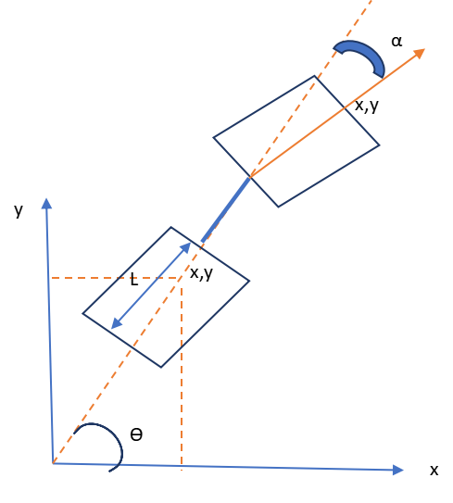

Figure 1. Vehicle model in X-Y Coordinates (top view)

The vehicle kinematic model is transformed into state vectors such as :

$$dq=\left[\dot{x},\dot{y},\dot{θ}\right] \left(4\right)$$

$${\dot{x}}_{1}=x_{2} (5)$$

${\dot{x}}_{2}=v_{x}cosθ=u (6)$

${\dot{y}}_{1}={\dot{y}}_{2} (7)$

${\dot{y}}_{2}=v_{x}sinθ=u (8)$

$${\dot{θ}}_{1}=θ_{2} (9)$$

$${\dot{θ}}_{2}=\frac{v_{x}}{L}\tan{α} (10)$$

Where vx correspond to vehicle velocity, (X,Y) is vehicle position on space coordinates, Ɵ is the heading angle of vehicle, L is the vehicle base length, and α is vehicle steering angle.

Then, equation (5) – (10) can be transformed into a state vector form, such as :

$$\left[\begin{matrix}{\dot{x}}_{1} \\ {\dot{x}}_{2}\end{matrix}\right]=\left[\begin{matrix}0 & 1 \\ 0 & 0\end{matrix}\right]\left[\begin{matrix}x_{1} \\ x_{2}\end{matrix}\right]+\left[\begin{matrix}0 \\ 1\end{matrix}\right]u \left(11\right)$$

$$\left[\begin{matrix}{\dot{y}}_{1} \\ {\dot{y}}_{2}\end{matrix}\right]=\left[\begin{matrix}0 & 1 \\ 0 & 0\end{matrix}\right]\left[\begin{matrix}y_{1} \\ y_{2}\end{matrix}\right]+\left[\begin{matrix}0 \\ 1\end{matrix}\right]u \left(12\right)$$

$$\left[\begin{matrix}{\dot{θ}}_{1} \\ {\dot{θ}}_{2}\end{matrix}\right]=\left[\begin{matrix}0 & 1 \\ 0 & 0\end{matrix}\right]\left[\begin{matrix}θ_{1} \\ θ_{2}\end{matrix}\right]+\left[\begin{matrix}0 \\ 1\end{matrix}\right]u (13)$$

With $A=\left[\begin{matrix}0 & 1 \\ 0 & 0\end{matrix}\right];B=\left[\begin{matrix}0 \\ 1\end{matrix}\right];C=\left[\begin{matrix}0 & 1\end{matrix}\right]$

Then, a control feedback is designed to meet the control law requirement and consider also the input reference such as :

$$u_{x}=−Kx+r_{x} (14)$$

Where K = [K1, K2] is the state feedback matrix

Design a characteristic equation with the desired overshoot and natural frequency, such as that

$$ρ^{2}+2σφ_{n}ρ+φ_{n}^{2}=0 (15)$$

Where $σ$ is overshoot and $φ_{n}$ is a natural frequency

This control law design is developed based on ref [24] . The state feedback gains are adjusted with this characteristic equation in order to reach stability around an equilibrium point. Then, observer feedback is added into this full state feedback systems as represented in Figure 2. The new state vector is transformed such as follows :

$$\tilde{\begin{aligned}\left[\begin{matrix}{\dot{\tilde{x}}}_{1} \\ {\dot{\tilde{x}}}_{2}\end{matrix}\right]=\left[\begin{matrix}0 & 1 \\ 0 & 0\end{matrix}\right]\left[\begin{matrix}{\tilde{x}}_{1} \\ {\tilde{x}}_{2}\end{matrix}\right]+\left[\begin{matrix}0 \\ 1\end{matrix}\right]u+\left[\begin{matrix}D_{1} \\ D_{2}\end{matrix}\right]\tilde{y} (16) \\ \tilde{y}=y−\left[0 1\right]\tilde{x} (17) \\ Where C=\left[0 1\right]\end{aligned}}$$

Where denotes the estimates of state x, and D is the observer gain.

Then, observer feedback D is designed in order to meet the requirement of desired overshoot and natural frequency, such as D = [ 16 100 ].

The real coordinates (x,y) related with desired coordinates (xd,yd), are described as follow:

$$\dot{x}={\dot{x}}_{d}+k_{x}x_{e} \left(18\right)$$

$$\dot{y}={\dot{y}}_{d}+k_{y}y_{e} (19)$$

Where

$$x_{e}=x_{d}−x \left(20\right)$$

$$y_{e}=y_{d}−y (21)$$

Transform equation 18-19 into state matrix as follows :

$$\left[\begin{matrix}{\dot{x}}_{e} \\ {\dot{y}}_{e}\end{matrix}\right]+\left[\begin{matrix}k_{x} & 0 \\ 0 & k_{y}\end{matrix}\right]\left[\begin{matrix}x_{e} \\ y_{e}\end{matrix}\right]=0 (22)$$

The following Lyapunov function, which is positive definite [12], guarantees the system's stability with a distinct equilibrium point at the origin:

$$V=\frac{1}{2}e^{T},e>0 (23)$$

Where $e=\left[\begin{matrix}x_{e} \\ y_{e}\end{matrix}\right] (24)$

$$\dot{e}=−\left[\begin{matrix}k_{x},x_{e} \\ k_{y},y_{e}\end{matrix}\right] (25)$$

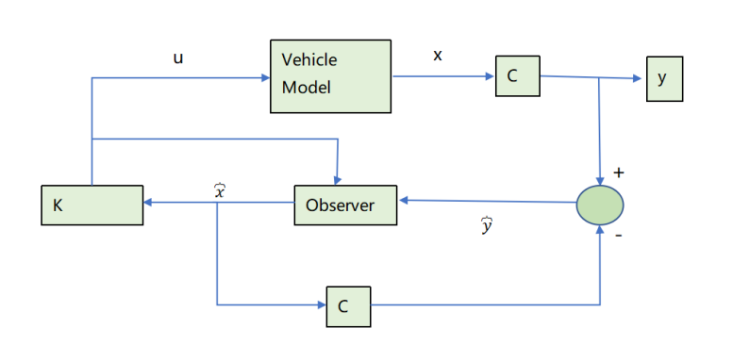

Figure 2. Control Architecture of State Feedback Linearization Method with Observer Feedback

And its derivative is negative definite [14], as follows:

$$\dot{V}=e^{T}.\dot{e}=−k_{x}x_{e}^{2}−k_{y}y_{e}^{2}<0 (26)$$

The error always converges to zero and the system is asymptotically stable. The new controller computes a steering angle to enable the vehicle tracks the desired course.

1. **RESULTS AND DISCUSSION**

An autonomous vehicle that navigate along reference sinusidal trajectory shown in Figure 3 as the simulation result. The velocity is fixed at 10 m/s and it start at (0,0) in two-dimension coordinate (x,y).

While Figure 4 shown the simulation result of the actual trajectory. The actual trajectory has a small error difference with the desired trajectory that approves the developed method. The goal of this approach is to put the desired poles in the stable space of the system. Therefore, the overshoot parameter is set to low overshoot to suit the desired settling time and to have a a fast response. However, the system requirement should be controllable to achieve the desired condition. So that the design controller can put the poles in a stable domain [24].

The vehicle quiate difficult to track the reference trajectory at a few second of initial time of simulation, but the vehicle response still reach stability according to the settling time set up. Therefore overshoot parameter suppose to be set almost zero so that the model still meet the desired requirement. While, settling time is set low to track the the reference trajectory fast. The chosen controller is adjusted with the model desired response also. Low overshoot and fast settling time can improve control performance.

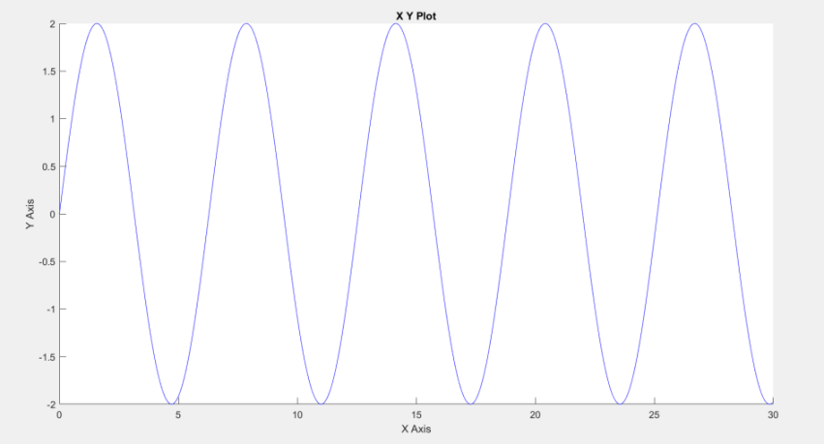

Figure. 3. Sinusidal trajectory reference

The ideal closed loop control system has all states always available for feedback and measurable process. However, many systems only have a sub of the state available for feedback and measurement. So that, the system usually use a lot of sensor to read undetected states [24]. This design is not cost-efficient and complex. Therefore, in this system observer is designed to reduce the number of sensor occupy .

The system should be observable in order to meet the requirement of this approach. The desired characteristic response place the poles in the stable domain. Therefore, the observel D is choosen to be suit with the characteristic response. The simulation result of this approach with sinusoidal path reference is presented in Figure 4 . The lateral error exixting due to the design overshoot and settling time, however the model fast enough to achieve stability. However, the model achieve stability after a few seconds as desired settling time and overshoot design in the method.

The trajectory error is shown in the Figure 5. The lateral error can be computed using Lyapunov method as represented in Figure 5. The lateral error is adjusted to asymptotically stable. Therefore, error always converges to zero.

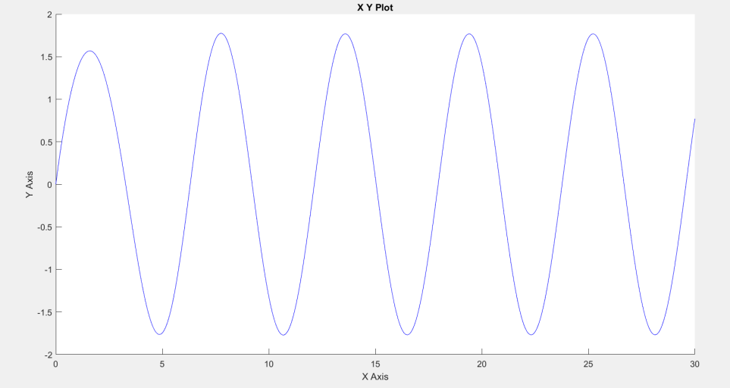

Figure. 4. Actual sinusidal trajectory

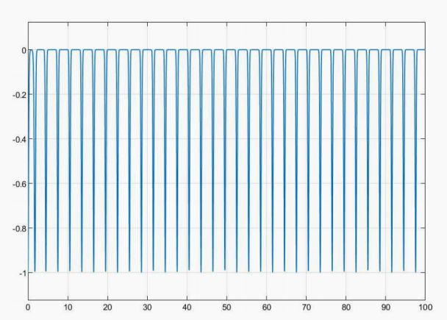

Figure 5 Trajectory error of sinusoidal trajectory

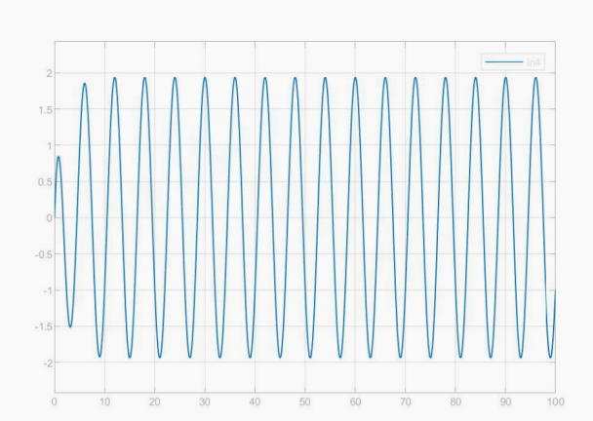

Figure 6 teering angle generates from sinusoidal trajectory

Moreover, Figure 6 represent the steering angle simulation results. The simulation result shows that, at initial condition the controller still try to track the desired trajectory, however in a few second, the controller find the desired tracjectory and reach stability. The steering angle is sinusoidal similar with the desired trajectory, because the steering try to track the desired trajectory.

1. **CONCLUSION**

This paper proposed a trajectory tracking of autonompus vehicle to tracks a curvature road path such sinusoidal. The state feedback linearization with observer feedback has been used to control the vehicle dynamic motion. The developed controller can control the model to navigate along desired trajectory with minimal lateral error. The simulation result shows a good performance of vehicle tracking control and a minimal lateral error.

State feedback linearization approach with observer feedback able to measures all the states so that can predict the uncertain parameters from the model. The approach generate a stable steering angle with minimimum error. In the future, the vehicle performance will be improved particularly for driving in a complex path scenario. So that, Model Predictive Control can be solution for such as problem. Combine this approach with convolutional neural network will give better result for control and computer vision parts of the autonomous vehicle technology

**ACKNOWLEDGEMENT**

The authors thank the Minister of Education, Culture, Research and Technology for funding research and community service in 2022 for the doctoral dissertation research skim. The authors also thank the referees for their valuable comments supporting this manuscript.

**REFERENCES**

[1] X. Yang, L. Xiong, B. Leng, D. Zeng, and G. Zhuo, “Design, validation and comparison of path following controllers for autonomous vehicles,” *Sensors (Switzerland)*, vol. 20, no. 21, pp. 1–24, 2020, doi: 10.3390/s20216052.

[2] L. Xiong, X. Yang, X. Guirong, B. Leng, and X. Rhenxie, “Review on Motion Control of Autonomous Vehicles,” *J. Mech. Eng.*, 2020.

[3] A. Mohammadzadeh and H. Taghavifar, “A robust fuzzy control approach for path-following control of autonomous vehicles,” *Soft Comput.*, vol. 24, no. 5, pp. 3223–3235, 2020, doi: 10.1007/s00500-019-04082-4.

[4] R. Hussain and S. Zeadally, “Autonomous Cars: Research Results, Issues, and Future Challenges,” *IEEE Commun. Surv. Tutorials*, vol. 21, no. 2, pp. 1275–1313, 2019, doi: 10.1109/COMST.2018.2869360.

[5] M. Fader, “Autonomous Ground Vehicle Path Following by Combining Feedback Linearization with Model Predictive Control,” no. December, p. 165, 2020, [Online]. Available: https://qspace.library.queensu.ca/handle/1974/28631.

[6] S. Bacha, M. Y. Ayad, R. Saadi, O. Kraa, A. Aboubou, and M. Y. Hammoudi, “Autonomous Vehicle Path Tracking Using Nonlinear Steering Control and Input-Output State Feedback Linearization.,” *Proc. 2018 3rd Int. Conf. Electr. Sci. Technol. Maghreb, Cist. 2018*, pp. 1–6, 2019, doi: 10.1109/CISTEM.2018.8613365.

[7] A. Trotta, A. Cirillo, and M. Giorelli, “A feedback linearization based approach for fully autonomous adaptive cruise control,” *2019 18th Eur. Control Conf. ECC 2019*, pp. 2614–2619, 2019, doi: 10.23919/ECC.2019.8795832.

[8] J. Cao, C. Song, S. Peng, S. Song, X. Zhang, and F. Xiao, “Trajectory Tracking Control Algorithm for Autonomous Vehicle Considering Cornering Characteristics,” *IEEE Access*, vol. 8, pp. 59470–59484, 2020, doi: 10.1109/ACCESS.2020.2982963.

[9] H. P. Wang, Y. Tian, and C. Vasseur, “State feedback trajectory tracking control of nonlinear affine in control system with unknown internal dynamics and disturbances,” *Control Eng. Appl. Informatics*, vol. 19, no. 3, pp. 22–30, 2017.

[10] C. Dai, C. Zong, and G. Chen, “Path tracking control based on model predictive control with adaptive preview characteristics and speed-assisted constraint,” *IEEE Access*, vol. 8, pp. 184697–184709, 2020, doi: 10.1109/ACCESS.2020.3029635.

[11] S. Yu, E. Sheng, Y. Zhang, Y. Li, H. Chen, and Y. Hao, “Efficient Nonlinear Model Predictive Control of Automated Vehicles,” *Mathematics*, vol. 10, no. 21, p. 4163, 2022, doi: 10.3390/math10214163.

[12] P. Tang, “Feedback linearization of mimo nonlinear system with measurable disturbance,” *Proc. - 2020 12th Int. Conf. Meas. Technol. Mechatronics Autom. ICMTMA 2020*, vol. 8, pp. 744–749, 2020, doi: 10.1109/ICMTMA50254.2020.00162.

[13] S. Dixit *et al.*, “Trajectory planning and tracking for autonomous overtaking: State-of-the-art and future prospects,” *Annu. Rev. Control*, vol. 45, pp. 76–86, 2018, doi: 10.1016/j.arcontrol.2018.02.001.

[14] A. Ziaei, H. Kharrati, and M. Salim, “Feedback linearization based fault tolerant control for affine non-linear systems,” *2020 28th Iran. Conf. Electr. Eng. ICEE 2020*, no. 1, pp. 1–4, 2020, doi: 10.1109/ICEE50131.2020.9260734.

[15] J. Umlauft, T. Beckers, M. Kimmel, and S. Hirche, “Feedback linearization using Gaussian processes,” *2017 IEEE 56th Annu. Conf. Decis. Control. CDC 2017*, vol. 2018-Janua, pp. 5249–5255, 2018, doi: 10.1109/CDC.2017.8264435.

[16] M. Ahmad, A. Khan, M. A. Raza, and S. Ullah, “A study of state feedback controllers for pole placement,” *5th Int. Multi-Topic ICT Conf. Technol. Futur. Gener. IMTIC 2018 - Proc.*, no. 1, 2018, doi: 10.1109/IMTIC.2018.8467276.

[17] J. Jiang and A. Astolfi, “Lateral Control of an Autonomous Vehicle,” *IEEE Trans. Intell. Veh.*, vol. 3, no. 2, pp. 228–237, 2018, doi: 10.1109/TIV.2018.2804173.

[18] M. Rick, J. Clemens, L. Sommer, A. Folkers, K. Schill, and C. Büskens, “Autonomous Driving Based on Nonlinear Model Predictive Control and Multi-Sensor Fusion,” *IFAC-PapersOnLine*, vol. 52, no. 8, pp. 458–473, 2019, doi: 10.1016/j.ifacol.2019.08.068.

[19] R. Liu, M. Wei, N. Sang, and J. Wei, “Research on Curved Path Tracking Control for Four-Wheel Steering Vehicle considering Road Adhesion Coefficient,” *Math. Probl. Eng.*, vol. 2020, 2020, doi: 10.1155/2020/3108589.

[20] Z. Shen and T. Tsuchiya, “State Drift and Gait Plan in Feedback Linearization Control of a Tilt Vehicle,” *AIRCC Publ. Corp.*, pp. 1–17, 2022, doi: 10.5121/csit.2022.120501.

[21] M. Baur and L. Bascetta, “An experimentally validated lqr approach to autonomous drifting stabilization,” *2019 18th Eur. Control Conf. ECC 2019*, pp. 732–737, 2019, doi: 10.23919/ECC.2019.8795883.

[22] E. Alimohammadi, E. Khanmirza, and H. Darvish Gohari, “Velocity tracking of cruise control system by using feedback linearization method,” *Int. J. Automot. Eng.*, vol. 8, no. 4, pp. 2826–2832, 2018.

[23] A. Patnaik *et al.*, “Design and Implementation of Path Trackers for Ackermann Drive based Vehicles,” *arXiv:2012.02978v1*, 2020, [Online]. Available: http://arxiv.org/abs/2012.02978.

[24] B. Dorf, “Full State Feedback Control,” in *Modern Control System*, 2020.

[25] M. Rokonuzzaman, N. Mohajer, S. Nahavandi, and S. Mohamed, “Review and performance evaluation of path tracking controllers of autonomous vehicles,” *IET Intell. Transp. Syst.*, vol. 15, no. 5, pp. 646–670, 2021, doi: 10.1049/itr2.12051.