An Experimental Method to Measure the Inter-Node Delay of a Telemonitoring System for Electrical Power Network Distribution Transformers
Nurqalbi*¹, Rhiza S. Sadjad², Sri Mawar Said³
¹Jurusan Teknik Elektro Fakultas Teknik Universitas Hasanuddin Jl. Perintis Kemerdekaan X, 90000 Makassar, Indonesia
*Email: nurqalbi.takdir@gmail.com

Abstract. A telemonitoring system is a necessity to maintain the quality of the service in a large electrical power network. In this research, a microcontroller-based telemonitoring system is designed for the distribution transformers, providing a data acquisition system to monitor 6 (six) power system parameters, including the three phase currents, two voltages and the temperature-humidity (in one sensor) in thousands of transformers in the area. The measurement is conducted using 6 (six) sensors installed in each one of the transformers as an outdoor unit along with the microcontroller and the network circuitry. The outdoor unit is designed as a node of a large interconnected wifi network. This paper shows an experiment conducted to measure the delay between 2 (two) nodes in the network and its effects to the performance of the whole network. A number of the outdoor unit prototypes are connected to a server in a mesh-topology. The inter-node delay is tested for both single-hop and multi-hop data transmission configurations. In the multi-hop configuration, the delay is 21.13 seconds when the distance between the farthest outdoor unit to the server is set to be 53 meters and in the single-hop configuration, the delay is 21.96 seconds for a 53 meters of inter-node distance from the closest unit to the server. This result proves that in a mesh-topology configuration the inter-node delay in the multi-hop configuration is smaller than the delay in the single-hop configuration.
Keywords: mesh, Telemonitoring, data transfer, routing, RTU, distribution transformers, current sensor, voltage sensor, delay.

Introduction
A telemonitoring system of distribution transformers is a very congested network because there are thousands of transformers whose load balance should always be monitored continuously to avoid the overloaded transformers that would affect the quality of electricity supply.
There are two important parts in this telemonitoring process. The first part is how the RTU can perform an accurate measurement of transformer parameters and the second one is how the RTU can send the measurement data to the server. The latest information on the state of any transformer is required at all times, therefore the transmission time of the telemonitoring system should be taken into account. This transmission time is defined as the inter-node delay.
It requires a stable connection among all Remote Terminal Units (RTUs) in order to shorten the inter-node delay, especially when data are transferred simultaneously. The telemonitoring system is proposed to use a networking technology of Wireless Mesh Network (WMN) as the best solution for a very dense traffic, according to [6].
The data of distribution transformer locations are obtained from the map show in Figure 1. The distance between transformers varies from 50 meters to 200 meters. There are 15 transformers located on the main road around the server site, providing a good wireless network connection even though there are tall buildings and trees in the surrounding.
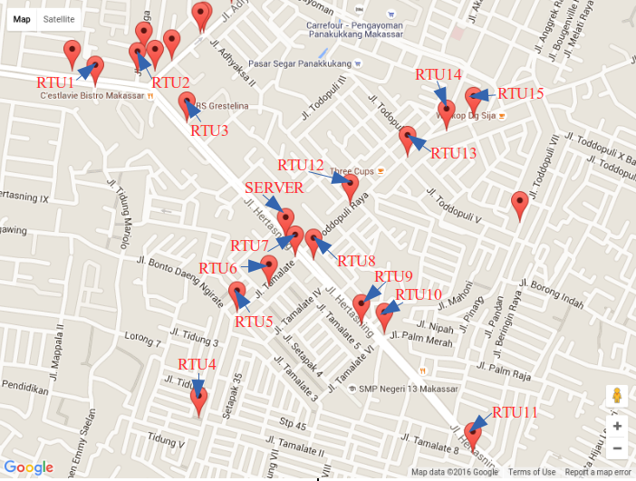

Figure 1: Google Map of Distribution Transformer at PLN Wil. Makassar (for the area around the server)
The research on this topic in [1], [2], [3], [4], and [5] has shown that a telemonitoring system of a dense network with multiple nodes should have a high quality of data transfer, however to simplify the infrastructure and to reduce the operational costs, the WMN is known to be the best solution.

System Design
All nodes in a mesh network define their own routing paths based on the WiFi connection provided. The protocol used to manage the routing path is the Optimized Link State Routing Protocol (OLSR), so that the telemonitoring system implementation for distribution transformers creates a communication line from the RTUs to a server in 2 (two) WMN configurations, namely the single hop configuration and the multi hop configuration.
Measurement data obtained by each RTU is sent to a server and stored in the server’s database. Therefore the user can monitor the data of each transformer and immediately discover any unbalanced-load or overloaded transformers.
The mesh network is a further development of an ad-hoc network where each RTU can be directly connected to a server without having to connect to any access point [INI PERLU REFERENSI]. An RTU is connected to another RTU via its own WiFi router. For a very dense network with particularly up to a thousand nodes, it requires a mesh network topology where each node not only serves as a client, but also serves as a router. So in this study each RTU is equipped with a WiFi router attached to the transformer panel, providing two or more lines of communication from single-hop to multi-hop, as shown in Figure 2.
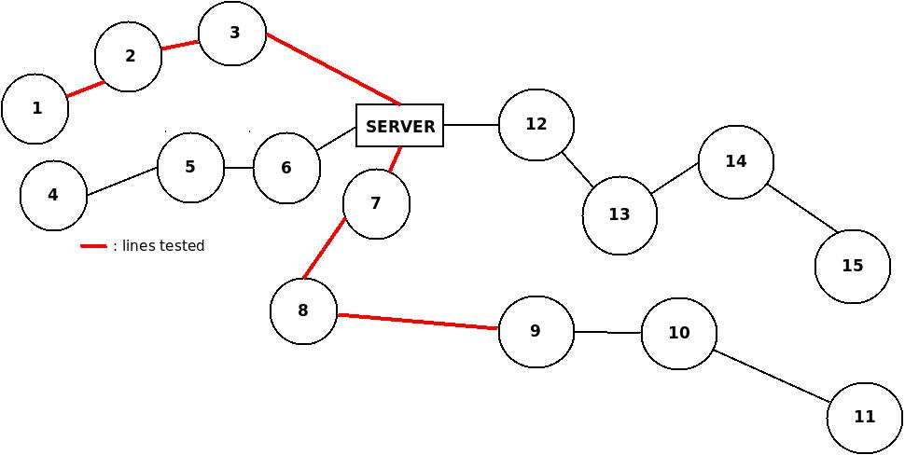
Figure 2 : Routing Path Design Distribution transformer
The design of the transformers monitoring routing path illustrates how the RTU farthest from server can take advantage of the WiFi router from each RTU in its path, enough to reach the server, and how the RTU closest to server can send its own data and also relay data from other nodes, in which all the data from each RTU are stored on server without any lost data packets from any RTU. Routing paths tested in this study are:
- RTU 9 is the furthest node from server that performs the data transmission process through three hops with routing path: node 9 - node 8 - node 7 - server. And all data from each RTU reached the server without any data loss occurs.
- How RTU 3 can transfer data to server with the same distance away between node 9 - server but through a single hop, and able to relay data from node 1 and node 2 until all the data reach the server without data packets lost.
Each node in a mesh network sends data packets to server by using the OLSR protocol so that when there is a node unable to reach the server, the closest node can act as a router. This large mesh networks can maintain the quality of the connection, so that if a broken link connection existed, the network can still pass the data to the server, because there is a node nearby assisting to forward the data packet.
The mesh network is very busy because all nodes transmit data to server using the same channel. It is then necessary to set the RTS / CTS (Request To Send / Clear To Send) on OLSR protocol which is a mesh network routing protocol to avoid data collisions, through the handshaking process before sending each data packet to server to determine whether or not the traversed channel is empty. In testing the system, the data were sent single hop and three-hop which is the implementation of multi-hop data transmission, because in the system there are actually many RTUs connected directly to server from a single hop to multi-hop based on the distance and each node has WiFi router respectively.
Testing of the mesh network in this system is carried out by using devices equipped with WiFi adapter. The experiment involves 3 (three) prototypes of microcotroller-based RTUs transferring data packages of 6 (six) sensors, namely : 3 (three) current sensors for the phase currents, 2 (two) voltage sensors fore the phase-to-phase voltage and the phase-to-neutral voltage and a combined temperature-humidity sensor.

Data Package Delivery Systems Between RTU and Server
Telemonitoring system is made based on client-server using PHP and MySQL database programming on the server side. RTU will make an http request to access a URL by sending the data in the form of a variable that will be responded by PHP using GET method. The data will be entered into the field corresponding to MySQL. Users who will monitor can use the browser to display data such as the name of a distribution transformer and its location, the value of the phase to phase voltage and phase to neutral voltage, the capacity of the transformer, the phase currents, and a combined temperature - humidity value.
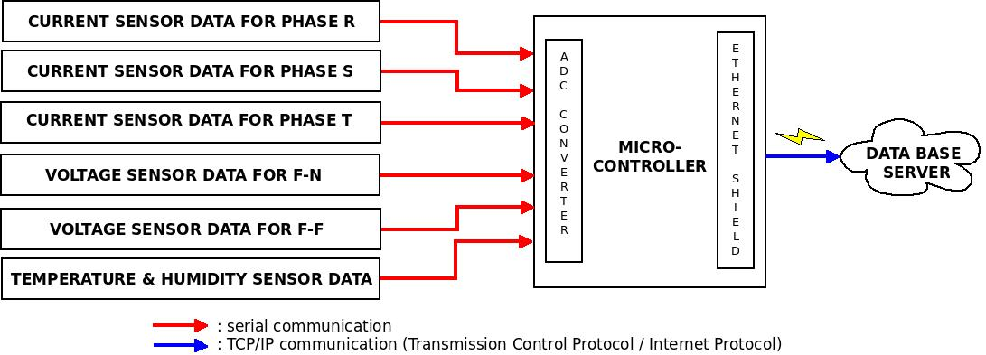
Figure 3 : Data Communication Process between Sensor, Microcontroller and Server

Data generated from the six sensors installed on the transformer is sent to the microcontroller using serial communication. Measurement of the phase currents uses three current sensors ( SCT 013-000 ) at each phase and provides the output of analog data with the current value ratio of 100A : 50mA. A microcontroller which handles only the voltage 0V-5V was given additional circuit so that the current value of the sensor can be converted into a voltage value by providing a load resistor in the current sensor.
This voltage circuit generates three analog input voltages at analog input pins 1-3 of a microcontroller derived from circuit of phase current sensors. ADC circuit contained in a microcontroller will convert the analog input data into digital data.
Measuring the phase-to-neutral voltage and the phase-to-phase voltage requires two voltage sensors built from step-down transformer. This transformer lowers the 220V AC voltage to 4,5V AC voltage. The output voltage is in analog form which is also converted into digital data by the microcontroller.
Measurement of temperature and humidity used DHT11 (a combined temperature – humidity sensor) which generates digital data that can be directly read by a microcontroller.
Comparison of current and voltage conversion value is included in the program which is then returned to the actual values to be sent to server along with other data that has been arranged in an array of variables in url.
Serial communication performed between each sensor and the microcontroller serves as a data transmitter (Tx), data receiver (Rx), grounding (GND), baudrate (data transfer rate) and data format (8 data bits, no parity and 1 bit for stop bit).
A microcontroller consisted of 16 pin ADC provides input signal expressed in 2¹⁶ = 65,536 discrete values. So the input voltage of 3V that will be obtained: ratio of V_{input} and V_{ref} are
, with a maximum scale : 65535 . Digital signal =

Data transmission from RTU to server used ethernet shield installed on the microcontroller and re-connected with a wireless access point so that the digital data on RTU were sent to server using TCP / IP (Transmission Control Protocol / Internet Protocol) communication starting from network layer to application layer.
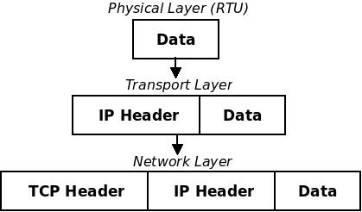

Figure 4 TCP / IP Communication Process on the side of the RTU

Data are transmitted from RTU in the form of data segments at transport layer then further are encapsulated with an IP header, so data packets will be formed on the network layer ready to be sent to server.

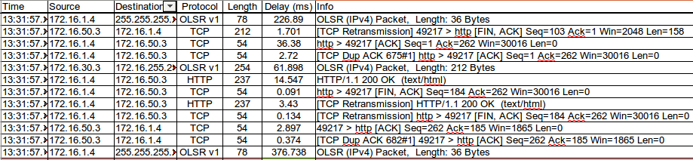

Figure 5 : Data Delivery Process from the RTU to server on Mesh Topology I (consisting of 12 segments)

On the server side, the data packets from RTU are de-capsulated or decomposed back into the data segment reading the IP header. The defined destination IP address is 172.16.1.4 (IP server) so that the data segments are sent to transport layer. TCP protocol will further in the transport layer make the process of handshaking and send the data to server.
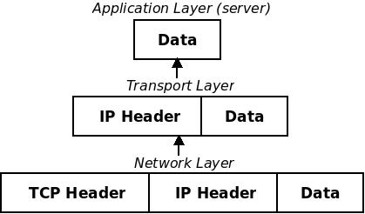

Figure 6 : TCP / IP Process Communication on the Server side
OLSR is a protocol used in this study for network layer that has been designed to manage the process of routing in a mesh network.
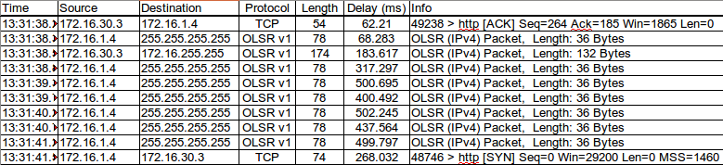

Figure 7: OLSR Protocol
OLSR protocol shown in Figure 7 illustrates 8 routing process when 172.16.30.3 finishes sending data to server (172.16.1.4).
TCP (Transmission Control Protocol) used in the transport layer functions to perform handshaking process by dividing the transmitted data into several segments, starting from initialization of connection until the data has been sent from the RTU to server at the end of the connection. TCP provides a sequence number at the start of the data transmission process and server sends ACK (acknowledgment) bits when the data is received, but the failure of package to be received means there is a time-out process.
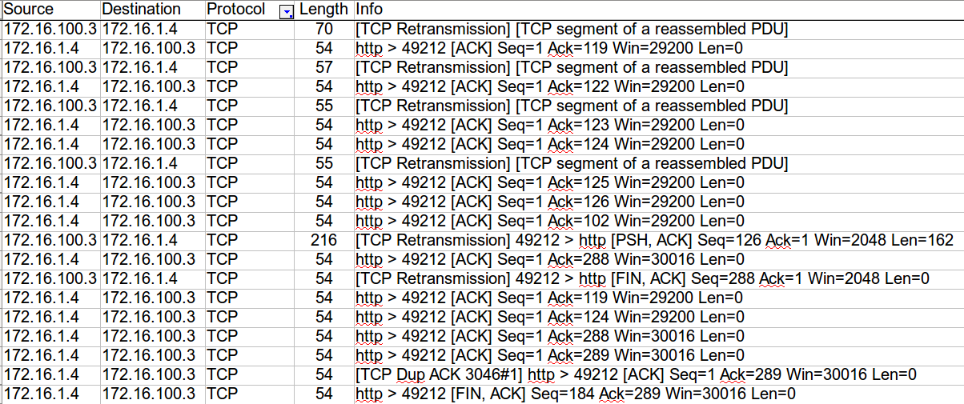
Figure 8 : TCP Protocol
Figure 8 illustrates that when there are some errors in the TCP packet delivery, they can be observed by the arrival of the retransmission message. When the RTUs with IP 172.16.100.3 send PSH flag, ACK: Seq = 126 Ack = 1 Win = 2048 Len = 162, the data has been successfully sent and until then the server sends ACK flag Seq = 1 Ack = 288 Win = 30016 Len = 0.
HTTP (Hypertext Transfer) is a protocol at the application layer that serves to regulate the format of the message to be transmitted, and how the Web server and browser respond to every command. In this case, the RTU uses HTTP to access the web server in the delivery of results of transformer parameter measurement and then stored them in a database server.
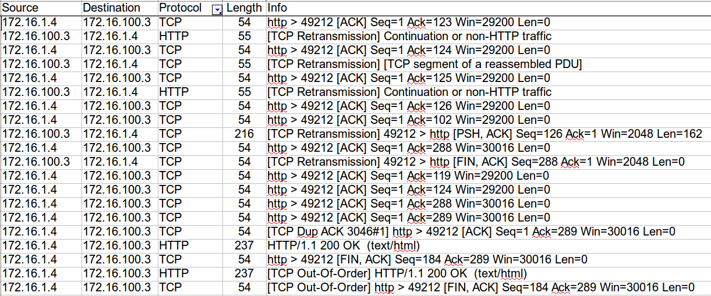
Figure 9: HTTP Protocol
While handshaking process by TCP protocol is running, the RTU (172.16.100.3) send HTTP request command to server (172.16.1.4) and as a sign that the server is ready to receive data from the RTU, server sends an ACK flag to the RTU. Furthermore, as a sign of successful data transmission the RTU send FIN (final) and ACK flags. And then the HTTP protocol sends an OK sign from server to the RTU if the TCP has sent ACK flag from server to the RTU.

Simulation of Mesh Network Topology
Telemonitoring Process conducted in this study are a MADZ RTU consisting of microcontroller with measurement sensors and equipped with WiFi installed on the transformer panel, microcontroller with ethernet shield with WiFi named LSKI, and ELKA. Each of these RTUs send data of transformer parameters comprises of transformer’s name and its location, transformer capacity, the phase currents, the phase-to-phase voltage and the phase-to-neutral voltage, and a combined temperature - humidity. MADZ RTU used wireless device connected to ethernet shield, also LSKI and ELKA. Every RTU has been configured in a mesh network, where the location of each RTU is according to figure 2.
Web server uses PHP programming and stores each data packet that has been successfully sent on server into a mysql database. Observations of each packet data transmission are performed using wireshark on server.
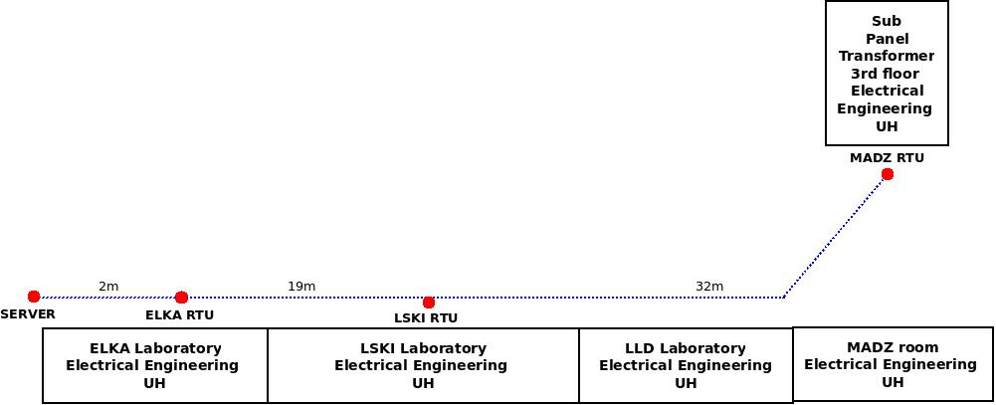
Figure 10 : Mesh Topology I

To test MADZ (IP: 172.16.100.3), LSKI (IP: 172.16.50.3) and ELKA (IP: 172.16.30.3) to server (IP: 172.16.1.4) in Mesh topology I, the design of mesh network routing path can be seen visually in figure 11 using OLSR application of the router. The figure below shows that the 172.16.50.3 tries to connect directly to 172.16.1.4, as well as 172.16.30.3.

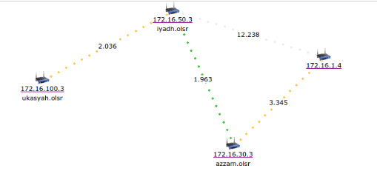

Figure 11 : Mesh Topology I on Monitoring instruments MADZ, LSKI, ELKA and Server

Routing path traversed by 172.16.100.3 to server passed through 172.16.50.3 and 172.16.30.3. Then 172.16.50.3 passed through 172.16.30.3 towards server, while 172.16.30.3 connected directly to server with a single hop. This process can be observed using traceroute application on server as shown in Figure 11a which represents the best routing path to be followed when sending data to server.

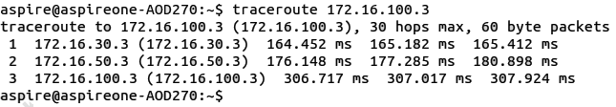
Figure 11a : Results of Traceroute in Mesh Topology I
The second test aims to test whether the server can receive data from any direction as to the actual implementation of the system therefore server is moved closer to the position of MADZ RTU.

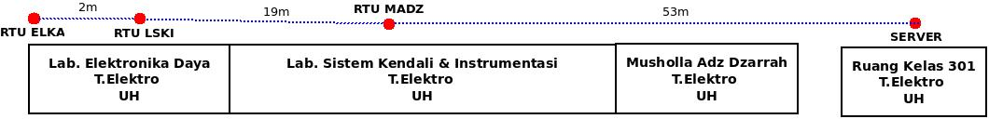
Figure 12: Mesh Topology II
For testing the connection of MADZ, LSKI and ELKA (IP: 172.16.30.3) to server (IP: 172.16.1.4) in Mesh topology II, the design of routing path in mesh network can be seen visually in the image below :
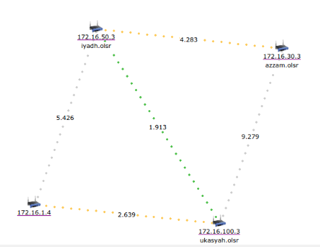

Figure 13: Mesh Topology II on Monitoring Server, MADZ, LSKI, ELKA
The displacement of server closer to MADZ is intended to observe the ability of the routing process on the actual instrument installed on the transformer panel. Figure 13 shows that 172.16.30.3 tried to find a direct path to 172.16.100.3 but it achieves the best path through
172.16.50.3 as shown in Figure 13a.
Mesh Topology II shows the routing path for 172.16.30.3 through three hops to server that are 172.16.30.3 - 172.16.50.3 - 172.16.100.3 - server. And 172.16.50.3 passes through two hops to server which are 172.16.100.3 – server. While 172.16.100.3 passes through a single hop directly to server. This process can be observed in traceroute application in the image below :
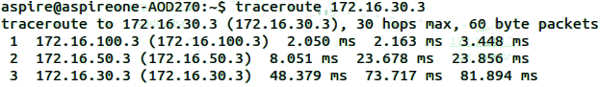

Figure 13a : Results of Traceroute in Mesh Topology II
Testing of data transmission process from a telemonitoring system for distribution transformers is conducted by calculating the total time required to send all data simultaneously and reach the server without exceeding the deadline. Because the real time system has a response time and deadline, time used in the data transmission process is affecting the quality of the telemonitoring system, in which the shorter the time it takes to get to server, the more optimal the performance of the system.

A. Data Transmission on Mesh Topology I
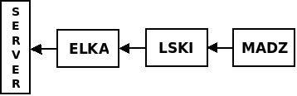

MADZ, LSKI and ELKA perform simultaneous data transmission to server, where MADZ carried out the process of data transmission in a three-hop way to implement the multihop process on the actual system.

B. Data Transmission on Mesh Topology II
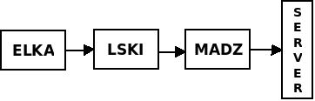

By moving the position of server, the ability of server to receive transformer data from the East, West, North, South and server can be calculated.

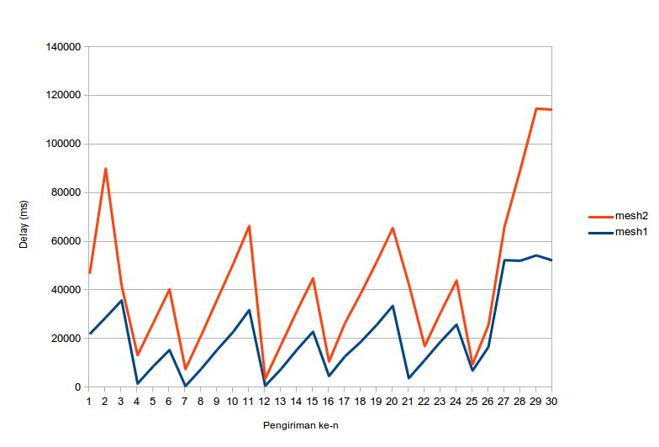

Figure 14 : Graph of Data Transfer Delay for Mesh 1 and Mesh
Topology II.

The permanent position of the instrument produces nearly the same delay on Mesh I and Mesh II. The distance between the MADZ to server on Mesh I is 53 meters with a routing position: MADZ - LSKI - ELKA - server generating an average delay of 21.13 s. Meanwhile the distance between the MADZ to server on Mesh II is 53 meters with a routing position: MADZ - server generating an average delay of 21.96 s. And on Mesh I, all data from each RTU reach the server, as well as on the Mesh II where data from LSKI and ELKA is also stored in server.
A distance of 53 meters through several RTUs on Mesh I have a faster data transmission time than from the RTU to server on Mesh II. So that on the implementation of the actual monitoring system, there is an RTU furthest from server at point Pannampu (north side), node Antang (south side), node Akkarena (west side) and node Sudiang (east side) able of sending parameter data of distribution transformers using multi-hop routing and finally forwarded by the RTU’s router closest to server that could be covered by the RTU. According to a survey the distance between each point is also not too far away which is about 200 meters, so the connection is still affordable by the wireless network. For example according to the calculation on a map the distance from node Pannampu to server is 5.8 km. It means that the RTU passes around 29 nodes, thus the RTU routing at node Pannampu is about 29 hops before reaching the server, or it could be less than 29 hops, depending on the quality of WiFi available.
The monitoring system will keep running despite the delay from the farthest instrument, and data from the furthest point still reach the server according to the time of delivery. And it does not matter if there are a lot of passing hops at routing time before reaching server, because mesh network is designed to handle up to multi-hop connection.
Conclusion
An experimental method to measure the inter-node delay of a telemonitoring system for distribution transformers has been developed in this research. The experiment involves 3 (three) prototypes of microcontroller-based RTUs transferring data packages of 6 (six) sensors, namely: 3 (three) current sensors for the phase currents, 2 (two) voltage sensors fore the phase-to-phase voltage and the phase-to-neutral voltage and a combined temperature-humidity sensor.
The inter-node delay is measured for 2 (two) WMN configurations, namely: the multi-hop configuration and the single-hop configuration. The inter-node delay of the multi-hop configuration (21.13 seconds) is proven to be shorter than the inter-node delay of the single-hop configuration (21.96 seconds) for the same distance of the nodes (53 meters). This is possible because in the multi-hop configuration all nodes are also functioned as routers.

References

- Hoang-Ha dan Kai-Juan Wong, Mesh Networking for Seismic Monitoring - The Sumatran cGPS Array Case Study, Wireless Communications and Networking Conference, 2009. WCNC 2009. IEEE.
- Ho-Hyun Lee, Sung-Taek Hong, Gang-Wook Shin, dan Han-Il Kim, Propagation analysis of wireless mesh network for real-time monitoring around the Four Major Rivers in South Korea, IEEE, Communications and Information Technologies (ISCIT), 2012 International Symposium on.
- N. A. Benjamin ; Mona Institute of Applied Science, Jamaica ; S. Sankaranarayanan, Performance of hierarchical agent based Wireless Sensor Mesh Network for patient health monitoring, IEEE, Nature & Biologically Inspired Computing, 2009. NaBIC 2009. World Congress on, 9-11 Dec. 2009 .
- Hardy, L. Dan Gafen, M., A synchronized wireless mesh network model for intelligent lighting control: Case study, IEEE, Networked Sensing Systems (INSS), 2010 Seventh International Conference on.
- Maloco, J.B. dan McLoone, S.C., The design and implementation of a wireless mesh sensor network for a housing community, Signals and Systems Conference (ISSC 2012), IET Irish , 28-29 June 2012 .
- Purbo, Onno W, Mesh Network, CyberLearning, http://cyberlearning.web.id/wiki/index.php/WiFi:_Mesh_Netw ork (27 December 2016).
- Purbo, Onno W., Jaringan Mesh, Penerbit Andi, 2012
- Kadir, Abdul, Arduino : From Zero to a Pro, Penerbit Andi, 2014

