**Identification of Image Visibility In Sultan Hasanuddin Airport Makassar**

Sananti Ningsih1, Rhiza S. Sadjad 2 & Inggrid Nurtanio 3

1Jurusan Teknik Elektro Fakultas Teknik Universitas Hasanuddin

Jln. Perintis Kemerderdekaan Km. 10 Makassar 90245

Email: sananti1985@gmail.com

Abstract. In aviation, weather information is very important for safety. Visibility is a part of the meteorological information required at the time of take-off and landing an aircraft. The changing weather circumstances surely will affect the visibility at an airport. In terms of determining visibility, meteorological observers are often faced with the problem of a large number of obstructions in observing visibility such as the large number of tall buildings and trees, a different interpretation between different observers and also lack of experience of the new observers. Therefore I conducted this study to determine the visibility at the Hasanuddin Airport Makassar. The process of identification of image visibility in this research is to use input digital imagery sampled 3 point observations that cover the area around 1800 from *aerodrome visibility chart*. Image processing visibility using 2 methods i.e. pattern recognition using histogram features extraction and verification processes using *phase only correlation* (POC). Then data visibility taken is the shortest distance in accordance with meteorological observations of the surface (Synoptic). In this study, the data visibility is the shortest distances from comparison of the 3 points of the sample observations. The empirical result obtained on database shows accuracy of 96,3 %.

***Keywords****: Histogram ,Image, POC, Sinoptic, Visibility.,*

# 1. Introduction

Meteorology is a study of atmospheric issues such as, temperature, air, wind, weather, and a variety of physical and chemical properties of the atmosphere used for weather forecasting purposes [1]. Surface meteorological observations (Synoptic) includes elements of weather such as wind speed and direction, cloud type, current weather, temperature, air pressure and visibility. Visibility data is much needed for a pilot to know the position of the run way used by the time the plane is landing or taking off.

The process of determining visibility infact is not an easy task because the observer has to estimate visibility around the airport without any tools. The large number of impediments such as tall buildings or trees is also a challenge for the observer. Especially during bad weather, the observer should provide an accurate report and this requires experience and a high confidence.

Some related researches concerning viewing distance i.e. research with a roadside camera system can estimate distances by observing the 3D structure and filter moving objects with modeling backgrounds. Mog by Hautiere, et.al in [2]. Researching visibility with video traffic using the method of contrasting threshold and curve fitting to detect the viewing distance, the result shows that there is still an error in the range (-10.10) and the system may not work properly if the camera shifts its position. By Zhou-zheng, et.al in [3].

Researching visibility with video traffic along the highway with least squares inverse transformation and resulting realtime system, can improve the accuracy of visibility and has a small margin of error. By Ming-wei, et.al in [4]. Some study related introduction images, methods of Phase Only Correlation managed to identify the image of fingerprints with poor quality by It, et.al in [5]. Histogram method and Phase Only Correlation successfully recognize a human face with up to 99.5% accuracy. By Fazl-e-Basit, et.al in [6].

Using some of the above researches about visibility and digital imagery, the author will try to use histogram and POC (Phase-Only Correlation) methods to determine the visibility at the Hasanuddin Airport Makassar.

# 2. Research Method

## 2.1. Aerodrome Visibility Chart

Aerodrome is a particular area on land or in water, including all buildings, installations and equipment that are all or partly intended to serve the arrival and departure of an aircraft [7]. While visibility in meteorology is the clarity level of the atmosphere with respect to human vision which is expressed in units of distance [8]. Aerodrome visibility chart is a map of the building locations or objects that become a reference in determining visibility, in this case, at Hasanuddin Airport in Makassar. Aerodrome visibility chart on the airport control tower is the main reference for all of the objects because meteorological observer observes under the tower. Aerodrome visibility chart can be seen in Figure 1 below :

.

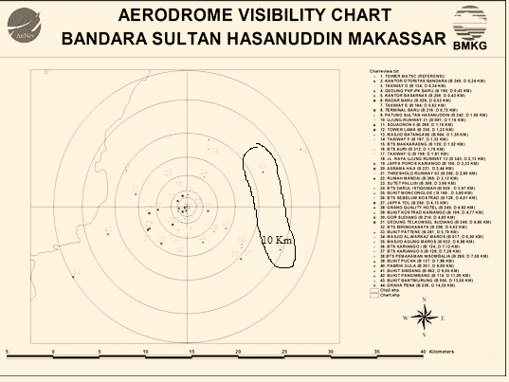

**Image 1** Aerodrome Visibility Chart

## 2.2. Sample Data

The sample data of visibility observation that is used here is the sample data taken with surface meteorological observation (synoptic) approach. Visibility observation made in an open space without hindrance, the visibility that is observed in all directions and the horizontal distance reported is the closest/shortest one [9]. The image data is taken every hour. Data sample that is used is in the form of three pieces of digital images taken at the same time when the observer is executing the meteorological observations. The three images that are taken have to represent a 180o area on visibility aerodrome chart from Northeast to Southwest. The sample datas from three points A , B and C can be seen in Figure 2 below:

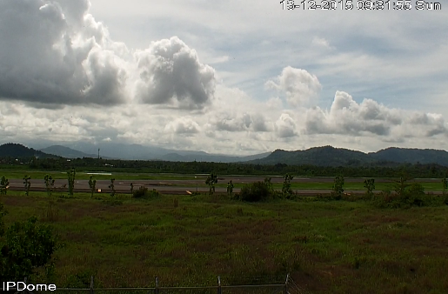 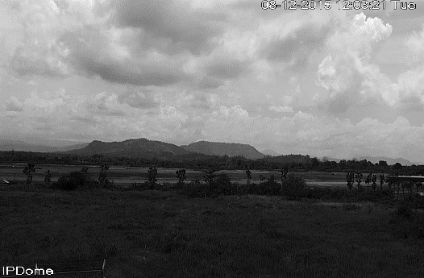

1. (b)

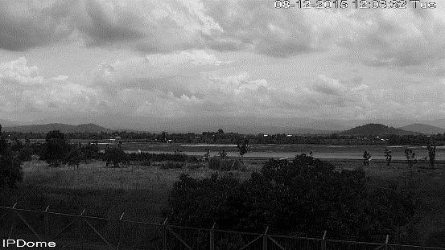

(c)

**Image 2** (a) Image in point A (b) Image in point B dan (c) Image in point C

## 2.3. Preprocessing

Preprocessing stages of the first stage before Data enters the feature extraction process. In the process of shooting,the resulting image size 1.280 x 720 pixel. To reduce the computational load then input image data is cut to parts that are not needed, then reduced to a cutting results 640 x 66 pixel. Color Image data is converted to image grayscale to fasilitate the processing of data as described in [10]. Figure 3 below shows the change image before and after prepocessing process.

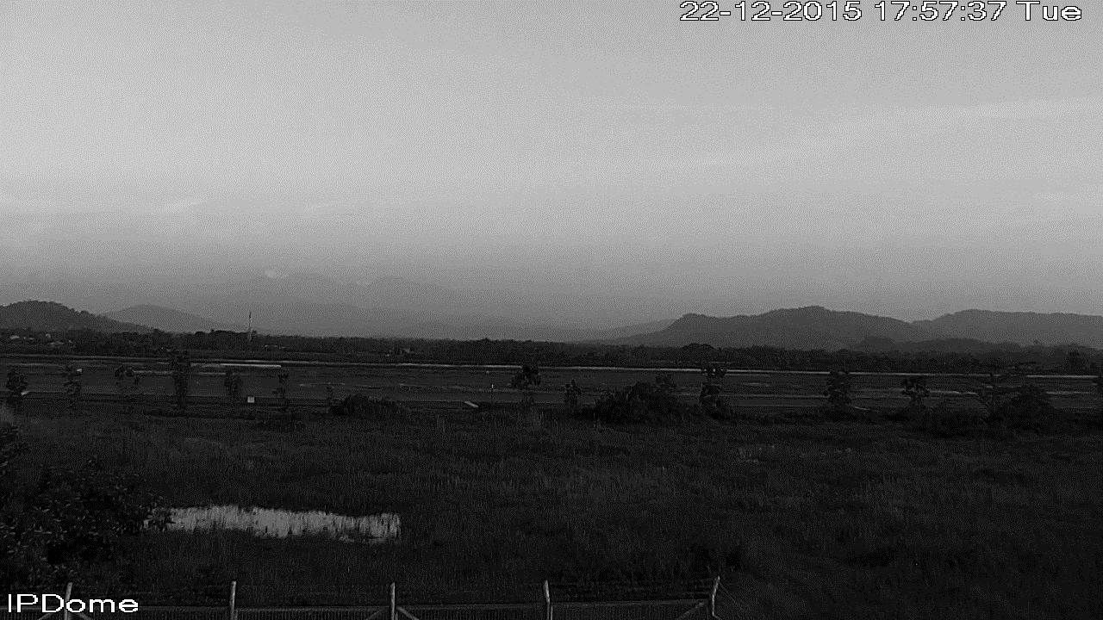

(a)



**(b)**

**Image 3** (a) Image before prepocessing dan (b) Image after prepocessing

## 2.4. Feature Extraction with histogram method

Image histogram is a diagram illustrating the frequency of each intensity value appears throughout the image pixels [11]. A great value states that the value of such intensity often arises. Feature extraction with histogram method is to change the original image into level 256 bin grey image. Every nine frequencies sequentially calculated and stored in vector form for comparison between the training images and test images. Training images and test images are distinguished by piece every nine bin. The set of average values is calculated to determine the absolute difference between corresponded training data and test data. The process of feature extraction with cutting histogram can be seen in figure 3 below

 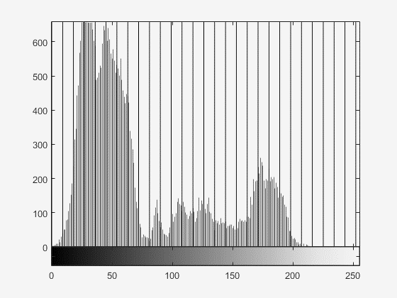

(a) (b)

**Gambar 4** (a) Citra jarak pandang 10 km dan (b) histogram pada citra

## 2.5. Phase Only Correlation Method

Phase Only Correlation method or POC is a method of matching two pieces of the image based on the value of its phase. The image in the spatial domain is transformed into the frequency domain to take the value of its phase [5].

Example, there are two images with size of *N*1 x *N*2 , where *f(n1,n2)* and *g(n1,n2)* assumed that the index ranges are *n1 = -M1...M1 (M1 > 0)* dan *n2* *= -M2...M2 (M2 > 0)* to simplify mathematically *N1 = 2M1* + 1 dan *N2* =2M2. Shape Discrete Fourier transform of both images is expressed [5] with:

$$F\left(k1,k2\right)= \sum_{n1n2}{f(n1,n2)W_{N1}^{k1n1}}W_{N2}^{k2n2}$$

${= A}_{F}(k1,k2)e^{jθF(k1,k2)}$ (1)

$$G\left(k1,k2\right)= \sum_{n1n2}{g(n1,n2)W_{N1}^{k1n1}}W_{N2}^{k2n2}$$

${= A}_{g}(k1,k2)e^{jθG(k1,k2)}$ (2)

With k1= -M1, ...,M1, k2= -M2, ..., M2, WN1 =, WN2 =, and operator ∑n1,n2 , , AF(*k1,k2*) and Ag(*k1,k2*) are components of the amplitude and $e^{jθF(k1,k2)}$ dan $e^{jθG(k1,k2)}$ are phase components. While the cross spectrum RFG *(k1,k2)* is represented by the formula:

$R_{FG}\left(k1,k2\right)= \frac{F(k1,k2)\overline{G(k1,k2)}}{\left|F(k1,k2)\right.\overline{G(k1,k2\left.)\right|}}$

$=e^{jθ(k1,k2)}$ (3)

With $\overline{G(k1,k2)}$ declaring the complex conjunction of θ(k1,k2) = θF(k1,k2) – θG(k1,k2) and G(k1,k2). POC function Ȓ(k1,k2) and is formulated as follows

$ȓ\left(n1,n2\right)= \frac{1}{N1N2}\sum_{k1k2}{Ȓ(k1,k2)W_{N1}^{-k1n1}}W_{N2}^{-k2n2}$ (4)

dengan $$\sum_{k1k2}{Mendefinisikan }∑_{k1= -M1}^{M1} ∑_{k2= -M2}^{M2}$$

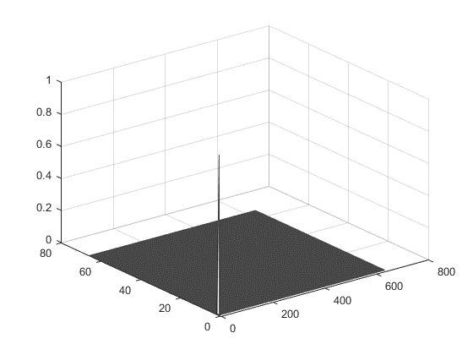



1. (b)

**Gambar 5** (a) Example of POC function with 2 identical images and (b) Two images visibilities are equally 10 km each

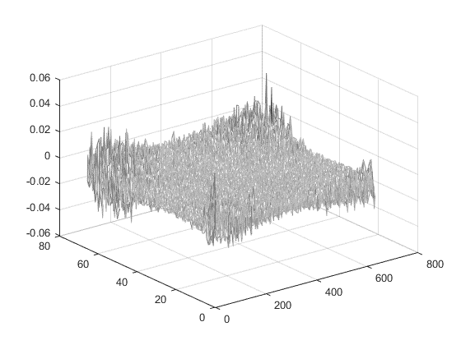





1. (b)

**Gambar 6** (a) Example of POC function with 2 different images and (b) Visibility image of 10 km and visibility image of 2 km

From the POC function contained in the equation 4 produces a clearly peak difference in the recognition of estimated visibility application when the two images are identical as shown in Figure 5 (a). When the two images are not the same then the peak will fall significantly as shown in Figure 6 (a). To assess the similarity between the two images POC function becomes more accurate than the usual correlation function.

## 2.6. The recognition of visibility by using the histogram and the POC methods

The recognition of visibility using the histogram and the POC methods begins with the image training process. The image visibility datas at observation points A, B and C are taken every 1 hour alternately with the time difference of shooting at point A to B and B to C intermittent 10 seconds in average. The process of training with grey image in 256 levels of bin at each observation point A, B and C. The frequency of each bin is calculated and stored in vector form to be processed. Every nine frequencies sequentially calculated and stored in the form of another vector to be used in the test phase. The set of average vectors is calculated to determine the absolute difference between training images and test images. The minimum difference shows the identification of suitability between class and test data. Training flow data can be seen in the block diagram below

Compare POC values with cut off value for verification

Calculate frequency of every bin of test image

Calculate mean of consecutive nine frequency of test image

Compare the means of test image with all trained matrix mean value of training algorithm

Identify the images with minimum absolute difference

Calculate POC values with that identified image

Calculate frequency of every bin and store in matrix

Training 5 image from every class (9)

Calculate mean of consecutive nine frequency and store in matrix for comparison

(a)

(b)

**Gambar 6** (a) Diagram blok proses training dan (b) Diagram blok proses uji

## 2.7. Validation

Ones the design system is done, The next process is to evaluate the performance of the system with calculating the level of accuracy. The validation method used is by comparing the results of the test system with the synoptic observations at Hasanuddin Makassar Meteorology Station. If the viewing distance between 10 km to 2 km shows the suitable class or the class below, then that means the test data is correct. Test data that shows the class below is considered correct because it can reduce the risk of accident and improve the safety of air transport.

The level of accuracy referred above can be described as follows:

$accuracy rate \left(\%\right)= \frac{Correct test data}{All of test data}$

**3.**  **Results and Discussion**

In this experiment, the sample images were taken with the camera PTZ (Pan Tilt Zoom) IPC-SD621ME-IR at a height of 8 m of land. The size of the images used for training data and test data is 640x66 pixels with a 3-point observation, namely A, B and C, where in each observation point there are 45 training images and 45 test images. There are nine visibility classifications, from 2 km till 10 km. So the total in the database, there are 9 X 10 X 3 = 270 images. The system was tested with a MATLAB 2015 program with specifications : Core i-3 processors, 1.9GHz and 4 GB of memory. The process took 33,98 second training and test process took 9.67 seconds.

The table below is a test result data of identification system visibility

**Tabel 1** System Testing result



In table 1 system testing result, we can see that the test data shows good results at the visibility 4 km until 10 km, there is one fail at 7 km at the observation point B. While the visibility 2 km and 3 km there are a lot of mistakes , ie each two errors in each data class. The accuracy of the results obtained from the test system reached 96.3 %

**4.**  **Conclusion**

In this study, Histogram method dan POC very well applied in visibility 10 km until 4 km. But for visibility 3 km dan 2 km it is less suitable method, because of many errors. The camera position is often shifted due to the strong winds that make the picture slightly shifted. To produce the good image, the camera should be regularly cleared from rain splash.

In the future , this research can be developed to improve accuracy and also combine other algorithm to correct the current research I have done.

**5 Reference:**

[1] Meteojuanda, Tentang meteorologi. Stasiun Meteorologi Juanda, <http://meteojuanda.info/index.php?option=com_content&view=article&id=36&Itemid=34>, (8 may 2016).

[2] Hautiere, N., Bigorgne, E. & Aubert, D., Day time visibility range Monitoring thought use of a roadside camera, Intellegent vehicles symposium., pp. 470-475, 2008.

[3] Zhou-zheng, C., Jia, L. & Qi-mei, Chen., Real time video detection of road visibility condition, World Congres on Computer Science and Information Engineering,. Pp. 472-476, 2009.

[4] Ming-wei, A., Zong-liang, G., Jibin, L. & Tao, Z., Visibility detection Based on traffic camera imaginary, Information Sciences and Interaction Sciences (ICIS), pp. 411-414, 2010.

[5] Koichi, I., Nakajima, H., Kobayasi, K., Aoki, Takafumi. & Higuchi, T., A Fingerprint Matching Algoritm Using Phase-Only Correlation, Application and Implementations of Digital Signal Processing. 2010.

[6] Fazl-e-Basit, Javed, M.Y. & Qayyum., Face recognition using processed histogram and phase-only correlation (POC), international Conference Emerging Tecnologies., pp. 238-242, 2007.

[7] International Civil Aviation Organization, *Operation of Aircraft*, Annex 6 to the Convention on International Civil Aviation, ICAO, Montreal, July. 2010.

[8] Website Stasiun Meteorologi Ahmad Yani, Visibility, Stasiun Meteorologi Ahmad Yani, www.cuacajateng.visibility.html, (23 agust 2015).

[9] Djakiman, Materi pengamatan/ observasi meteorologi permukaan, AMG-JAKARTA, 2014.

[10] Widyaningsih, M., Identifiksi kematangan buah apel dengan gray lavel co-occurrence matrix (GLCM), Jurnal saintekom, Vol.6, pp.71-88, March.2016.

[11] Abdul kadir, *Dasar Pengolahan Citra dengan DELPHI* , Ed. 1, Penerbit Andi Yogyakarta, 2013.