Reconfigurable Analog Fuzzy Controller Design
Part 1: Fuzzifier Circuit

Faizal A. Samman ¹, Rhiza S. Sadjad ²

Department of Electrical Engineering – Hasanuddin University
Jl. Perintis Kemerdekaan Km. 10 Makassar 90245
E-mail: faizalas@engineer.com ¹, rhiza@unhas.ac.id ²

Abstract – Reconfigurable membership function circuit using MOS analog electronics is presented in this paper. Fuzzification circuit, which is also called membership function circuit, is very important in fuzzy logic controller circuit. It has function to fuzzify or convert a crisp input into fuzzy input based on membership function of fuzzy linguistic term related to the input. This paper proposes fuzzification circuit, which can be reconfigured in term of its membership form, as well as its membership location in universe of discourse of the input voltage domain. Those main features result in flexible membership function circuit and place the circuit functions in wider application areas. This paper is the branch of the project to design analog fuzzy logic controller chip resembling standard-cell-like technique as in digital design technology, where membership function circuit is one of the important cells in the chip.

Keywords: Fuzzy logic circuit, Fuzzification circuit, electronic design, circuit simulation.

- Introduction

Fuzzy Logic Controller (FLC) as one of the intelligent control systems has been extensively used in some electronic equipment such as in air conditioner, vacuum cleaner, rice cooker, washing machine, and as automatic transmission controller and cruise control in automotive. FLC has also intensively applied in process control system both in evaporation control and distillation control. FLC applications in chemical process are for examples in sterilizing process of CPO (crude palm oil) production, pH control in pharmaceutical production, food processing, and so on. Even fuzzy controller is suitable to handle chemical process control with multiple distillation columns.
In industrial practices, fuzzy logic is used especially in the systems that have complicated mathematical model even in the system whose model is extremely difficult to be derived. As an alternative and non-conventional control system, fuzzy logic controller emerges not to replace or eliminate all conventional control system. Sometimes fuzzy controller is used to complement an existing PID controller, where FLC control the parameters of the PID controller, or supervised PI, PD or PID control action signals. This experiment has been investigated in reference [8]. This paper is part 1 of three parts. Part 2 will discuss reconfigurable fuzzy inference circuit, and part 3 will discuss defuzzifier circuit. In this paper, fuzzifier circuit for FLC architecture of two-input one output (discussed topics in this paper) will be presented. Both input1 and input2 have three membership functions. The basic theory of the topics such as fuzzy sets, fuzzy terms, and membership function will be briefly described.

  - Fuzzy Sets

In classical set theory, which is based on bivalent logic, a number or object is either a member of a set or not. For example, an object is either big or small. In theoretic terms, it says that the same object cannot simultaneously be a member of a set and its complement. With fuzzy set theory, an object can be a member of multiple sets with a different membership degree of membership in each set. It might be able to allow the same object be considered “big” to some degree and be considered “small” to another degree. The degree of membership of an object in a fuzzy set expresses the degree of compatibility of the object with the linguistic term represented by the fuzzy set

  - Fuzzy Linguistic Term

A linguistic term is characterized by its term set. The linguistic term weight can be defined by the term set T in the following way: T(weight)={heavy, medium, light}. T(weight) denotes the term set of weight, that is, the set of names of linguistic values of weight, with each value being a fuzzy variable, ranging over a universe of discourse.
Three to seven terms are often appropriate to cover a linguistic term. Rarely, one uses less than three terms, since most concepts in human language consider at least the two extremes and the middle in between them. On the other side, one rarely uses more than seven terms because humans interpret technical figures using their short-term memory. The human short-term memory can only compute up to seven symbols at a time. Another observation is that most linguistic variables have an odd number of terms. This is due to the fact that most linguistic terms are defined symmetrically, and one term describes the middle between the extremes. Hence, most fuzzy logic systems use 3, 5, or 7 terms.
Fuzzy linguistic terms can be of several types:
- fuzzy predicates, such as heavy, large, old, small, medium, normal, expensive, near, smart, and the like;
- fuzzy truth values, such as true, false, fairly true, or somewhat true;
- fuzzy probabilities, such as likely, unlikely, very likely, or extremely unlikely;
- fuzzy quantifiers, such as many, few, most, or all.

  - Membership Function and The Fuzzification

For a continuous variable, the degree of membership is expressed by a function called membership function. The fuzzy concept (or linguistic term) “level” is represented by the fuzzy sets (or terms) “low”, “medium” and “high”. And The fuzzy concept (or linguistic term) “speed” is represented by the fuzzy sets (or terms) “slow”, “medium” and “fast”. The membership functions of the terms of level and speed are represented in figure 1(a) and 1(b) respectively. The functions show the degree of membership with which a person belongs to the fuzzy sets low, medium, high, slow and fast. The membership function Low assigns to each element, x (Input 1), of the universal set X, a number, μ_{low}(x), which characterizes the degree of membership of the element in the fuzzy set Low, as in equation (1).

$\text{Low}=\left\{x, μ_{\text{LOW}}\left(x\right)| x|X\right\}$ (1)

The degree of membership in a normal set is based on a scale from 0 to 1, with 1 being complete membership and 0 being no membership. At 80 km/s speed and below, a vehicle does not belong to the class fast. At 150 km/s and above, a vehicle speed fully belongs to the class fast. Between 80 km/s and 150 km/s the membership increases linearly between 0 and 1. The membership function is not limited to values between 0 and 1.

- Membership Function Circuit

In general, Fuzzy logic controller hardware consists of three main components:
- Membership function circuits, or fuzzifier components.
- Fuzzy inference mechanism circuit.
- Defuzzification circuit.

In this part 1 of the paper, we will mainly concern with membership function circuit (MFC) or fuzzification circuit. Before fuzzy inference process is undertaken, signals from sensor devices in crisp values are fuzzified by MFC to be fuzzy values. The fuzzy values are taken from the grade values related to any membership form of the crisp inputs. The understanding of fuzzy sets is basic knowledge to surf the fuzzy logic theory. Reference [1] and [4] give basic explanations of fuzzy sets and fuzzy logic theory. Figure 1 shows fuzzy sets or membership function of the input terms, and it also shows how fuzzified inputs are calculated from its related membership forms.
Input 1 has three membership functions called low, med and high. And Input 2 also has three membership functions called slow, med and fast. The form and the number membership functions can be freely specified by the user/designer. However, the emerging of adaptive neuro-fuzzy system makes the membership forms of the FLC are specified by itself through training the input-output data of system/plant to be controlled.

(a)
(b)

Fig.1. Fuzzification processes for each fuzzy term of input 1 and input 2.

For every one crisp signal of the input 1 in the universe of discourse, the MFC will give three fuzzified values in accordance with the three membership function forms. This process is also valid for input 2. As shown in figure 1, MFC will give μ_{low}(In1), μ_{med}(In1) and μ_{high}(In1) for input 1, and μ_{slow}(In2), μ_{med}(In2) and μ_{fast}(In2) for input 2. Thus fuzzy logic controller architecture as shown in figure 2, the MFCs will feed six fuzzified inputs (MFC outputs) to nine minimum operation circuit of the fuzzy inference circuit, three signals from input 1 and three signals from input 2. Each one signal from MFC output will be fed together with one from another MFC to two-input min circuit.

Fig.2. The architecture of the proposed programmable analog fuzzy logic controller, colored/in dashed line box components are the scope of this paper.

Figure 3 shows the general criteria for membership form. There are four membership types and they have their own criteria. The four membership forms are S-form, Z-form, trapezoidal and triangle form. MFC is constructed by two-pair differential amplifier configuration coupled with two-stage level shifter circuit.

Fig.3. General criteria for the shape of the membership-function circuit.

Based on figure 3, parameter T or the half-length of membership slope is determined by following equation:

$\begin{aligned}T_{j}=\sqrt{\frac{2I_{\text{ss}}}{β_{j}}}, \\ j=\text{diffrensial} \text{pair} j^{\text{th}} \\ β=\text{conductance} \text{parameter} \text{of} \text{NMO}S\end{aligned}$ (1)

If triangular function is preferred then following equation must be fulfilled

$\begin{aligned}{\text{Vref}}_{1}+T_{1}={\text{Vref}}_{2}−T_{2}, \\ \text{if} T_{1}=T_{2} =T, {\text{Vref}}_{2}={\text{Vref}}_{1}+2T\text{.}\end{aligned}$ (2)

If trapezoidal function is preferred then following equation must be met.

$\begin{aligned}{\text{Vref}}_{1}+T_{1}< {\text{Vref}}_{2}−T_{2}, \\ \text{if} T_{1}=T_{2} =T, {\text{Vref}}_{2}>{\text{Vref}}_{1}+2T\text{.}\end{aligned}$ (3)

If Z-form function is preferred then I_{SS1}=0, and if S-form function is required then I_{SS2}=0.

The circuit shown in figure 4(a) has output range between 4 to 5 volts. Therefore, two-stage level shifter circuit as in figure 4(b) is coupled to the output of MFC circuit. Thus the result will give MFC that gives ideal range of membership grade, i.e. the output with range between 0 to 1 volts.

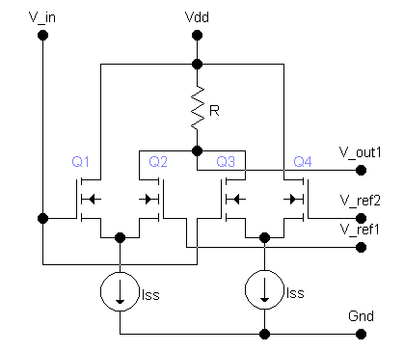
(a)
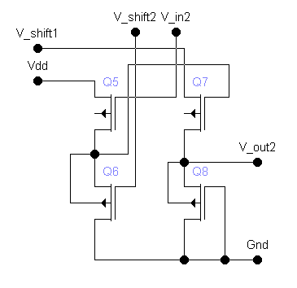
(b)
Fig.4. (a) Two-differential amp pair of MFC schematic, (b) two-stage level shifter circuit.

- Simulation Results

In this section, the simulation results of the MFC will be described. Figure 5(a) and 5(b) exhibits triangular and trapezoidal membership function forms with different slope references performed by the MFC. The trapezoidal form is obtained by setting V_{ref1} somewhat further than V_{ref2}. And the triangular form is obtained by setting V_{ref1} quite close to V_{ref2}. However, criteria as in (2) and (3) must be concerned.

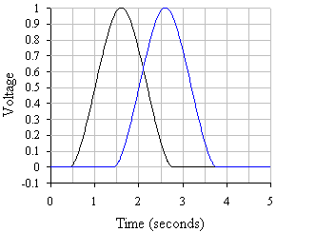
(a)
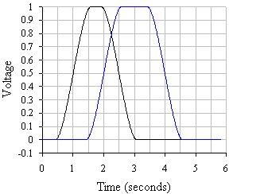
(b)

Fig.5. (a) The triangular and (b) trapezoidal forms.

Figure 6 shows the S-form and the Z-form membership function respectively with different reference voltages. The S-form is obtained by setting I_{ss1}=0, thus differential pair 1 does not work, and V_{ref2}=2 V (left-side curve) and V_{ref2}=3 V (right-side curve). And the Z-form is obtained by setting I_{ss2}=0, thus the differential pair 2 does not work, and V_{ref1}=2 (left-side curve) and V_{ref1}=3 V (right-side curve).

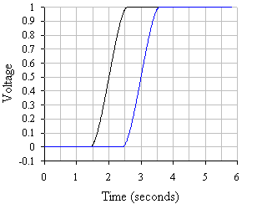
(a)
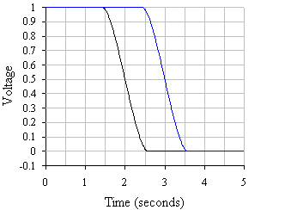
(b)

Fig.6. (a) S-form and (b) Z-form membership function.
Figure 7(a) shows the triangular membership function forms with different slopes. The inner curve shows membership function with transconductance parameter β=0.00003 A/V², as well as V_{ref1}=2.4 V and V_{ref2}=3.6 V. And the outer curve shows another form with transconductance parameter β=0.00001 A/V², as well as V_{ref1}=2 V and V_{ref2}=4 V.
Figure 7(b) shows the S-forms with different slopes, but they have the same reference voltages, i.e.V_{ref1}=2 V. Figure 7(c) shows Z-forms with different slope, but they have the same reference voltages, i.e.V_{ref2}=3 V.

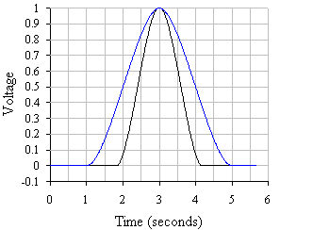
(a)
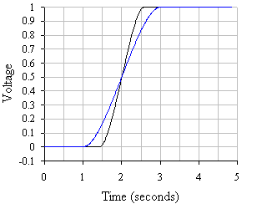
(b)
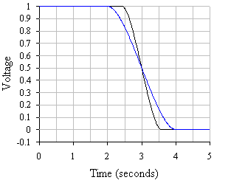
(c)

Fig.7. (a) Triangular forms (b) S-form, and (c) Z-form membership function with different slopes.

- Concluding Remarks

Membership function circuit (MFC) proposed in this manuscript comprises two-pair of differential amplifier configuration with its output is coupled with two-stage level shifter configuration, thus it gives ideal membership function output range between 0 to 1 volt. The MFC can be programmed or reconfigured by sending external signals to the MFC, which adjusting its membership function type, membership center location in the universe of discourse and the slope of the membership function form.
Because of using metal oxide silicon (MOS) transistors and less-resistor, the MFC is suitable to be implemented in an IC (integrated circuit). The MFC also utilize small number of MOS, thus the full-costume IC design technique is of a little problem. Full-costume IC design gives high performance IC product. The circuit layout is not presented in this paper, for readers who familiar with IC layout will not have problem to design and simulate it layout results. Then comparing the results with ones presented in section 3 of this paper.
The study and analysis about power consumption and the processing speed of the circuit is not presented. The quantitative and qualitative analysis about both performances is important and open to the following researches of this paper.

References:

[1] Brown, M., Harris, C.: Neurofuzzy Adaptive Modeling and Control. Prentice-Hall, New Jersey, 1994.
[2] Guo, S., Peters, L., Surmann, H.: Design and Application of Analog Fuzzy Logic Controller. IEEE Trans. on Fuzzy Systems, Vol. 4, No. 4, Nov. 1996.
[3] Hollstein, T., Halgamuge, S.K., Glesner, M.: Computer-Aided Design of Fuzzy Systems Based on Generic VHDL Specifications. IEEE Transactions on Fuzzy Systems, Vol. 4, No. 4, Nov. 1996
[4] Jamshidi, Moh., Vadiee, N., Ross, J.T.: Fuzzy Logic and Control, Software and Hardware Applications. Prentice-Hall, New Jersey, 1993.
[5] Manaresi, N., Rovatti, R., Franchi, E., Guerrieri, R., Baccarani, G.: A Silicon Compiler of Analog Fuzzy Controller: From Behavioral Specifications to Layout. IEEE Transactions on Fuzzy Systems, Vol. 4, No. 4, Nov. 1996
[6] Marshall, G.F., Collins, S.: Fuzzy Logic Architecture Using Subthreshold Analogue Floating-Gate Devices. IEEE Trans. on Fuzzy Systems, Vol. 5, No. 1, Feb. 1997.
[7] Tsukano, K., Inoue, T.: Synthesis of Operational Transconductance Amplifier-Based Analog Fuzzy Functional Blocks and Its Application. IEEE Trans. on Fuzzy Systems, Vol. 3, No. 1, Feb. 1995.
[8] Li, Han-Xiong: A Comparative Design and Tuning for Coventional Fuzzy Control, IEEE Trans. On Systems, Man and Cybernetics – Part B: Cybernetics, Vol. 27, No.5, Oct. 1997.

