April 10, 2009.

LETTER OF RECOMMENDATION

To Whom It May Concern:

Ms. Yunita Rachmuddin, S.T. has asked that I prepare this official Letter of Recommendation to support her intention to continue her study to pursue a Masters Degree in Automatic Control, Industrial Automation, Process Control Technology, or other related fields of study at your university. I do so with great enthusiasm.
Ms. Yunita Rachmuddin completed her first degree in the Department of Electrical Engineering, Hasanuddin University, Makassar, INDONESIA, where I myself have been with since 1983. Ms. Yunita Rachmuddin was one of the best students; she was graduated in 2004 with the GPA of 3.17 out of 4.00. I supervised her undergraduate final project on modeling and simulation of a tele-robotic system. This is an advance project in industrial robotics, automation and control. Her experience working on this project was very valuable for her future career as an engineer at a nickel mining and processing plant.
During her tenure as my student from 1999 to 2004, she took almost all my classes in the area of Automatic Control Systems and Industrial Electronics. She always made excellent grades. After her graduation, she applied for an engineering position in a prominent nickel mining company, PT. INCO, South Sulawesi, Indonesia. She was appointed as an Instrumentation and Control engineer at almost no time, and continuously works in this field since then.
I have been so thoroughly impressed by Ms. Yunita Rachmuddin’s personality as well as her technical competence in her field, and that she shows a strong motivation to continue her study and to seek knowledge, I wholeheartedly recommend her for any opportunity to pursue a higher degree program in her field.
Should you wish any further information, please feel free to contact me, and I will gladly respond to your inquiries.

Sincerely Yours,
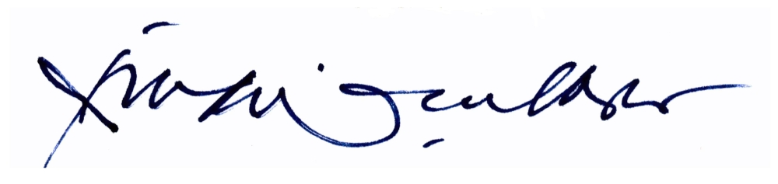

Rhiza S. Sadjad, Ir., M.S.E.E., Ph.D.

