October 1, 2005

LETTER OF RECOMMENDATION

To Whom It May Concern:

Ms. Cahyana, S.T. has asked that I prepare this official Letter of Recommendation to support her intention to continue her study to pursue a Masters Degree in Electrical and Computer Engineering, Computer Science, Information Technology or other related area. I do so with great enthusiasm.

About four years ago, Ms. Cahyana completed her first degree in the Department of Electrical Engineering, Hasanuddin University, Makassar, INDONESIA, where I myself have been with since 1983. Ms. Cahyana was one of my best students. She took all of my classes, mostly in Automatic Control and Linear Systems area, and as I remember it, she was almost always among the top 10% students in my classes. As a laboratory assistant in our Basic Electrical Engineering Laboratory, Ms. Cahyana was among a very few students who were trusted to supervise her fellow students to do experiments to strengthen their fundamental knowledge and skills in Electrical Engineering. With this experience, she apparently had chosen teaching as a career. She might have chosen a job in industry, so this clearly showed the quality Ms. Cahyana has in her personality as well as her strong motivation to seek knowledge. This also shows how much she values education.

Ms. Cahyana had her study program in our Department very well planned, and had her undergraduate final project well in mind. I supervised her undergraduate final project, which was a unique project related to the development of the state-owned electrical power company’s on-line billing system. This was a very sophisticated programming work, and Ms. Cahyana has demonstrated that she has all the skills needed to complete the project successfully in a relatively very short time, with a good collaboration with her partner. She came to see me regularly to show the progress of her work, and in all these encounters she showed her openness to suggestions and an eagerness to engage in professional discussions that could enhance her understanding of the subject she is interested in. I see in her the many qualities of both an excellent engineer and an enthusiastic researcher.

I have been so thoroughly impressed by Ms. Cahyana’s technical competence in her field, and that she showed a strong motivation to continue her study, I wholeheartedly recommend her for any opportunity to pursue a higher degree program in her field.

Should you wish any further information, please feel free to contact me, and I will gladly respond to your inquiries.

With kindest regards,
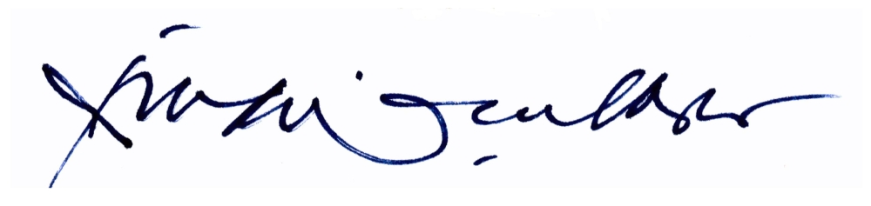

Rhiza S. Sadjad, Ir., M.S.E.E., Ph.D.

