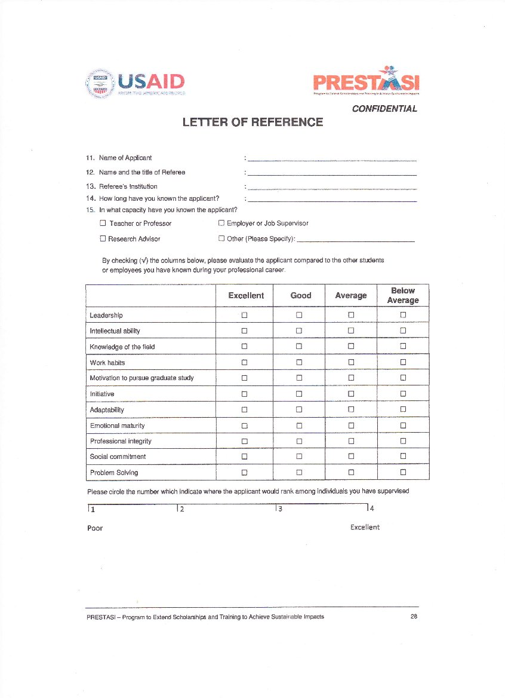
Misbahuddin Azis, S.Kep.
Rhiza S. Sadjad, Ph.D.
Hasanuddin University MAKASSAR, Indonesia
Since 2005
✓
Partner in Social Works
✓
✓
✓
✓
✓
✓
✓
✓
✓
✓
✓
✓3.75

