Researches in the Fields of Energy, Control, Electronics and Computer, Telecommunication and Informatics at UNHAS: Trends and Challenges

#E. Palantei¹, R.S. Sadjad², M. Anshar³, Indrabayu A.⁴, N.N.R.A. Makobombang⁵, N.Harun⁶, A. Suyuti⁷, and Z. Zainuddin⁸
¹⁻⁸ Electrical Engineering Department, Faculty of Engineering, Hasanuddin University (UNHAS)
Jl. Perintis Kemerdekaan Km.10 Tamalanrea, Makassar
¹ elyas_palantei@unhas.ac.id, ² rhiza@unhas.ac.id, ³anshar@unhas.ac.id, ⁴indrabayu@unhas.ac.id, ⁵novy@unhas,.ac.id, ⁶n_harun@unhas.ac.id, ⁷ansar_suyuti@unhas.ac.id, and ⁸zahir@yahoo.com

1. Introduction

This document gives formatting instructions for authors preparing manuscripts for IWoRMEE2009. This format was adopted from ISAP template. The authors must follow the instructions given in this document. Entire document should be in Times New Roman Font with single space.

2. Recent Study on Energy and Electrical Power Engineering

2.1 Renewable Energy Study

The research project, on the development of the electric power generation to utilize the available renewable energy on a remote area, is under development at the Centre of Renewable Energy Study (CRES), Electrical Engineering Department, Hasanuddin University. The research is very important for the sustainability of the electric power supply to all people living at the isolated region such as highlander, islanders and remote villagers throughout South Sulawesi province. The main goal of the research is to assembly a prototype of the low cost, stable, and easy of installation, operational and maintenance of the power generation system. This activity is a very urgent need especially on the actual situation where the world life facing the energy crisis for several times, even in the future. The research on this area was initially introduced at the Electrical Engineering Department since [N. Harun, 2002] successfully completed his Doctoral degree from the Postgraduate Faculty, Hasanuddin University. The extension of this study was reported in [N. Harun and E. Palantei, 2002]. A number of the similar researches have been consistently developed after this era.

[Suyuti et al., 2008-2009] elaborated some factors that cause the electricity crisis in South Sulawesi province such as: firstly, mismatching between the improvement of the electrical power supply capacity (which is only 3.5 % per year) and power consumption demand (which is about 7% per year). There is a trend that the increasing of power consumption is not linear comparing to the availability of the energy power supply; secondly, there is no development of new power generation station for along period that also become the main cause of the instability of power supply. To provide sufficient supply the development of new power station is compulsory; thirdly, on several areas at South Sulawesi province some power generation systems are relied on the fuel energy, for instance PLTD Suppa using diesel machines to generate the electricity power. The fuel energy is unrenewable resources. It has limited availability in the future.

Considering those crucial problems, some researchers collaborated within CRES group are conducting the studies on the development of hybrid power generation system which optimally utilize the availability of the local renewable energy reseources. Recently, the study of hybrid power generation prototype is capable to generate the electricity capacity less than 1,5 k Watt . This hybrid power system combined two single-power generators utilizing the local available energy resources such as wind and hydro.

The designed hybrid power generator is going to be expanded to involve other renewable energy resources such as: solar, thermal, and biofuels. Researches on this area are playing the important role as one solution to overcome the crisis on the electricity generation, particularly, in a remote area at South Sulawesi Province. The importance of the researches is not only stimulated by the limited availability of the fuels energy to generate the sufficient electricity supplies to the local people but also forced by the fact that our environment provide us the unlimited and sustainable energy resources, so-called the renewable energy resources. The capacity of the electric power that can be potentially generated from this kind of the energy resources throughout Indonesian archipelagos is depicted in Table 1.

Table 1: Potential and capacity of non fossil fuels in Indonesia (Year of 2000) [Sources: S.M. Simorangkir, Directorate General of Electricity and Energy Utilization: Pemanfaatan Energy, 2002, p.1, and Center for Energy Study University of Indonesia: Indonesia 2002 Energy Outlook & Statistic, 2002
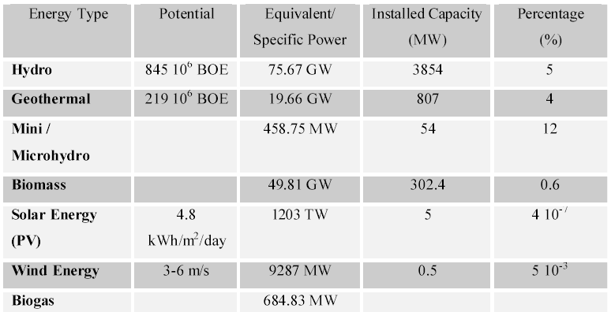

To implement the designed hybrid power generation system, our research activities are divided into three main sub-activities including field surveys, prototyping and installation of hybrid power generation system and field-testing (testbed system). It is expected that the research will gain a great success to build the prototype of the renewable hybrid power generation that will be capable for sufficiently supplying the electric power to the people of particular isolated area.

2.2 Costs Optimisation

2.3 Study on Power System Stability

3. Advanced Researches in Control, Computer and Electronics Fields

Headings must be in 14 pt bold. There must be a line gap before and after main headings.

3.1 Introduction to AI Robotics

Since the appearance of Artificial Intelligence (AI) for the first time which was coined by John McCarthy, the study of AI has become a fruitful research area. Through vast achievement of this area, humans life have significantly benefit from. Let say, in robotics field, the implementation AI has been greatly improved and this area latter known as Artificial Intelligent Robotics (AI Robotics).

Currently, AI Robotics is one of research field which has forged the advancement of robot technology. However, in particular Indonesia region, there is a very limited research effort dedicated to AI robotics. Hence, through this paper, we encourage more research effort emerges in this area. Implementation of AI Robotics typically focuses on autonomy aspect as the essential element of an intelligent robot. As an introduction, this paper briefly describes the so-called robotic paradigms.

In the book of Introduction to AI Robotics by Murphy, R.R., the author describes the three commonly accepted primitive of robotics which are sensing, planning and actions. These three primitives play a major role in the functionality of robots and latter, the robotic paradigms are strongly link to each primitive. The first is hierarchical paradigm in which the functionality of robots refers to the primitives of robotics in sequence. In other words, the robot senses the world, makes the plan for the next action, and then executes (sense-plan-act). The second one is reactive paradigm. In this paradigm, functionality of the robot is organized based on the sense-then-act type. No plan entity is involved, only sensor information will directly execute an action. The last paradigm is hybrid deliberative/reactive which is emerged in the 1990’s. The organization of this type is that the functionality of robot is firstly initiated with plan and then followed by the sense-then-act paradigm. In other words, the plan is carried out at first step followed by the sensing and acting together. These three paradigms and primitives play a major role as one fundamental element of AI Robotics.
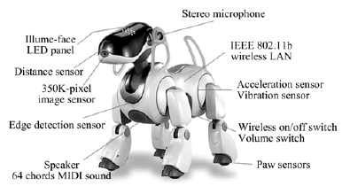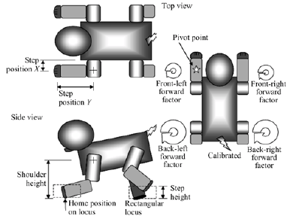
Figure xx: [Adopted from M. Anshar and M-A. Williams, 2007]

3.2 Sensor Networks

4. Telecommunication and Information Engineering: Current Studies and Future Directions

As the growth of research in telecommunication and the need of interdisciplinary among study programs, the future of TIE or I would say Multimedia Telecommunication program would be divided into three major programs i.e. Wireless Telecommunication, Multimedia Signal Processing, and Multimedia Communication Network.
The elucidating of each major program are as follows:
Wireless Telecommunication
The trend will be mainly on the use of high frequency. The main constraint in wireless is bandwidth and one of the easiest ways to increase bandwidth by shifting the system to higher frequency. However, not only shifting to higher frequency give benefits of bandwidth but also degrading effect particularly fading in wireless.
Currently TIE working on WiMAX (2 – 11 GHz) implementation in Indonesia, particularly in Antenna Issues. Some research also conducted on the use of beneficial characteristic of QoS in WiMAX.
Local to Multipoint Distribution System (LMDS) a system that work at 18 – 32 GHz. Current research still investigating on how to implement the system in Indonesia. Rain Fading become the main problem of the LMDS system and unfortunately Indonesia is a tropical country with high rain fall rate. Research on Channel Coding, Adaptive Modulation, diversity, MIMO, etc will be crucial to the LMDS system.
4G and NGN (Next Generation Network) are two topics that will have many attentions among wireless researcher, especially mobile cellular. A change of paradigm which mobile users are now distributed with an IP-based system.

Multimedia Signal processing
In telecommunication area, signal processing more focusing on Watermarking, Steganography, Multimedia recognition (speech, image, video) and last but not least is how to cope with the common enemy of telecommunication i.e. noise.
It is inevitable situation where signal processing is not matter only to telecommunication but also on other focus of study like medical, geology, etc. The finding of wavelet transformation has pushed the researchers to investigate it in medical purposes as the tool for supported diagnoses.

Multimedia Network Communication
Nowadays, people tend to use multimedia in telecommunication. A voice only based conversation will be left behind in the next telecommunication era. Hence, Research in Multimedia Communication is also interesting area that TIE Study program will work on.
Current research working on finding best method in routing, queuing of packet in buffering are conducted in order to achieve a better performance of Multimedia Network i.e. throughput, latency, and jitter. Coding and compression techniques are also crucial in this area which the need of smaller size of data during transmission that can be transformed back into bigger data at the end.
Wireless Ad-hoc is also current topic which TIE program study in. Our Research mainly focuses in the application of routing and identifying object (user) location. In the future, the application of wireless ad-hoc will be on larger enterprise like how to apply it in vehicle, boats and other vehicular objects.

All the research items above can be summarized by the research diagram as follows:

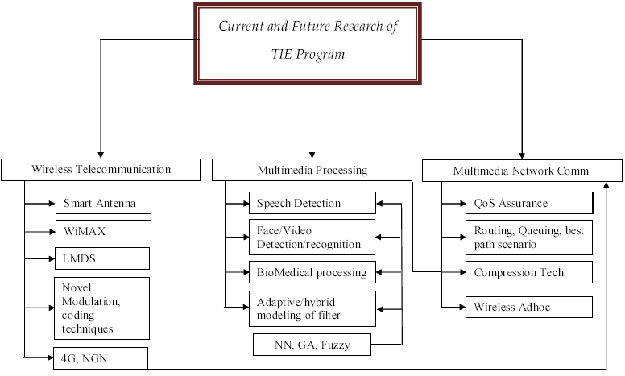

4.2 The importance of telecommunication management
This Summary of Research and Development prospects has been prepared to describe the major plans in which research is moving at the Telecommunication and Technology Informatics (TTI) concentration of Electrical Engineering Department in Hasanuddin University. The document is intended to inform the ideas to fit the plans within the context of TTI concentration.

The Plan focuses on several core objectives:
- building on existing research programs;
- partnering in innovative ways with the governments, industry, and others in developing a knowledge-based emerging telecommunication technology
- maximizing benefits and potential skills from TTI resources;
- expanding interdisciplinary research and development programs within the University, and with researchers outside the University;
- maintaining the flexibility to respond research opportunities;
- maximizing the benefits of research through effective technology and knowledge transfer within lecturer; and
- Expanding undergraduate and graduate programs with research program strengths.

Teaching, research, and artistic activity are central to Hasanuddin University vision and mission and over the next two to five years, TTI must continue to foster excellence in those areas. Based on IDI (ICT Development Index) presentation presented in ITU Seminar, India on May 2009 , Information, Computer and Telecommunications (ICT) technologies continue to evolve in different directions and are now become increasingly important and have significant implications of any aspects in institutions, organizations and companies. For example, wireless and wired networks complemented by a growing range of mobile devices are having a tremendous impact on the ways companies serve customers and run their operations.
With the incredible growth in telecommunications technologies, telecommunication management has become increasingly important in the digital world. Telecommunications penetration, digital divide and the ranging of telecommunication technology such as fixed line voice and data services, Mobile voice and data services, communication usage and spending of SMEs and IP VPN have introduced the important of Telecommunication Management.

In order to reward research innovations, including those that arise through team-teaching and researcher and student, recommended research topics include, but are not limited to, the following:

- Case studies in telecommunications planning and management in telecommunication operator companies, on how services can mitigate imbalance penetration and digital divide among Indonesia islands.
- Challenges and opportunities in telecommunications technologies and applications such as Telecommunication Management Network (TMN).
- Network Management (IP, WDM, 3G/4G, Wireless, Ad-hoc/Mesh, Sensor, Home, Access, NGN, Grid)
- Management System Development (enterprise network, public network, dedicated network, VPN, internet, intranet, mobile network, access network, multimedia network, customer network, VoIP network and integrated management)
- Modeling, designing, deploying, and using networked systems.
- Effects of regulation on telecommunications products and services.
- Issues in Indonesia telecommunications planning and management. Such as pay-TV, submarine cable serving, broadband services and satellite serving Indonesia.
- Telecommunications architecture such as 3.5 G, WiMAX and LTE 3GPP architecture models.
- All other related issues in how the telecommunications planning and management can minimize telecommunication issues in Indonesia.

In conjunction with above R&D themes, consider how TTI management, lecturer, researches and students helping define and advance the plan over the next two to five years. TTI team proactively work with Department, faculty, University and others to gauge the advancement of the research activities accommodating all factors by which excellence can be monitored in each area.

5. Conclusions

Figure captions must be placed below the figures, as shown in Fig. 1. Tables should have caption with the table number before the table, as shown in Table 1. Figure and Table captions are in 11 pt regular.

Acknowledgments

This document was prepared guided in part by the IEICE Document.

Figure 1: SVM Misclassification Rate

Table 1: Font Sizes for Papers
Font Size | Appearance
Font Size | Regular | Bold
11 | Body texts,  equations,  Author Addresses, Figure captions, Table captions | Sub-sub-headings
8 | subscripts, superscripts
12 | Author names | Sub-headings
14 |  | Headings
20 |  | Title

References

[1] A. Author, B. Author, “Title of the paper”, Journal Name, vol. XX, No. NN, pp. 000-999, Year.
[2] A. Author, B. Author, C. Author, Book Name, N-th edition, Publisher, Place, pp.000-999, Year.
[3] A. Author, B. Author, C. Author, D. Author, “Title of paper with only first word capitalized,” Proc. Conference Name, Where, Vol. VV, pp. 000-999, Year.

M. Anshar and M-A. Williams, “Extended Evolutionary Fast Learn-to-Walk Approach
for Four-Legged Robots,” Journal of Bionic Engineering 4 (2007) 255−263. On line available at: www.sciencedirect.com

“A Consideration on the development of Utilizing Renewable Energy for Electricity Generation on Remote Areas as Substitution of Fossil Energy Resources”, N. Harun and E. Palantei. Presented in the International Conference and Exhibition on Energy (ICEE 2002). 29th – 31 July 2002, Jogjakarta. Indonesia.
S.M. Simarangkir, “The Impact of the New Law of Republic of Indonesia Number 20 of 2002 to the Energy Planning In Indonesia,” Master Thesis, University of Flensburg, Germany. E-Mail: sms_sierra@hotmail.com

Hasanuddin University Vision and Mission, taken from http://www.unhas.ac.id/index.php?option=com_content&task=view&id=14&Itemid=33
The ICT Development Index (IDI) presentation by Susan Teltscher, Head of Market Information and Statistics Division, International Telecommunication Union, in Seminar on ICT Measurement and Indicators, New Delhi, India 12-14 May 2009, http://www.itu.int/ITU-D/ict/papers/2009/7.1%20teltscher_IDI%20India%202009.pdf

