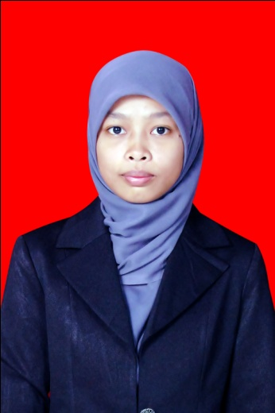4cmae

**AGUSTUS 2009 – SEPTEMBER 2013**

**Hasanuddin University (UNHAS), Indonesia**

**Engineering Faculty – Informatics Engineering**

* GPA 3.54 (Scale 4.00)
* **Thesis** : *“An Analysis of management of industrial machine maintenance by using artificial neural network of feed forward-back propagation (Study case at PT. Semen Bosowa Maros*”

**EDUCATION**

**SKILLS**

**Language**

Bahasa Indonesia (Native)

English (Excellent)

**Computer**

Office Application

*(Word, Excel, PowerPoint, etc)*

Operating System

*(Windows, Ubuntu)*

**Programming Language**

*(C++, Java, PHP, HTML)*

**Framework**

*(CodeIgniter)*

**Data Base**

*(MySql, SQL Server, XML)*

**PERSONAL INFORMATION**

**Date of Birth**

September, 21, 1990

**EMAIL**

rafrinmardhiyyah@gmail.com

**PHONE**

+6285656001671

**ADDRESS**

Jl. Selayar 13 Blok M no. 195

Makassar-Indonesia 90242

**Mardhiyyah Rafrin**

**WORKING EXPERIENCE**

**NOVEMBER 2015 – FEBRUARY 2015**

* **Programmer**

**PT. Docotel Celebes Technology**

*Writing codes and fixing bugs of a start-up/website*

**JULY – AUGUST 2015**

* **Tutor**

**Private**

*Mentoring some students and employees in short course of web based programming*

**FEBRUARY 2014 – JUNE 2015**

* **Web Analysts and Programmer**

**PT. Mandala Mediatama**

*Building web based Information System*

**OCTOBER - NOVEMBER 2013**

– **Web Programmer**

**CV. Trisula Rekacipta**

*Building web application named “Corelog system” to one of the mining corporation in Indonesia.*

**OCTOBER 2012 - JANUARI 2013**

– **Laboratory Assistant**

**Department of Informatics Engineering, Hasanuddin University**

*Assisting a lecturer to teach the student in Object oriented programming subject.*

**JUNE-AUGUST 2012**

– **Internship**

**Center of Technology Information and Communication of Hasanuddin University (PTIK)**

*Responsible for Repository of Hasanuddin University website and made a wiki website of Hasanuddin University*

**OCTOBER 2010 - JANUARI 2011**

– **Laboratory Assistant**

**Department of Informatics Engineering, Hasanuddin University**

*Assisting a lecturer to teach the student in Practice of Computer Programming Basis subject*

**SUMMARY**

* Motivated, strong personality, and detail-oriented
* High-energy, enthusiastic and competitive environments
* Proficient in programming language
* Work well in team and individual

4cm

**NOVEMBER 2010 - FEBRUARI 2013**

– **Private Tutor**

**Private**

*Teaching junior and senior high school students on physics and mathematics*

**ORGANIZATION**

**MARCH 2010 - SEPTEMBER 2013**

**- Member Active**

**Workshop Elektro Fakultas Teknik Universitas Hasanuddin**

*Studying together about IT development and sharing IT knowledge to university students and senior high school students.*

**NOVEMBER 2012 - SEPTEMBER 2013**

**- Editor**

**Neo Electrical Media**

*Responsible to Wall magazine and bulletin publishing, Department of electrical engineering, Unhas*

**MARCH-AUGUST 2013**

* **Staff of Skill and Talent Division**

**Association of Electrical Student**

*Improving and developing university student skills*

**AWARDS**

**JULY 2006 – JULY 2009**

*The grantee sponsored by the Enrekang District Government*

**SEPTEMBER 2009 – AGUSTUS 2012**

*The**grantee of IMHERE (Improvement of Management and Higher Education) Scholarship sponsored by World Bank*

**PRESENT**

*The**grantee of Indonesia Endowment for Education (To pursue postgraduate degree abroad)*