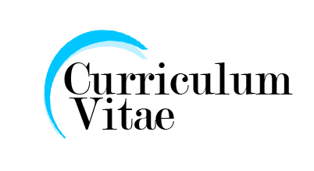
C.V

Omar Salem Addeeb
Libya – Al Shati – Gogam
Tel : Mobile N. 00218910528634
E-Mail : omaredeep2012@yahoo.com

Objective

I worked as a cooperating teacher and taught some different subjects in Sabah University, High Institute of Comprehension Occupations in Sebha, High Institute of Comprehension Occupations in Om Elaranib and University of Letter in Sabah.

Personal Data

Place of birth : Libya
Date of birth : Date of Birth 15-1-1982
Nationality : Libyan
Marital status : Married
Religion : Muslim

Education

- Diploma from Sabah High Institute of Comprehension Occupations in 2001-2002 in Electric Engineering (Specialist in Controlling).
- MA in Electrical Engineering (Specialist in Controlling) from Hassan Edeen University in Indonesian in 2014-2015.

Work History

I worked as a cooperating teacher and taught some different subjects in Sabah University, High Institute of Comprehension Occupations in Sabah, High Institute of Comprehension Occupations in Om Elaranib and University of Letter in Sabah. University of Letter in Sabah.

Interests, Activities

* My hobbies: Research Writing – computer and Internet – computer – teaching

Capabilities

* Self-related skills
Ambitious – Willing to learn – Reliable – Cooperative
* Communication and other transferable skills
Sociable – Public speaking – Negotiative – Motivate other – Solve problem – Meeting deadlines

* Language skills
. Mother Tongue Arabic
. Good English

* Computer skills
- Operating System (xp, Win7, Win8, Win10).
- Microsoft Office)
- Generally familiar with computer and internet.

Training Courses and Workshop

- I got a certificate as participant in an international conference in electrical engineering from Indonesia in 2014-2015.
- English diplomas from 3 institutes in India in 2012-2013.
- Very skillful in computers and all the computer software including Microsoft software such as Word PowerPoint etc.
- I have a good experience in oil well maintenance after working with Al Halliburton Company in 2010-2012

