MICROCONTROLLER AT89C51
Chip of micro controller that is implemented in
The Research Grant proposal “RESCUE-ME”

Micro controller 89C51 is classified as an eight bit family CMOS microcomputer of mcs-51. It needs 3 capacitors, 1 resistor and 1 crystal as well as 5-volt power supply in operating. Micro controller 89C51 is provided with memory not only RAM but also ROM, parallel and serial port (Universal Asynchronous Receiver/ Transmitter), etc which all are in one single chip With Flash EPROM in micro control 89C51 chip, the advantages are the designing of a system basis on micro controller can be more cheap and easier. Flash EPROM is loaded with programs include the instructions that will be compiled by the micro controller. Besides that, it can be reused for many times.
Microcontroller 89C51 has 40 pins, 32 pins for parallel port. One port includes 8 pins, so 32 pins formed 4 parallel ports, each of them is recognized as port 0, port 1, port 2 and port 3. Number of each pin of parallel port starts from 0 through 7,first pin of port 0 is named P0.0 and the last pin of port 3 is named P3.7. Pins diagram of AT 89C51 can be seen in Figure C.1.
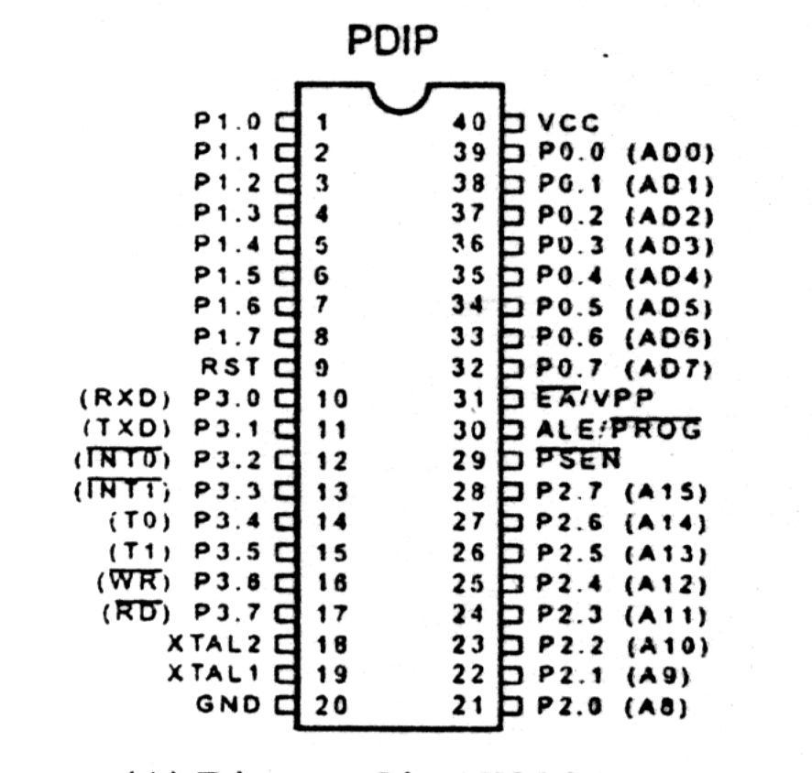
Figure.C.1. Pins diagram of AT 89C51 from ATMEL

