INFRARED SENSOR
Sensor implemented in the research program “RESCUE-ME”

Infra Red Sensor
This sensor is divided in two part, they are:

- Transmitter Circuit
The main part in this circuit is the LED, which transmits infrared wave.

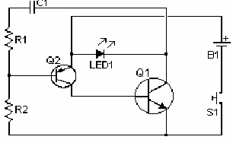

2. Receiver Circuit
Photo detector Transistor plays as the main component of the circuit, which is used to detect infrared wave. IC1 is an operational amplifier that its function as a comparator and IC2 as driver to control the relay.

