Reconfigurable Analog Fuzzy Controller Design
Part 3: Defuzzifier Circuit

Faizal A. Samman ¹, Rhiza S. Sadjad ²

Department of Electrical Engineering – Hasanuddin University
Jl. Perintis Kemerdekaan Km. 10 Makassar 90245
E-mail: faizalas@engineer.com ¹, rhiza@unhas.ac.id ²

Abstract – Accuracy assessment and test by simulation for defuzzification circuit used in analog fuzzy logic controller is presented in this paper. Defuzzification circuit is used in fuzzy logic controller where it converts fuzzy sets of aggregated fuzzy inference engine outputs into crisp output. Defuzzifier circuit (DFC) presented in this paper avoids the use of op-amp divider and multipliers, which relatively use large design area. To substitute the use of division circuit, a new defuzzification circuit based on center of gravity method called a voltage follower-aggregation circuit configuration is proposed. In order to give accuracy output, an intensive test using electronic design automation software is run by giving variable inference and consequence voltages. Then defuzzifier circuit outputs are evaluated and compared with hand-calculated of defuzzification outputs. This paper is the branch of the project to design analog fuzzy logic controller chip resembling standard-cell-like technique as in digital design technology, where defuzzification circuit is one of the important cells in the chip.

Keywords: Fuzzy logic circuit, defuzzification circuit, circuit design and simulation

1. INTRODUCTION

Part 1 and part 2 of this paper have discussed the fuzzification and fuzzy inference procedures, which lead the defuzzification procedure. The output of the fuzzy inference engine is a set of fuzzy terms with certain degree, which represents the possible distribution of the control action. In practical application, a crisp output is commonly required. Thus, a defuzzifier circuit interface is required to convert the inferred fuzzy control action into a non-fuzzy (crisp) control action. The analog FLC architecture represented in this paper has output membership function in the forms of fuzzy singleton, as shown in figure 1. It seems like constant values, where the term has VS, S, M, L and VL fuzzy singleton.

  - Composition

Under composition, all of the fuzzy sets assigned to the conclusion part of the rules under inference, are combined together to form a single fuzzy subset for every term in the term set of the output variable. Usually max or sum is used.
In most texts, the term inference method is used to mean the combination of the things referred to separately here as inference and composition. In literature terms like max-min inference and sum-product inference can be seen. They are the combination of max composition and min inference, or sum composition and product inference, respectively. The reverse terms min-max and product-sum means the same things as the reverse order.

MAX composition
In max composition, combined output fuzzy set is constructed by taking point-wise maximum over all of the fuzzy sets assigned to a term by the inference rule. This combination for instance can be seen in figure 2 where the output term has fuzzy membership function. As described in part 2 of this three-part paper, the fuzzy inference circuit uses Takagi-Sugeno-Kang (TSK) inference system with zero-order method, thus the membership function of the output term consists of fuzzy singleton. Inference signals from FIC (fuzzy inference circuit), i.e. V_{inf} determine the grade of the output terms. All graded fuzzy output terms is then combined or composed to represent the fuzzy action. At last, defuzzification procedure is done to find crisp action of the FLC.

Fig.1. Membership function for output terms with five fuzzy singleton memberships.
  - Defuzzification

The continuos fuzzy action, the result of MAX composition, as in figure 2(a) is sometimes lead by discretisizing fuzzy action to ease to undertake defuzzification procedure. This yield is shown in figure 2(b) where it takes 24 discrete points. The more discrete points are taken the more accurate of the defuzzification processes.

(a)
(b)
Fig.2. Compositional diagram of fuzzy action in (a) continuos form, (d) discrete form.

In case of the output term with fuzzy singleton, the max composition is represented in figure 3. This approach is referred to TSK fuzzy inference method as mentioned before. It only uses five fuzzy singleton terms that could be determined by the designer. It is used in the proposed FLC architecture as shown in figure 4. This approach is not only faster than one shown in figure 2(a) and 2(b) but also it give simple implementation on circuit, because it reduces the large number of transistor use.
There are several defuzzification techniques that are available. Among other techniques, Center of Gravity method has been widely used in practices and is preferred in this paper.

Fig.3. Aggregation diagram resulted from membership functions of inference outputs of figure 1.

Fig.4. The architecture of the proposed reconfigurable analog fuzzy logic controller, colored/in dashed line box components are the scope of this paper.

2. DEFUZZIFIER CIRCUIT

Defuzzification circuit (DFC) presented in this paper uses principle of the voltage-follower aggregation circuit. The next sub-section will described the operational principle of that circuit and the realization of the DFC using five-pair-voltage-follower aggregation circuit

2.1 Principle of voltage-follower aggregation

Defuzzification circuit implementation is based on the principle of a voltage follower-aggregation circuit. Transconductance amplifiers (TCA₁, TCA₂, …, TCA_{k-1}, TCA_{k}) are used to aggregate the inference voltage V_{con1}, V_{con2}, …, V_{con-k} respectively. By Assuming that the transconductance of an amplifier A_{j} is G_{j}, then the current from the jth amplifier A_{j} to the common point V_{out} is I_{j} = G_{j}(V_{j} – V_{out}). Based on Kirchoff’s current law, the sum of the currents I_{j} coming from the k amplifier is zero.

$\sum_{j=1}^{k}{G_{j}\left(V_{\text{con}−j}−V_{\text{OUT}}\right)}=\sum_{j=1}^{k}{I_{j}}=0$ (1)

Thus we have
$V_{\text{OUT}}=\frac{\sum_{j=1}^{k}{G_{j} \text{.} V_{\text{con}−j}}}{\sum_{j=1}^{k}{G_{j} }}$ (2)

The equation above means that V_{out} is the average of V_{con-j}. The contribution of each V_{con-j} to V_{out} is weighted by the transconductance of corresponding amplifier G_{j}. The transconductance G_{j} of an amplifier is proportional to the root of the current source when the amplifier operates in its linear region, and the VCC_{k} converts an input voltage V_{inf-k} into a current I_{j} with a square law. If we used a voltage to current converter to drive the current source of a transconductance amplifier, then the proposed circuit in figure 6 represents the defuzzified value or crisp output as follows

$z=V_{\text{OUT}}=\frac{\sum_{j=1}^{k}{V_{\text{inf}−j} \text{.} V_{\text{con}−j}}}{\sum_{j=1}^{k}{V_{\text{inf}−j} }}$ (3)

  - Configuration of the five-pair-voltage-follower aggregation

Generally configuration of the DFC using voltage-follower aggregation is shown in figure 5. As mentioned in advance, the one pair of voltage-follower aggregation consists of one transconductance amplifier circuit and one voltage to current circuit. Detail schematic of the DFC or the five-using voltage-follower aggregation circuit is presented in figure 6.

Fig.5. General schematic of defuzzifier circuit with voltage follower aggregation configuration.

Table 1: Comparison between hand-calculated and CAD-simulated results for defuzzification circuits with V_{DD}=7 V, Range of V_{CON}: 2-10 V.

No | V_{con} | V_{inf} | V_{con}.V_{inf} | V_{inf} | V_{con}.V_{inf} | V_{inf} | V_{con}.V_{inf} | V_{inf} | V_{con}.V_{inf} | V_{inf} | V_{con}.V_{inf}
1 | 2 V | 1.00 | 2.00 | 0.30 | 0.60 | 0.10 | 0.20 | 0.90 | 1.80 | 0.10 | 0.20
2 | 4 V | 0.40 | 1.60 | 0.90 | 3.60 | 0.10 | 0.40 | 0.80 | 3.20 | 0.20 | 0.80
3 | 6 V | 0.50 | 3.00 | 0.00 | 0.00 | 0.20 | 1.20 | 0.10 | 0.60 | 1.00 | 6.00
4 | 8 V | 0.80 | 6.40 | 1.00 | 8.00 | 0.40 | 3.20 | 0.00 | 0.00 | 0.30 | 2.40
5 | 10 V | 1.00 | 10.00 | 0.20 | 2.00 | 0.80 | 8.00 | 0.30 | 3.00 | 0.10 | 1.00
Sum |  |  | 3.70 | 23.00 | 2.40 | 14.20 | 1.60 | 13.00 | 2.10 | 8.60 | 1.70 | 10.40
Hand Calculated |  |  |  |  | 6.2162 |  | 5.9167 |  | 8.1250 |  | 4.0952 |  | 6.1176
Simulation result |  |  |  |  | 6.2525 |  | 6.0736 |  | 6.7892 |  | 2.6928 |  | 6.0349

Table 2: Comparison between hand-calculated and CAD-simulated results for defuzzification circuits with V_{DD}=7 V, Range of V_{CON}: 1-5 V.

No | V_{con} | V_{inf} | V_{con}.V_{inf} | V_{inf} | V_{con}.V_{inf} | V_{inf} | V_{con}.V_{inf} | V_{inf} | V_{con}.V_{inf} | V_{inf} |  | V_{con}.V_{inf}
1 | 1 V | 1.00 | 1.00 | 0.30 | 0.30 | 0.10 | 0.10 | 0.90 | 0.90 |  | 0.10 | 0.10
2 | 2 V | 0.40 | 0.80 | 0.90 | 1.80 | 0.10 | 0.20 | 0.80 | 1.60 |  | 0.20 | 0.40
3 | 3 V | 0.50 | 1.50 | 0.00 | 0.00 | 0.20 | 0.60 | 0.10 | 0.30 |  | 1.00 | 3.00
4 | 4 V | 0.80 | 3.20 | 1.00 | 4.00 | 0.40 | 1.60 | 0.00 | 0.00 |  | 0.30 | 1.20
5 | 5 V | 1.00 | 5.00 | 0.20 | 1.00 | 0.80 | 4.00 | 0.30 | 1.50 |  | 0.10 | 0.50
Sum |  | 3.70 | 11.50 | 2.40 | 7.10 | 1.60 | 6.50 | 2.10 | 4.30 |  | 1.70 | 5.20
Hand Calculated |  |  |  |  | 3.1081 |  | 2.9583 |  | 4.0625 |  | 2.0476 |  |  | 3.0588
Simulation result |  |  |  |  | 3.6142 |  | 3.2998 |  | 4.8021 |  | 1.5235 |  |  | 3.0352

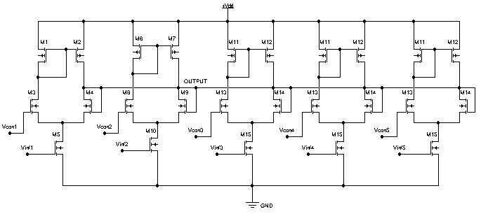

Fig.6. Schematic for defuzzification circuit with 5 TCA-VCC (Trans-Conductance Amplifier-Voltage-to-Current Converter) pairs.

3. TEST BY SIMULATION

The DFC output of figure 6 is test by setting all the V_{inf} and V_{con} of the circuit, then measured the output. Test 1 result is shown in table 1. The universe of discourse is between 0 to about 10 volts, and then V_{con1}, V_{con2}, V_{con3}, V_{con4}, and V_{con5} are set to 2, 4, 6, 8, and 10 volts respectively. Random voltages ranging between 0.00 to 1.00 volt are set to V_{inf1}, V_{inf2}, V_{inf3}, V_{inf4} and V_{inf5}. The test 2 result is shown in table 2. In this test, the universe of discourse is between 0 to about 5 volts, and then V_{con1}, V_{con2}, V_{con3}, V_{con4}, and V_{con5} are set to 1, 2, 3, 4, and 5 volts respectively. As in test 1, random voltages ranging between 0.00 to 1.00 volt are set to V_{inf1}, V_{inf2}, V_{inf3}, V_{inf4} and V_{inf5}.
In both tables, the experimental measurements are compared with hand-calculated results using equation (3). The results show that the simulation results and hand-calculated results are generally the same. However there any points where the results show a quite big error.
To show that the errors are not too significant, the simulation results shown in figure 7 represent that DFC outputs give willingness of desired responses. The simulation is running by sweeping one of five V_{inf} between 0.00 to 1.00 volt, and the others are set to 0.3 volt. V_{con1}, V_{con2}, V_{con3}, V_{con4} and V_{con5} are set to 1, 2, 3, 4 and 5 volt respectively. The DFC output tends to 1 volt if V_{inf1} is swept from 0 to 1 V as shown in figure 7(a). Figure 7(b) shows that the DFC output tend to 2 volt if V_{inf2} is swept from 0 to 1 V. It can be concluded that for experiment in figure 7, the DFC output will tend to V_{con-k} if V_{inf-k} is swept approaching 1 volt.
Figure 8 shows another simulation result where V_{inf4} is swept from 0 to 1 volt and the others are set to 0.1 volt. If the result is compared with one shown in figure 7(d), it seems that the both outputs tend to V_{con4}=4 volt but different starting points. This is because in figure 7 the others Vinf are set to 0.3 volt, whereas in figure 8 the others Vinf are set to 0.1 volt, this gives DFC output will tend to have higher starting point than that shown in figure 7.
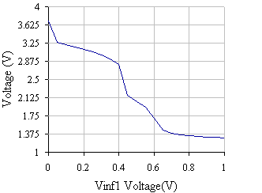
(a)
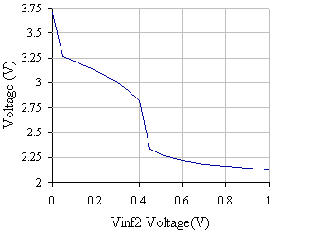
(b)
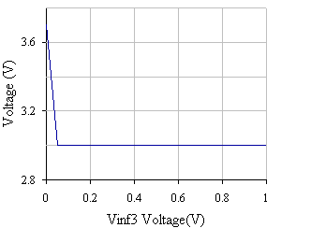
(c)
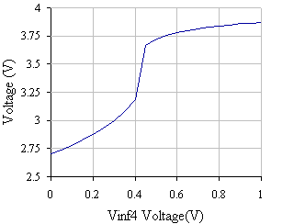
(d)
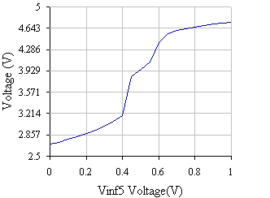
(e)

Fig.7. Simulation results of sweeping from 0 to 1 voltage for (a) V_{inf1}, (b) V_{inf2}, (c) V_{inf3}, (d) V_{inf4}, and (e) V_{inf5}.

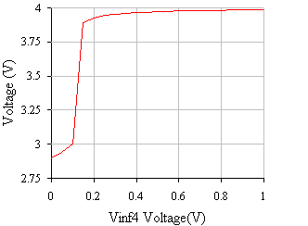

Fig.8. Simulation results for V_{inf4} is swept from 0 to 1 volt and the others are set to 0.1 volt.
4. CONCLUDING REMARKS

The tests by simulation of the DFC circuit proposed in this article have given desired output tendency. The DFC uses center of gravity method to realize the defuzzification process with simple fuzzy singleton on its consequent or output terms. Because of the simple configuration this proposed defuzzifier circuit not only gives extremely fast operation but also gives small number of transistor use, which implies to small silicon area needed to implement it on microelectronic chip or integrated circuit.
This paper is opened for deeper investigation on processing speed and power consumption of the DFC performances, which are not described here. The quantitative study and qualitative description about both performances is important to realize a reliable and economical circuit.
This part 3 of the three-part paper of “Reconfigurable Analog Fuzzy Controller Design” concludes this manuscript. For industries with massive electronic products or marketed-electronic equipment, circuit implementation of fuzzy controller is much more economic than using microprocessors. Analog technology as counterpart of digital technology has given the FLC circuit that has real-time or fast operation and extremely small chip realization. The last advantage will let the production engineers concern the state-or-the-art or artistic performs of their products.

References:

[1] Brown, M., Harris, C.: Neurofuzzy Adaptive Modeling and Control. Prentice-Hall, New Jersey, 1994
[2] Guo, S., Peters, L., Surmann, H.: Design and Application of Analog Fuzzy Logic Controller. IEEE Trans. on Fuzzy Systems, Vol. 4, No. 4, Nov. 1996.
[3] Hollstein, T., Halgamuge, S.K., Glesner, M.: Computer-Aided Design of Fuzzy Systems Based on Generic VHDL Specifications. IEEE Transactions on Fuzzy Systems, Vol. 4, No. 4, Nov. 1996
[4] Jamshidi, Moh., Vadiee, N., Ross, J.T.: Fuzzy Logic and Control, Software and Hardware Applications. Prentice-Hall, New Jersey, 1993.
[5] Manaresi, N., Rovatti, R., Franchi, E., Guerrieri, R., Baccarani, G.: A Silicon Compiler of Analog Fuzzy Controller: From Behavioral Specifications to Layout. IEEE Transactions on Fuzzy Systems, Vol. 4, No. 4, Nov. 1996
[6] Marshall, G.F., Collins, S.: Fuzzy Logic Architecture Using Subthreshold Analogue Floating-Gate Devices. IEEE Trans. on Fuzzy Systems, Vol. 5, No. 1, Feb. 1997.
[7] Tsukano, K., Inoue, T.: Synthesis of Operational Transconductance Amplifier-Based Analog Fuzzy Functional Blocks and Its Application. IEEE Trans. on Fuzzy Systems, Vol. 3, No. 1, Feb. 1995.

