Analog Fuzzy Controller Circuit Design
For Control Applications

Faizal A. Samman ¹, Rhiza S. Sadjad ²

Department of Electrical Engineering – Hasanuddin University
Jl. Perintis Kemerdekaan Km. 10 Makassar 90245
E-mail: faizalas@engineer.com ¹, rhiza@unhas.ac.id ²

Abstract – Analog fuzzy controller circuit design for control applications is presented in this paper. The analog fuzzy logic controller (FLC) consists of three main cells: Membership function circuits (MFC), fuzzy inference circuit (FIC) and defuzzification circuit (DFC). The MFC has function to fuzzify or convert a crisp input into fuzzy input based on membership function of fuzzy linguistic term related to the input. This paper proposes fuzzification circuit, which can be programmed in term of its membership form, as well as its membership location in universe of discourse of the input voltage domain. The FIC can be reconfigured in term of the fuzzy rules determined by the controller designers in line with their fuzzy controller specification. The DFC presented in this paper avoids the use of op-amp divider and multipliers, which relatively use large design area. To substitute the use of division circuit, a new defuzzification circuit based on center of gravity method called a voltage follower-aggregation circuit configuration is proposed. Those main features result in flexible membership function circuit and place the circuit functions in wider application areas. This paper is the project to design analog fuzzy logic controller chip resembling standard-cell-like technique as in digital design technology.

Keywords: Fuzzy logic circuit, electronic design, circuit simulation.

- Introduction

Fuzzy Logic Controller (FLC) as one of the intelligent control systems has been extensively used in some electronic equipment such as in air conditioner, rice cooker, washing machine, and as automatic transmission controller in automotive. FLC has also intensively applied in process control system both in evaporation control and distillation control. FLC applications in chemical process are for examples in sterilizing process of CPO (crude palm oil) production, pH control in pharmaceutical production, food processing, and so on.
In industrial practices, fuzzy logic is used especially in the systems that have complicated mathematical model even in the system whose model is extremely difficult to be derived. As an alternative and non-conventional control system, fuzzy logic controller emerges not to replace or eliminate all conventional control system. Sometimes fuzzy controller is used to complement an existing PID controller, where FLC control the parameters of the PID controller.

Fig.1. The architecture of the proposed programmable analog fuzzy logic controller, colored/in dashed line box components are the scope of this paper.
Fuzzy logic controller hardware as shown in figure 1 consists of three main components:
- Membership function circuits, or fuzzifier components.
- Fuzzy inference mechanism circuit.
- Defuzzification circuit.

Before fuzzy inference process is undertaken, signals from sensor devices in crisp values are fuzzified by MFC to be fuzzy values. The fuzzy values are taken from the grade values related to any membership form of the crisp inputs. The understanding of fuzzy sets is basic knowledge to surf the fuzzy logic theory. Reference [1] and [4] give basic explanations of fuzzy sets and fuzzy logic theory. Figure 1 shows fuzzy controller operation using Takagi-Sugeno zero-order inference method.

Fig.2. Fuzzy inference mechanism for three rules.

- FUZZY CONTROLLER Circuit

  - Membership Function Circuit (MFC)

Figure 3 shows the general criteria for membership form. There four membership forms and they have their own criteria. The four membership forms are S-form, Z-form, trapezoidal and triangle form. MFC is constructed by two-pair differential amplifier configuration coupled with two-stage level shifter circuit.
Based on figure 3, parameter T or the half-length of membership slope is determined by following equation:

$\begin{aligned}T_{j}=\sqrt{\frac{2I_{\text{ss}}}{β_{j}}}, \\ j=\text{diffrensial} \text{pair} j^{\text{th}} \\ β=\text{conductance} \text{parameter} \text{of} \text{NMO}S\end{aligned}$ (1)

Fig.3. General criteria for the shape of the membership-function circuit.

If triangular function is preferred then following equation must be fulfilled

$\begin{aligned}{\text{Vref}}_{1}+T_{1}={\text{Vref}}_{2}−T_{2}, \\ \text{if} T_{1}=T_{2} =T, {\text{Vref}}_{2}={\text{Vref}}_{1}+2T\text{.}\end{aligned}$ (2)

If trapezoidal function is preferred then following equation must be met.

$\begin{aligned}{\text{Vref}}_{1}+T_{1}< {\text{Vref}}_{2}−T_{2}, \\ \text{if} T_{1}=T_{2} =T, {\text{Vref}}_{2}>{\text{Vref}}_{1}+2T\text{.}\end{aligned}$ (3)

If Z-form function is preferred then I_{SS1}=0, and if S-form function is required then I_{SS2}=0.

The circuit shown in figure 4 has output range between 4 to 5 volts. Therefore, two-stage level shifter circuit is coupled to the output of circuit. Thus the result will give MFC that gives ideal range of membership grade, i.e. the output with range between 0 to 1 volts.

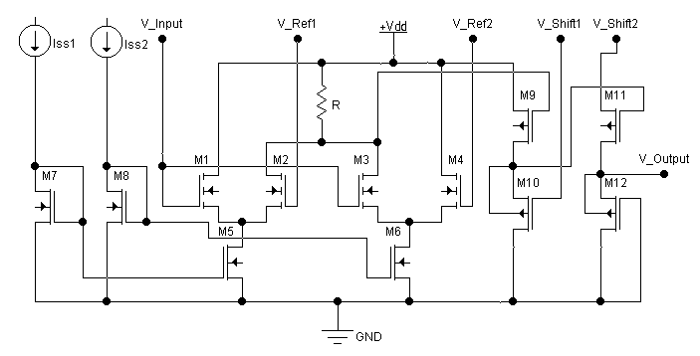

Fig.4. Membership function circuit schematic coupled with two-stage level shifter circuit.

  - Fuzzy Inference Circuit (FIC)

The basic schematic of minimum (MIN) circuit is exhibited in figure 5. It comprises two pMOSFET and two nMOSFETs for current mirror configuration.

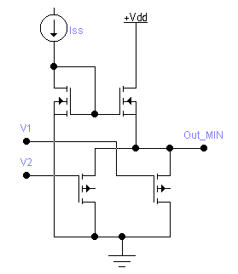

Fig.5. Schematic of minimum circuit

Basic schematic or representation of one maximum column circuit is shown in figure 6. It consists of ten nMOSFETs including two NMOSFET for current mirror configuration, i.e. Q₁ and Q₂. Rule voltages signal from nine outputs of MIN circuits are fed to the gates of nine nMOSFETs, i.e. M₁, …, M₉ respectively. For complete structure as in figure 3, it will need five maximum circuits like one in figure 6.

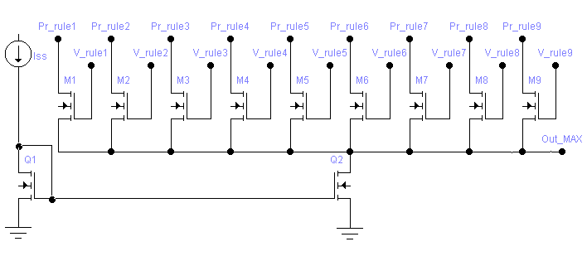

Fig.6. Schematic of maximum column circuit drawn in row format.

  - Defuzzification Circuit (DFC)

Defuzzification circuit implementation is based on the principle of a voltage follower-aggregation circuit. Transconductance amplifiers (TCA₁, TCA₂, …, TCA_{k-1}, TCA_{k}) are used to aggregate the inference voltage V_{con1}, V_{con2}, …, V_{con-k} respectively. By Assuming that the transconductance of an amplifier A_{j} is G_{j}, then the current from the jth amplifier A_{j} to the common point V_{out} is I_{j} = G_{j}(V_{j} – V_{out}). Based on Kirchoff’s current law, the sum of the currents I_{j} coming from the k amplifier is zero.

$$\sum_{j=1}^{k}{G_{j}\left(V_{\text{con}−j}−V_{\text{OUT}}\right)}=\sum_{j=1}^{k}{I_{j}}=0$$

Thus we have
$$V_{\text{OUT}}=\frac{\sum_{j=1}^{k}{G_{j} \text{.} V_{\text{con}−j}}}{\sum_{j=1}^{k}{G_{j} }}$$

The equation above means that V_{out} is the average of V_{con-j}. The contribution of each V_{con-j} to V_{out} is weighted by the transconductance of corresponding amplifier G_{j}. The transconductance G_{j} of an amplifier is proportional to the root of the current source when the amplifier operates in its linear region, and the VCC_{k} converts an input voltage V_{inf-k} into a current I_{j} with a square law. If we used a voltage to current converter to drive the current source of a transconductance amplifier, then the proposed circuit in figure 7 represents the defuzzified value or crisp output as follows

$z=V_{\text{OUT}}=\frac{\sum_{j=1}^{k}{V_{\text{inf}−j} \text{.} V_{\text{con}−j}}}{\sum_{j=1}^{k}{V_{\text{inf}−j} }}$

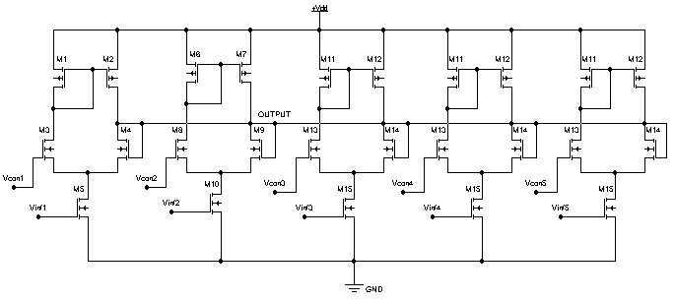

Fig.7. Schematic for defuzzification circuit with 5 TCA-VCC (Trans-Conductance Amplifier-Voltage-to-Current Converter) pairs.

- Simulation Results

  - Simulation Results for MFC

In this section, the simulation results of the MFC will be described. Figure 5 exhibits trapezoidal (outer curve) and triangular (inner curve) membership function form. The trapezoidal form is obtained by setting V_{ref1}=1 V and V_{ref2}=4.5 V. And the triangular form is obtained by setting V_{ref1}=2 V and V_{ref2}=4 V.

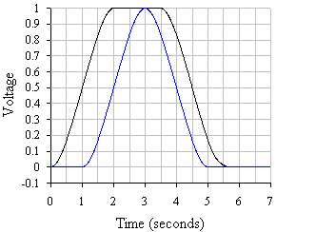

Fig.5. The trapezoidal and triangular forms.

Figure 6 shows the S-form and the Z-form membership function. The S-form (right-side curve) is obtained by setting I_{ss1}=0, thus differential pair 1 does not work, and V_{ref2}=2.5 V. And the Z-form (left-side curve) is obtained by setting I_{ss2}=0, thus the differential pair 2 does not work, and V_{ref1}=3 V.

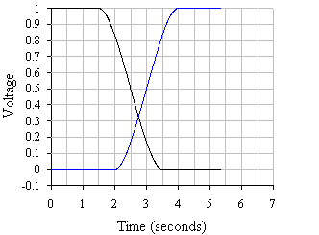

Fig.6. S-form and Z-form membership function.

Figure 7 shows the triangular membership function forms with different slopes. The inner curve shows membership function with transconductance parameter β=0.00003 A/V², as well as V_{ref1}=2.4 V and V_{ref2}=3.6 V. And the outer curve shows another form with transconductance parameter β=0.00001 A/V², as well as V_{ref1}=2 V and V_{ref2}=4 V.

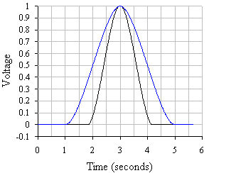

Fig.7. Triangular forms with different slopes.

  - Simulation Results for FIC

The simulation results for MIN circuit is shown in figure 8, where V₁ is supplied by sinusoidal signal with 1 V amplitude, and V₂ is supplied by DC 0.3 V. It can be seen that MIN circuit output is always equal or less than 0.3 V.

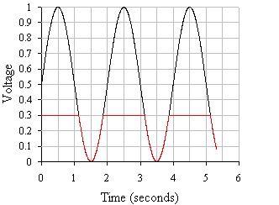
Fig.8. Simulation result of minimum circuit

Table 1: Example of Fuzzy Rules

In1 \ In 2 | Slow | Med | Fast
Low | L ¹ | VS ² | S ³
Med | VS ⁴ | M ⁵ | L ⁶
High | VL ⁷ | S ⁸ | M ⁹

An example of fuzzy implication rules is exhibited in table 1. The first column denotes fuzzy terms for input 1 and the first row denotes fuzzy terms for input 2. The other 9 boxes in table 1 are fuzzy consequences for each rule. For each consequence, a superscript denotes the rule number. Examples of fuzzy rules based on table 1 are as follow:

#3: IF In1 is Low AND In2 is Fast THEN Out is S
#7: IF In1 is High AND In2 is Slow THEN Out is VL

Table 2: Programming signals for each rule (Pr_rule) fed to V_{dd} of MAX circuit based on fuzzy rules in table 1.

 | Column  1 | Column  2 | Column  3 | Column 4 | Column 5
Rule 1 | 0 | 0 | 0 | 1 | 0
Rule 2 | 1 | 0 | 0 | 0 | 0
Rule 3 | 0 | 1 | 0 | 0 | 0
Rule 4 | 1 | 0 | 0 | 0 | 0
Rule 5 | 0 | 0 | 1 | 0 | 0
Rule 6 | 0 | 0 | 0 | 1 | 0
Rule 7 | 0 | 0 | 0 | 0 | 1
Rule 8 | 0 | 1 | 0 | 0 | 0
Rule 9 | 0 | 0 | 1 | 0 | 0
Consequent | VS | S | M | L | VL

As in table 2, programming signal for rule k (Pr_rule-k) is fed to the drain of nMOSFET-k (M_{k}). And the k^{th} rule voltage from MIN circuit output is connected to the gate of M_{k}. Thus the MAX circuit will only process the rules voltages whose drain connected to 6 volts supply. The simulation result is described in table 3. It can be seen that MAX circuit will only process V_rule-k having Pr_rule-k set to 1.

Table 3: Simulation results of maximum column circuit.

k | Pr_  rule-k | V_  rule-k | Pr_  rule-k | V_  rule-k | Pr_  rule-k | V_  rule-k
1 | 1 | 0.50 | 0 | 0.50 | 0 | 0.50
2 | 1 | 0.30 | 1 | 0.30 | 0 | 0.30
3 | 1 | 0.60 | 0 | 0.60 | 1 | 0.60
4 | 1 | 0.10 | 1 | 0.10 | 0 | 0.10
5 | 1 | 0.61 | 0 | 0.61 | 0 | 0.61
6 | 1 | 0.20 | 0 | 0.20 | 0 | 0.20
7 | 1 | 0.90 | 0 | 0.90 | 0 | 0.90
8 | 1 | 0.20 | 0 | 0.20 | 1 | 0.20
9 | 1 | 0.00 | 0 | 0.00 | 0 | 0.00
 | Max: | 0.890 | Max: | 0.294 | Max: | 0.592

0 V_{dd} is grounded
1 V_{dd} is set 6 V

  - Test Results for DFC

The test results of the DFC are shown in table 4 and 5. The test is ran by feeding signals for inference voltages, V_{inf} and consequence voltages, V_{cons}, then the output of the DFC is measured.

Table 4: Comparison between hand-calculated and CAD-simulated results for defuzzification circuits with V_{DD}=7 V, Range of V_{CON}: 2-10 V.

No | V_{con} | V_{inf} | V_{con}.V_{inf} | V_{inf} | V_{con}.V_{inf} | V_{inf} | V_{con}.V_{inf} | V_{inf} | V_{con}.V_{inf} | V_{inf} | V_{con}.V_{inf}
1 | 2 V | 1.00 | 2.00 | 0.30 | 0.60 | 0.10 | 0.20 | 0.90 | 1.80 | 0.10 | 0.20
2 | 4 V | 0.40 | 1.60 | 0.90 | 3.60 | 0.10 | 0.40 | 0.80 | 3.20 | 0.20 | 0.80
3 | 6 V | 0.50 | 3.00 | 0.00 | 0.00 | 0.20 | 1.20 | 0.10 | 0.60 | 1.00 | 6.00
4 | 8 V | 0.80 | 6.40 | 1.00 | 8.00 | 0.40 | 3.20 | 0.00 | 0.00 | 0.30 | 2.40
5 | 10 V | 1.00 | 10.00 | 0.20 | 2.00 | 0.80 | 8.00 | 0.30 | 3.00 | 0.10 | 1.00
Sum |  | 3.70 | 23.00 | 2.40 | 14.20 | 1.60 | 13.00 | 2.10 | 8.60 | 1.70 | 10.40
Hand Calculated |  |  | 6.2162 |  | 5.9167 |  | 8.1250 |  | 4.0952 |  | 6.1176
Simulation result |  |  | 6.2525 |  | 6.0736 |  | 6.7892 |  | 2.6928 |  | 6.0349

Table 5: Comparison between hand-calculated and CAD-simulated results for defuzzification circuits with V_{DD}=7 V, Range of V_{CON}: 1-5 V.

No | V_{con} | V_{inf} | V_{con}.V_{inf} | V_{inf} | V_{con}.V_{inf} | V_{inf} | V_{con}.V_{inf} | V_{inf} | V_{con}.V_{inf} | V_{inf} | V_{con}.V_{inf}
1 | 1 V | 1.00 | 1.00 | 0.30 | 0.30 | 0.10 | 0.10 | 0.90 | 0.90 | 0.10 | 0.10
2 | 2 V | 0.40 | 0.80 | 0.90 | 1.80 | 0.10 | 0.20 | 0.80 | 1.60 | 0.20 | 0.40
3 | 3 V | 0.50 | 1.50 | 0.00 | 0.00 | 0.20 | 0.60 | 0.10 | 0.30 | 1.00 | 3.00
4 | 4 V | 0.80 | 3.20 | 1.00 | 4.00 | 0.40 | 1.60 | 0.00 | 0.00 | 0.30 | 1.20
5 | 5 V | 1.00 | 5.00 | 0.20 | 1.00 | 0.80 | 4.00 | 0.30 | 1.50 | 0.10 | 0.50
Sum |  | 3.70 | 11.50 | 2.40 | 7.10 | 1.60 | 6.50 | 2.10 | 4.30 | 1.70 | 5.20
Hand Calculated |  |  | 3.1081 |  | 2.9583 |  | 4.0625 |  | 2.0476 |  | 3.0588
Simulation result |  |  | 3.6142 |  | 3.2998 |  | 4.8021 |  | 1.5235 |  | 3.0352

- Layout of ANALOG FLC

WE WILL GIVE THE STANDARD-CELL LAYOUT, IF OUR PAPER IS ACCEPTED FOR THE CONFERENCE

- Concluding Remarks

UNDER CONSTRUCTION – THE CONCLUSION AND COMPLETE EXPLANATION FOR EACH SECTION WILL BE GIVEN IF THIS PAPER IS ACCEPTED FOR ASCC 2002 IN SINGAPORE.

References:

[1] Brown, M., Harris, C.: Neurofuzzy Adaptive Modeling and Control. Prentice-Hall, New Jersey, 1994.
[2] Guo, S., Peters, L., Surmann, H.: Design and Application of Analog Fuzzy Logic Controller. IEEE Trans. on Fuzzy Systems, Vol. 4, No. 4, Nov. 1996.
[3] Hollstein, T., Halgamuge, S.K., Glesner, M.: Computer-Aided Design of Fuzzy Systems Based on Generic VHDL Specifications. IEEE Transactions on Fuzzy Systems, Vol. 4, No. 4, Nov. 1996
[4] Manaresi, N., Rovatti, R., Franchi, E., Guerrieri, R., Baccarani, G.: A Silicon Compiler of Analog Fuzzy Controller: From Behavioral Specifications to Layout. IEEE Transactions on Fuzzy Systems, Vol. 4, No. 4, Nov. 1996
[5] Marshall, G.F., Collins, S.: Fuzzy Logic Architecture Using Subthreshold Analogue Floating-Gate Devices. IEEE Trans. on Fuzzy Systems, Vol. 5, No. 1, Feb. 1997.
[6] Tsukano, K., Inoue, T.: Synthesis of Operational Transconductance Amplifier-Based Analog Fuzzy Functional Blocks and Its Application. IEEE Trans. on Fuzzy Systems, Vol. 3, No. 1, Feb. 1995.

